Area under Graphs and Gradients GREEN

Question 1  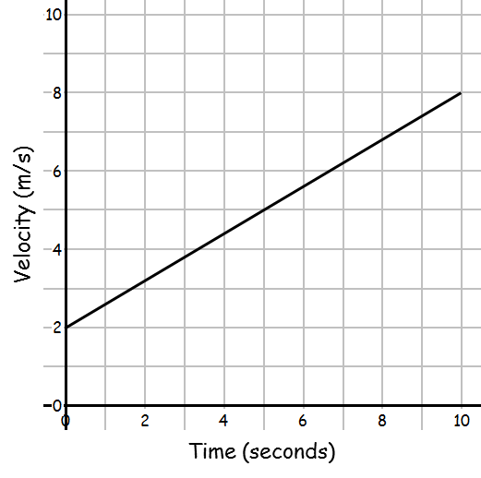  - Calculate the rate of acceleration from 0 to 10 seconds.  _________ m/s²  - Calculate the distance travelled.  _________ m | Question 2  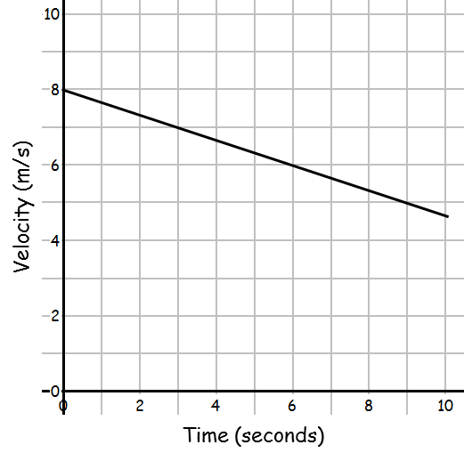  - Calculate the rate of deceleration from 0 to 10 seconds.  _________ m/s²  - Calculate the distance travelled in the first 9 seconds.  _________ m
Question 3  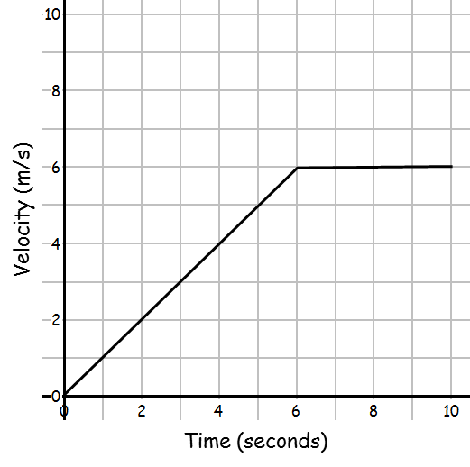  - Calculate the rate of acceleration from 0 to 6 seconds.  _________ m/s²  - Calculate the distance travelled.  _________ m | Question 4  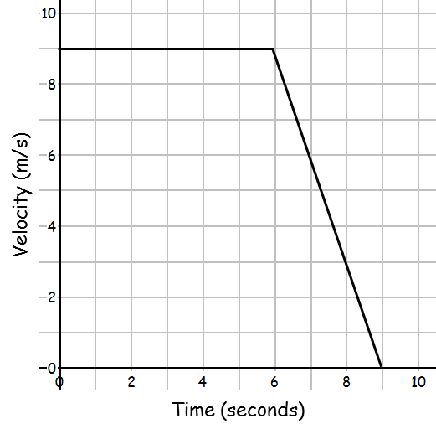  - Calculate the rate of deceleration from 6 to 10 seconds.  _________ m/s²  - Calculate the distance travelled.  _________ m

Question 5  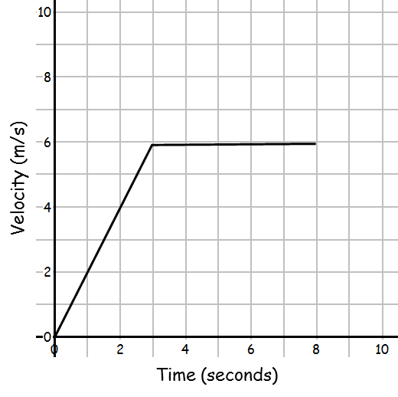  - Calculate the rate of acceleration from 0 to 3 seconds.  _________ m/s²  - Calculate the distance travelled.  _________ m | Question 6  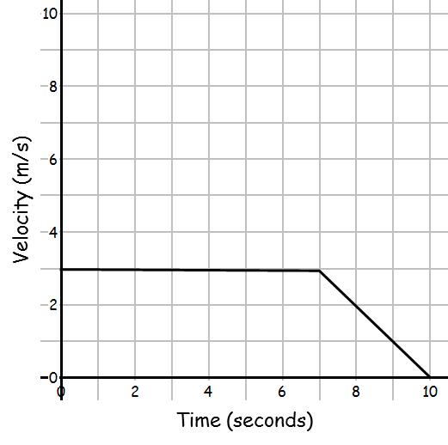  - Calculate the rate of deceleration from 7 to 10 seconds.  _________ m/s²  - Calculate the distance travelled.  _________ m
Question 7  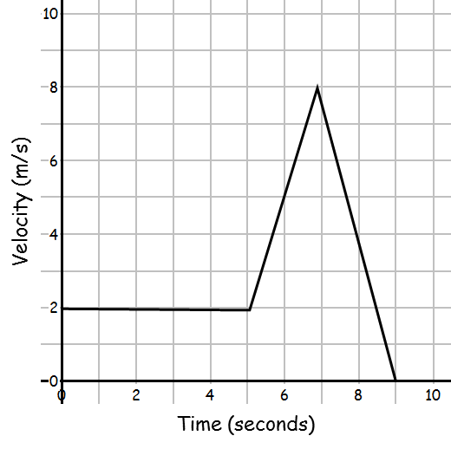  - Calculate the rate of acceleration from 5 to 7 seconds.  _________ m/s²  - Calculate the distance travelled.  _________ m | Question 8  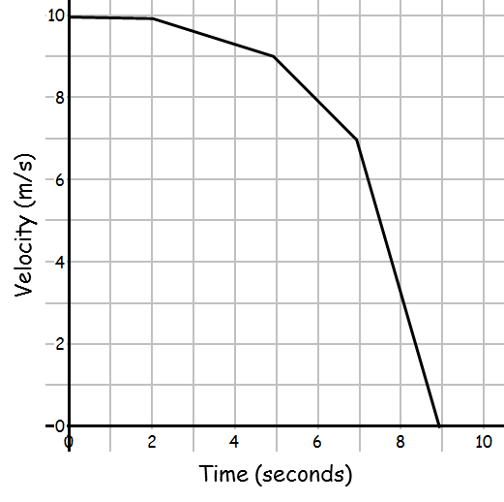  - Calculate the rate of deceleration from 7 to 9 seconds.  _________ m/s²  - Calculate the distance travelled.  _________ m
Area under Graphs and Gradients AMBER
Acceleration/deceleration = gradient
Distance travelled = area under the graph

Question 1  - Calculate the rate of acceleration from 0 to 10 seconds.  _________ m/s²  - Calculate the distance travelled.  _________ m | Question 2  - Calculate the rate of deceleration from 0 to 10 seconds.  _________ m/s²  - Calculate the distance travelled in the first 9 seconds.  _________ m
Question 3  - Calculate the rate of acceleration from 0 to 6 seconds.  _________ m/s²  - Calculate the distance travelled.  _________ m | Question 4  - Calculate the rate of deceleration from 6 to 10 seconds.  _________ m/s²  - Calculate the distance travelled.  _________ m

Question 5  - Calculate the rate of acceleration from 0 to 3 seconds.  _________ m/s²  - Calculate the distance travelled.  _________ m | Question 6  - Calculate the rate of deceleration from 7 to 10 seconds.  _________ m/s²  - Calculate the distance travelled.  _________ m
Question 7  - Calculate the rate of acceleration from 5 to 7 seconds.  _________ m/s²  - Calculate the distance travelled.  _________ m | Question 8  - Calculate the rate of deceleration from 7 to 9 seconds.  _________ m/s²  - Calculate the distance travelled.  _________ m
Area under Graphs and Gradients RED
Acceleration/deceleration = gradient
Distance travelled = area under the graph

Question 1  Area of trapezium = ½ (a + b) h  Gradient = rise  run  - Calculate the rate of acceleration from 0 to 10 seconds.  _________ m/s²  - Calculate the distance travelled.  _________ m | Question 2  - Calculate the rate of deceleration from 0 to 10 seconds.  _________ m/s²  - Calculate the distance travelled in the first 9 seconds.  _________ m
Question 3  - Calculate the rate of acceleration from 0 to 6 seconds.  _________ m/s²  - Calculate the distance travelled.  _________ m | Question 4  - Calculate the rate of deceleration from 6 to 10 seconds.  _________ m/s²  - Calculate the distance travelled.  _________ m

Question 5  - Calculate the rate of acceleration from 0 to 3 seconds.  _________ m/s²  - Calculate the distance travelled.  _________ m | Question 6  - Calculate the rate of deceleration from 7 to 10 seconds.  _________ m/s²  - Calculate the distance travelled.  _________ m
Question 7  - Calculate the rate of acceleration from 5 to 7 seconds.  _________ m/s²  - Calculate the distance travelled.  _________ m | Question 8  - Calculate the rate of deceleration from 7 to 9 seconds.  _________ m/s²  - Calculate the distance travelled.  _________ m

