Compound Shapes with Circles GREEN

Calculate the areas and perimeters of the shapes below. Give your answers correct to 2 decimal places.

1) 2) 3)
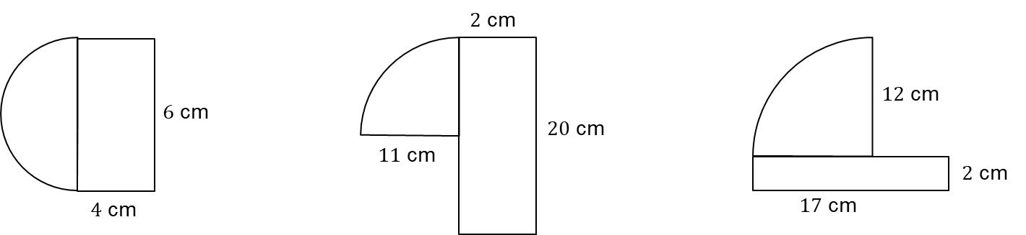

4) 5) 6)
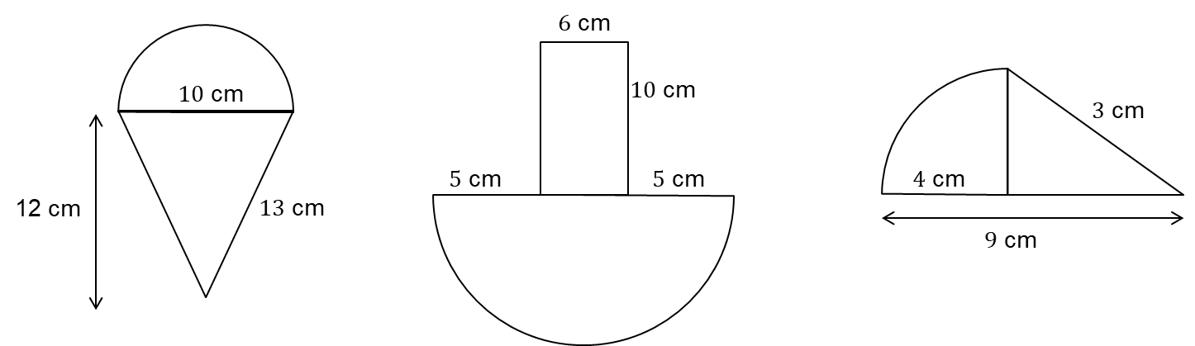

Compound Shapes with Circles AMBER

Calculate the areas and perimeters of the shapes below. Give your answers correct to 2 decimal places.

1) 2) 3)

Area of semi-circle: Area of quarter-circle: Area of quarter -circle:

Area of rectangle: Area of rectangle: Area of rectangle:

Total area: Total area: Total area:

Arc length: Arc length: Arc length:

Total perimeter: Total perimeter: Total perimeter:

4) 5) 6)

Compound Shapes with Circles RED

Calculate the areas and perimeters of the shapes below. Give your answers correct to 2 decimal places.

1) 2) 3)

Area of semi-circle: $3^{2}×π÷2=$ Area of quarter-circle: ${11}^{2}×π÷4$ Area of quarter -circle:
$=$ $=$
Area of rectangle: Area of rectangle: Area of rectangle:

Total area: Total area: Total area:

Arc length: $6×π÷2$ Arc length: $22×π÷4$ Arc length:
$=$ $=$
Total perimeter: Total perimeter: Total perimeter:

4) 5) 6)

Area of semi-circle: Area of semi-circle: Area of quarter -circle:

Area of triangle: Area of rectangle: Area of triangle:

Total area: Total area: Total area:

Arc length: Arc length: Arc length:

Total perimeter: Total perimeter: Total perimeter:

