Problem Solving with Algebra

Name: _____________________________________
Class: _____________________________________

Time: 1 hour 20 mins
Total marks available: 70 | Total marks achieved: _____
Q1.
The diagram shows three sides of a regular polygon.
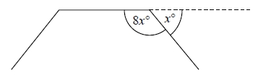
The size of each exterior angle of the regular polygon is x°.
The size of each interior angle of the regular polygon is 8x°.
Work out the number of sides the regular polygon has.

(Total for question = 3 marks)

Q2.
The diagram shows shape A.
All the measurements are in centimetres.
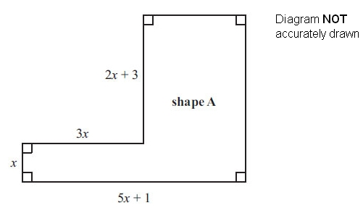
(a) Find an expression, in terms of x, for the perimeter of shape A.

. . . . . . . . . . . . . . . . . . . . .
(3)
A square has the same perimeter as shape A.
(b) Find an expression, in terms of x, for the length of one side of this square.

. . . . . . . . . . . . . . . . . . . . .
(1)
(Total for Question is 4 marks)

Q3.
ABC is a triangle.
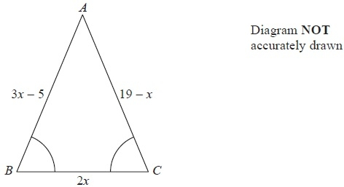
Angle ABC = angle BCA.
The length of side AB is (3x − 5) cm.
The length of side AC is (19 − x) cm.
The length of side BC is 2x cm.
Work out the perimeter of the triangle.
Give your answer as a number of centimetres.
........................................................... cm
(Total for Question is 5 marks)

Q4.
(a) Expand 5(2c + 3d)
...........................................................
(1)
(b) Here are two straight lines, ABCDE and PQ.
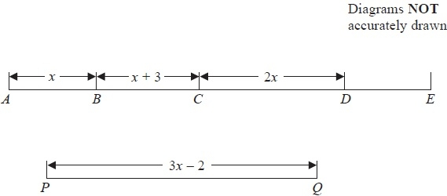
In the diagrams all the lengths are in cm.
AE = 2PQ.
Find an expression, in terms of x, for the length of DE.
Give your answer in its simplest form.
........................................................... cm
(4)
(Total for Question is 5 marks)

Q5.
The diagram shows the plan of a floor.
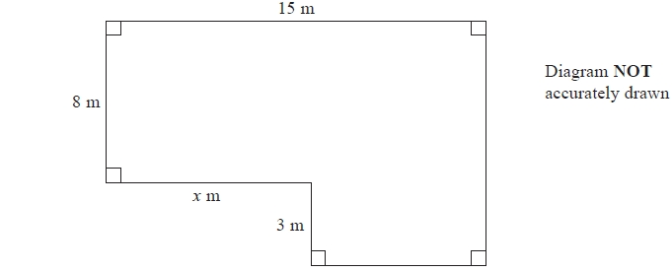
The area of the floor is 138 m².
Work out the value of x.
...........................................................
(Total for Question is 4 marks)

Q6.
Here is a rectangle.
All measurements on the diagram are in centimetres.
(a) Find the value of x.
...........................................................
(2)
Here is a triangle.
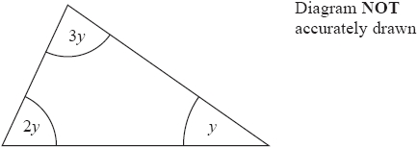
(b) Find the size of the angle marked y.
...........................................................°
(2)

(Total for question = 4 marks)

Q7.
The diagram shows a right-angled triangle.
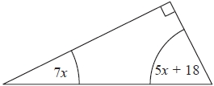
All the angles are in degrees.
Work out the size of the smallest angle of the triangle.
...........................................................°

(Total for question is 3 marks)

Q8.
You can use this rule to work out the total hire charge, in pounds (£), for hiring a satellite phone.
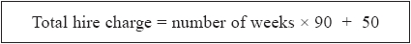
Ismail wants to hire a satellite phone for 4 weeks.
(a) Work out the total hire charge.
£...........................................................
(2)
Dominik hires a satellite phone.
His total hire charge is £ 860
(b) For how many weeks did he hire the phone?
........................................................... weeks
(3)

(Total for question = 5 marks)

Q9.
The diagram shows a garden in the shape of a rectangle.
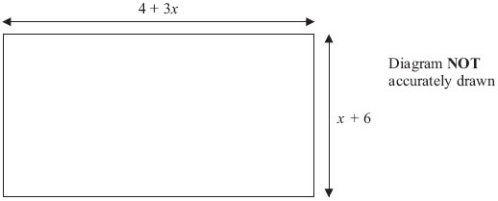
All measurements are in metres.
The perimeter of the garden is 32 metres.
Work out the value of x

. . . . . . . . . . . . . . . . . . . . . .
(Total for Question is 4 marks)

Q10.
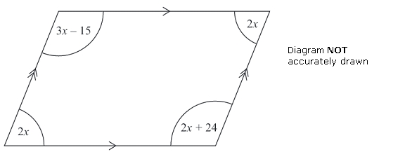
The diagram shows a parallelogram.
The sizes of the angles, in degrees, are
2x
3x – 15
2x
2x + 24
Work out the value of x.

x = . . . . . . . . . . . . . . . . . . . . . .
(Total for Question is 3 marks)

Q11.
Here is a parallelogram.
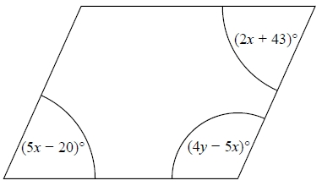
Work out the value of x and the value of y.
x = ...........................................................
y = ...........................................................

(Total for question = 5 marks)

Q12.
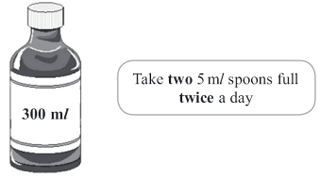
There are 300 ml of medicine in a bottle.
Mary has to take two 5 ml spoons full of medicine twice a day.
Mary has to take the medicine until the bottle is empty.
(a) How many days does Mary have to take the medicine for?

. . . . . . . . . . . . . . . . . . . . . . days
(3)
You can work out the amount of medicine, c ml, to give to a child by using the formula
c = ^{ma}⁄₁₅₀
m is the age of the child, in months.
a is an adult dose, in ml.
A child is 30 months old.
An adult's dose is 40 ml.
(b) Work out the amount of medicine you can give to the child.

. . . . . . . . . . . . . . . . . . . . . . ml
(2)

(Total for Question is 5 marks)

Q13.
* This formula is used to work out the body mass index, B, for a person of mass M kg and height H metres.
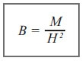
A person with a body mass index between 25 and 30 is overweight.
Arthur has a mass of 96 kg.
He has a height of 2 metres.
Is Arthur overweight?
You must show all your working.

(Total for Question is 3 marks)

Q14.
Here is information about the cost of sending a parcel to Europe by Parcel Link.
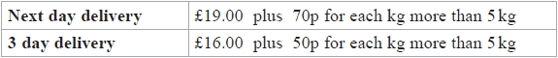
Kate is going to send a parcel to Europe by Parcel Link.
The parcel weighs 12 kg.
Kate can send the parcel using next day delivery or using 3 day delivery.
(a) Work out the difference in the two costs.
£...........................................................
(3)
Adam sends a parcel to Europe by Parcel Link.
He uses 3 day delivery.
The cost is £25
(b) Work out how many kilograms Adam's parcel weighs.
........................................................... kg
(3)

(Total for question = 6 marks)

Q15.
Penelope is going to cook a chicken.
She uses this rule to find the cooking time.
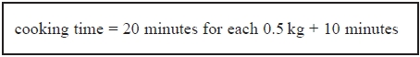
The chicken has a weight of 2 kg.
Penelope wants to finish cooking the chicken at 12 30 pm.
What time should Penelope start cooking the chicken?
...........................................................

(Total for question = 4 marks)

Q16.
You can use these rules to change temperatures from °C to °F.
approximate rule
exact rule
Amy uses the approximate rule to change 20°C to °F.
Dan uses the exact rule to change 20°C to °F.
(a) Work out the difference between Amy's result and Dan's result.
...........................................................°F
(4)
Jade uses the approximate rule to change a temperature from °C to °F.
The result is 110°F.
(b) What °C temperature did Jade change to °F?
...........................................................°C
(3)
(Total for Question is 7 marks)

