Arcs and Sectors GREEN

3. In each diagram below the length of arc AB is given. Calculate the size of the angle at the centre of the sector.

4. In each diagram below the area of the sector is given. Calculate the size of the angle at the centre of the sector.

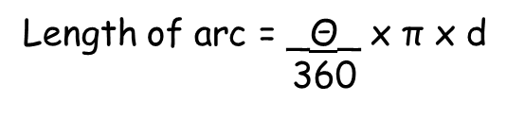
Arcs and Sectors AMBER

3. In each diagram below the length of arc AB is given. Calculate the size of the angle at the centre of the sector.
Substitute into the given formula for length of an arc

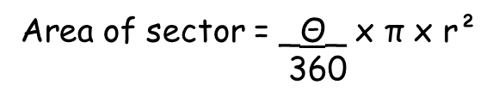
4. In each diagram below the area of the sector is given. Calculate the size of the angle at the centre of the sector.

Substitute into the given formula for area of a sector

Arcs and Sectors RED

3. In each diagram below the length of arc AB is given. Calculate the size of the angle at the centre of the sector.

Substitute into the given formula for length of an arc
12.56 = _Θ_ x π x 24
360

4. In each diagram below the area of the sector is given. Calculate the size of the angle at the centre of the sector.

Substitute into the given formula for area of a sector

120 = _Θ_ x π x 14²
360

