Multiplying Fractions

To multiply fractions, you need to multiply the numerators together, and multiply the denominators together.

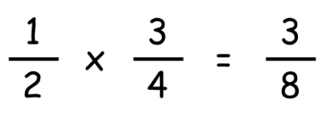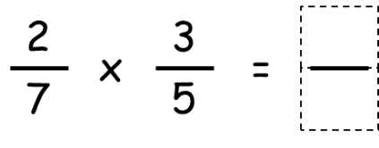

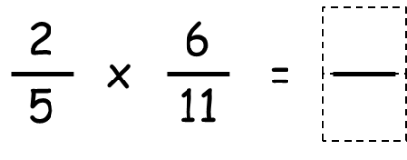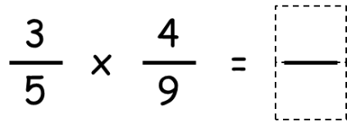

Sometimes you can cancel the fractions before multiplying. Remember that you cannot cancel numbers that are both on the top of a fraction.

