**Probability (F)**

Post-Intervention Assessment

Name: _______________________________

Class: _______________________________

Date: _______________________________

|  |  |  |
| --- | --- | --- |
| **Question** | **Objective** | **RAG** |
| 1 | Solve probability problems |  |
| 2 | Calculate probability from sample space diagrams |  |
| 3 | Calculate with relative frequency |  |
| 4 | Calculate probability from Venn Diagrams |  |
| 5 | Draw and complete probability trees |  |

**1.** Kevin buys one raffle ticket.  
A total of 350 raffle tickets are sold.  
One of these tickets will win the raffle.  
Each ticket has an equal chance of winning the raffle.

Write down the probability that Kevin’s ticket will win the raffle.

………………………..

**2**. The diagram shows a security lock.

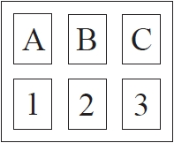

You have to enter the correct code to open the lock.   
The correct code is B3

Dan does not know the code.

He enters at random one of the letters.   
He then enters at random one of the numbers.

Work out the probability that Dan enters the correct code.

...........................................................

**3**. The probability that a biased dice will land on a five is 0.3

Megan is going to roll the dice 400 times.

Work out an estimate for the number of times the dice will land on a five.

...........................................................

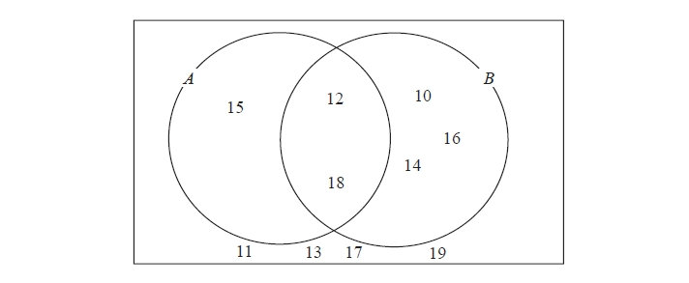**4**. Here is a Venn diagram.

(a)   Write down the numbers that

are in set

(i)   *A* ∪ *B*

.............................................

(ii)   *A* ∩ *B*

.............................................

One of the numbers in the diagram is chosen at random.

(b)  Find the probability that the number is in set *A'*

...........................................................

**5**. Mary has a drawing pin.  
When the drawing pin is dropped it can land either ‘point up’ or ‘point down’.  
The probability of it landing ‘point up’ is 0.4

Mary drops the drawing pin twice.

(a) Complete the probability tree diagram.



(b) Work out the probability that the drawing pin will land ‘point up’ both times.

...........................................................

[Glue here]