Three-Way Ratio Problems GREEN

1. In a pot of stationery, the ratio of paper clips to drawing pins is 4 : 5 and the ratio of paper clips to bulldog clips is 3 : 2. Work out the ratio of paper clips to drawing pins to bulldog clips.

2. A café has three different sizes of plate. The ratio of small to medium plates is 2 : 5, and the ratio of medium to large plates is 3 : 4. Find the ratio of small plates to medium plates to large plates.

3. In an orchard the ratio of apple trees to pear trees is 3 : 7, and the ratio of pear trees to peach trees is 3 : 4. Work out the ratio of apple trees to pear trees to peach trees.

4. On a farm, the number of cows and the number of sheep are in the ratio 6 : 5 and the number of sheep and the number of pigs are in the ratio 2 : 1. The total number of cows, sheep and pigs on the farm is 189. How many sheep are there on the farm?

5. A wine merchant stocks white, rose and red wine. The ratio of white to rose is 5 : 2 and the ratio of white to red is 3 : 4. There are currently 205 bottles in the shop. How many bottles of rose are there?

6. Over the years I have lost many pieces of cutlery. The ratio of forks to knives is 3 : 5 and the ratio of knives to spoons is 7 : 2! I still have 20 spoons however. How many forks do I have?

7. Alan, Bobby and Chris are comparing their ages. The ratio of Alan’s age to Bobby’s is 7 : 8 and the ratio of Bobby’s to Chris’ is 5 : 4. If Alan is 70, how old is Chris?

8. In a holiday resort, the ratio of men to women is 5 : 6 and the ratio of women to children is 4 : 7. There are 200 men staying at the resort. How many children are there?

Three-Way Ratio Problems AMBER

1. In a pot of stationery, the ratio of paper clips to drawing pins is 4 : 5 and the ratio of paper clips to bulldog clips is 3 : 2. Work out the ratio of paper clips to drawing pins to bulldog clips.
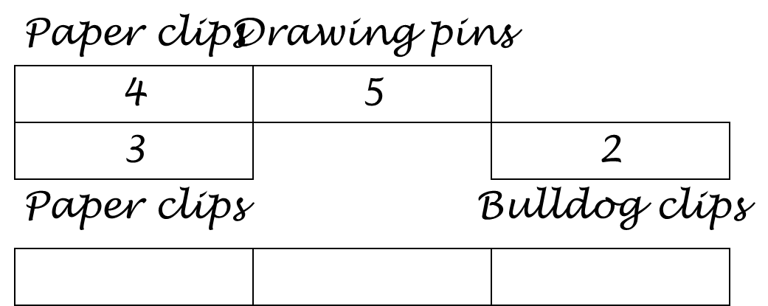
LCM of 4 and 3 =

Ratio ____ : ____ : ____

2. A café has three different sizes of plate. The ratio of small to medium plates is 2 : 5, and the ratio of medium to large plates is 3 : 4. Find the ratio of small plates to medium plates to large plates.

3. In an orchard the ratio of apple trees to pear trees is 3 : 7, and the ratio of pear trees to peach trees is 3 : 4. Work out the ratio of apple trees to pear trees to peach trees.

4. On a farm, the number of cows and the number of sheep are in the ratio 6 : 5 and the number of sheep and the number of pigs are in the ratio 2 : 1. The total number of cows, sheep and pigs on the farm is 189. How many sheep are there on the farm?
5. A wine merchant stocks white, rose and red wine. The ratio of white to rose is 5 : 2 and the ratio of white to red is 3 : 4. There are currently 205 bottles in the shop. How many bottles of rose are there?

6. Over the years I have lost many pieces of cutlery. The ratio of forks to knives is 3 : 5 and the ratio of knives to spoons is 7 : 2! I still have 20 spoons however. How many forks do I have?

7. Alan, Bobby and Chris are comparing their ages. The ratio of Alan’s age to Bobby’s is 7 : 8 and the ratio of Bobby’s to Chris’ is 5 : 4. If Alan is 70, how old is Chris?

8. In a holiday resort, the ratio of men to women is 5 : 6 and the ratio of women to children is 4 : 7. There are 200 men staying at the resort. How many children are there?

Three-Way Ratio Problems RED

1. In a pot of stationery, the ratio of paper clips to drawing pins is 4 : 5 and the ratio of paper clips to bulldog clips is 3 : 2. Work out the ratio of paper clips to drawing pins to bulldog clips.
LCM of 4 and 3 =

Ratio ____ : ____ : ____

2. A café has three different sizes of plate. The ratio of small to medium plates is 2 : 5, and the ratio of medium to large plates is 3 : 4. Find the ratio of small plates to medium plates to large plates.
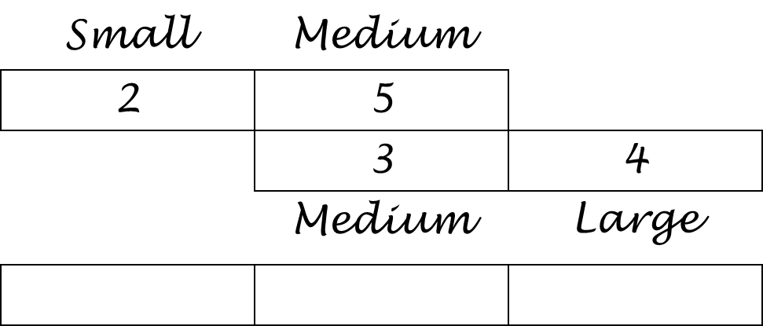
LCM of 5 and 3 =

Ratio ____ : ____ : ____

3. In an orchard the ratio of apple trees to pear trees is 3 : 7, and the ratio of pear trees to peach trees is 3 : 4. Work out the ratio of apple trees to pear trees to peach trees.

4. On a farm, the number of cows and the number of sheep are in the ratio 6 : 5 and the number of sheep and the number of pigs are in the ratio 2 : 1. The total number of cows, sheep and pigs on the farm is 189. How many sheep are there on the farm?

5. A wine merchant stocks white, rose and red wine. The ratio of white to rose is 5 : 2 and the ratio of white to red is 3 : 4. There are currently 205 bottles in the shop. How many bottles of rose are there?

6. Over the years I have lost many pieces of cutlery. The ratio of forks to knives is 3 : 5 and the ratio of knives to spoons is 7 : 2! I still have 20 spoons however. How many forks do I have?

7. Alan, Bobby and Chris are comparing their ages. The ratio of Alan’s age to Bobby’s is 7 : 8 and the ratio of Bobby’s to Chris’ is 5 : 4. If Alan is 70, how old is Chris?

8. In a holiday resort, the ratio of men to women is 5 : 6 and the ratio of women to children is 4 : 7. There are 200 men staying at the resort. How many children are there?

