3D Pythagoras’ Theorem GREEN

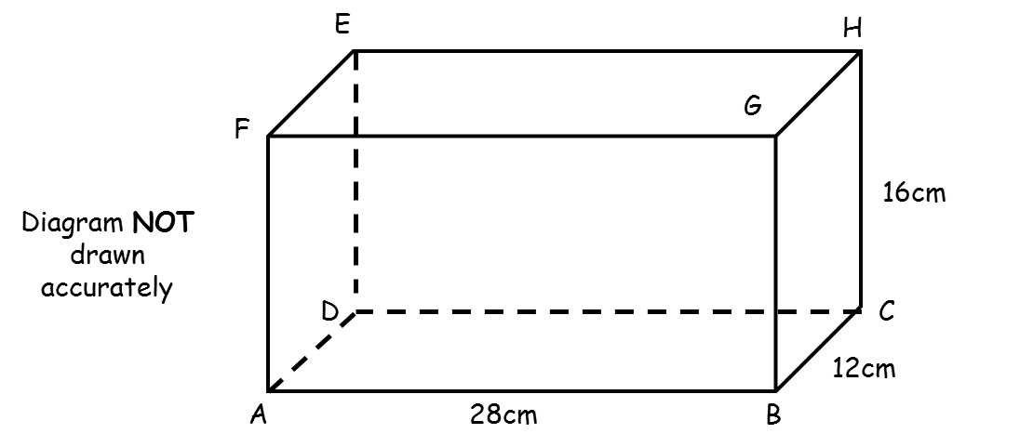

The diagram represents a cuboid ABCDEFGH.

AB = 28cm. BC = 12cm. CH = 16cm.

Calculate the length of AH.

…………………cm
(4 marks)
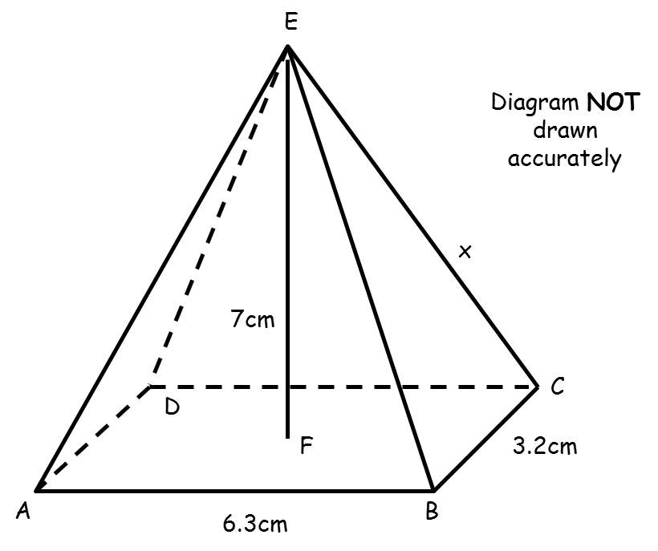
The diagram represents a pyramid ABCDE with height EF.

AB = 6.3cm. BC = 3.2cm. EF = 7 cm. CE = xcm.

Calculate x.

…………………cm
(4 marks)
3D Pythagoras’ Theorem AMBER

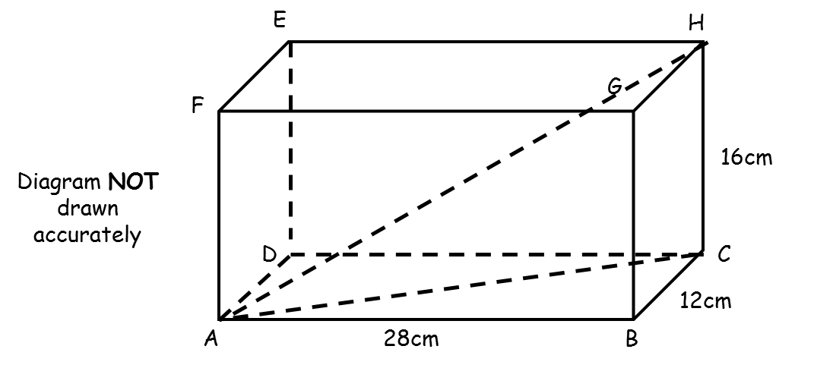

The diagram represents a cuboid ABCDEFGH.

AB = 28cm. BC = 12cm. CH = 16cm.

Calculate the length of AH.

…………………cm
(4 marks)
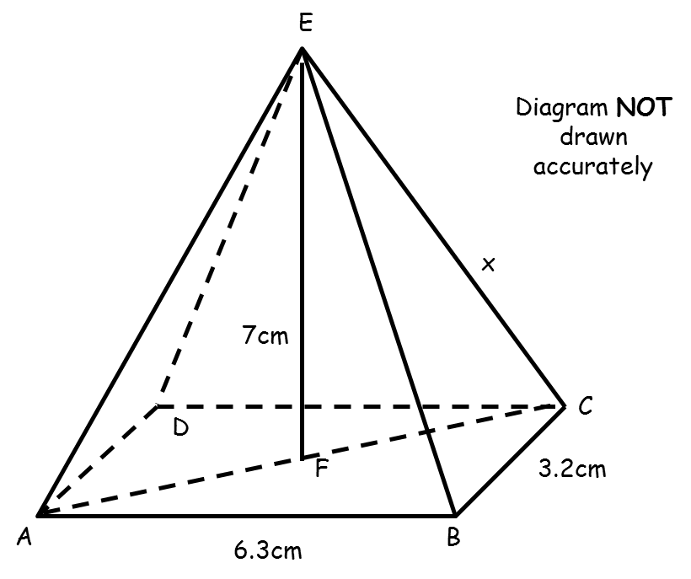
The diagram represents a pyramid ABCDE with height EF.

AB = 6.3cm. BC = 3.2cm. EF = 7 cm. CE = xcm.

Calculate x.

…………………cm
(4 marks)
3D Pythagoras’ Theorem RED

Start by using Pythagoras’ Theorem with triangle ABC to calculate length AC.
Then use Pythagoras’ Theorem with triangle ACH to calculate length AH.
The diagram represents a cuboid ABCDEFGH.

AB = 28cm. BC = 12cm. CH = 16cm.

Calculate the length of AH.

…………………cm
(4 marks)
The diagram represents a pyramid ABCDE with height EF.
Start by using Pythagoras’ Theorem with triangle ABC to calculate length AC.
Divide AC by 2 to calculate length FC.
Then use Pythagoras’ Theorem with triangle CEF to calculate x.
AB = 6.3cm. BC = 3.2cm. EF = 7 cm. CE = xcm.

Calculate x.

…………………cm
(4 marks)

