**Integers, Powers and Roots (H)**

Intervention Booklet

Name: _______________________________

Class: _______________________________

**Useful websites:**

**www.mathswatchvle.com**

*(Video explanations and questions)*

Centre ID: twgash

Username: firstname

Password: lastname

**www.methodmaths.com**

*(Past papers online that get instantly marked)*

Centre ID: wga

Username: firstname

Password: lastname

**www.hegartymaths.com**

*(Online tutorials and quizzes)*

Login: first name and last name are backwards and case sensitive

**www.bbc.co.uk/schools/gcsebitesize/maths**

**Laws of Indices**

**Things to remember:**

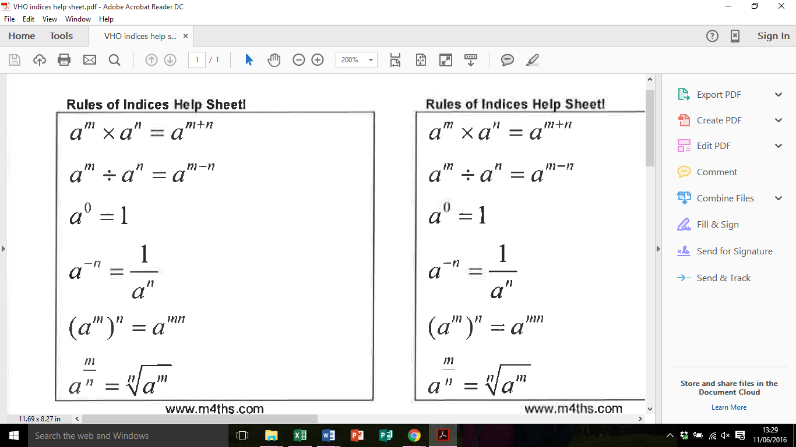 

**Questions:**  
**1.** (a) Simplify *m*5 ÷ *m*3

……………………………………

**(1)**

(b) Simplify 5*x*4*y*3 × *x*2*y*

 ……………………………………

**(2)**

**(Total for Question is 3 marks)**

**2.** Write these numbers in order of size.  
 Start with the smallest number.



    …...........................................................................................................................................

**(Total for Question is 2 marks)**

**3.** Write down the value of 125

……………………………………

**(Total for question is 1 mark)**

**4.** (a) Write down the value of 10–1

……………………………………

**(1)**

(b) Find the value of 

……………………………………

**(2)**

**(Total for Question is 3 marks)**

**5.** (a) Find the value of        5°

……………………………………

**(1)**

(b) Find the value of        27 1⁄3

……………………………………

**(1)**

(c) Find the value of        2-3

……………………………………

**(1)**

**(Total for Question is 3 marks)**

**6.** (a) Write down the value of  271⁄3

……………………………………

**(1)**

(b) Find the value of  25-½

……………………………………

**(2)**

**(Total for Question is 3 marks)**

**7.** (a)   Write down the value of 

……………………………………

**(1)**

(b)   Find the value of 

……………………………………

**(2)**

**(Total for question = 3 marks)**

**8.** (a)   Write down the value of 60

……………………………………

**(1)**

(b)  Work out 64

……………………………………

**(2)**

**(Total for question = 3 marks)**

**Standard Form**

**Things to remember:**

* a x 10b

1 ≤ a < 10

**1.** A floppy disk can store 1 440 000 bytes of data.

(a) Write the number 1 440 000 in standard form.

……………………………………

**(1)**

A hard disk can store 2.4 × 109 bytes of data.

(b) Calculate the number of floppy disks needed to store the 2.4 × 109 bytes of data.

……………………………………

**(3)**

**(Total 4 marks)**

**2.** A nanosecond is 0.000 000 001 second.

(a) Write the number 0.000 000 001 in standard form.

……………………………………

**(1)**

A computer does a calculation in 5 nanoseconds.

(b) How many of these calculations can the computer do in 1 second?  
Give your answer in standard form.

……………………………………

**(2)**

**(Total 3 marks)**

**3.** (a) (i) Write 40 000 000 in standard form.

……………………………………

(ii) Write 3 x 10–5 as an ordinary number.

……………………………………

**(2)**

(b) Work out the value of

3 x 10–5 x 40 000 000

Give your answer in standard form.

……………………………………

**(2)**

**(Total** **4** **marks)**

**4.** Work out (3.2 × 105) × (4.5 × 104)

Give your answer in standard form correct to 2 significant figures.

……………………………………

**(Total 2 marks)**

**5.** (a) Write the number 40 000 000 in standard form.

……………………………………

**(1)**

(b) Write 1.4 × 10–5 as an ordinary number.

……………………………………

**(1)**

(c) Work out

(5 × 104) × (6 × 109)

Give your answer in standard form.

……………………………………

**(2)**

**(Total 4 marks)**

**6.** Write in standard form

(a) 456 000

……………………………………

**(1)**

(b) 0.00034

……………………………………

**(1)**

(c) 16 × 107

……………………………………

**(1)**

**(Total 3 marks)**

**7.** (a) Write 5.7× 10–4 as an ordinary number.

……………………………………

**(1)**

(b) Work out the value of (7 × 104) × (3 × 105)

Give your answer in standard form.

……………………………………

**(2)**

**(Total 3 marks)**

**8.** (a) Write 30 000 000 in standard form.

……………………………………

**(1)**

(b) Write 2 × 10–3 as an ordinary number.

……………………………………

**(1)**

**(Total 2 marks)**

**9.** (a) (i) Write 7900 in standard form.

……………………………………

(ii) Write 0. 00035 in standard form.

……………………………………

**(2)**

(b) Work out 

Give your answer in standard form.

……………………………………

**(2)**

**(Total 4 marks)**

**10.** Work out



Give your answer in standard form correct to 3 significant figures.

……………………………………

**(Total 3 marks)**

**11.** (a) Write 6.4 × 104 as an ordinary number.

……………………………………

**(1)**

(b) Write 0.0039 in standard form.

……………………………………

**(1)**

(c) Write 0.25 × 107 in standard form.

……………………………………

**(1)**

**(Total 3 marks)**

**Surds**

**Things to remember:**

* √ means square root;
* To simplify surds, find all its factors;
* To rationalise the denominator, find an equivalent fraction where the denominator is rational.

**Questions:**

**1.** Work out

Give your answer in its simplest form.

……………………………………

**(Total 3 marks)**

**2.** (a) Rationalise the denominator of

……………………………………

**(1)**

(b) Expand

Give your answer in the form where *a* and *b* are integers.

……………………………………

**(2)**

**(Total 3 marks)**

**3.** (a) Rationalise the denominator of

……………………………………

**(2)**

(b) (i) Expand and simplify

Give your answer in the form where *a* and *b* are integers.

……………………………………

(ii) All measurements on the triangle are in centimetres.

*ABC* is a right-angled triangle.  
*k* is a positive integer.



Find the value of *k*.

*k* = ……………………………………

**(5)**

**(Total 7 marks)**

**4.** Expand and simplify

……………………………………

**(Total 2 marks)**

**5.** (a) Write down the value of

……………………………………

**(1)**

(b) Write in the form , where *k* is an integer.

……………………………………

**(1)**

**(Total 2 marks)**

**6.** Write in the form where *a* and *b* are integers.

*a* = ……………………………………

*b* = ……………………………………

**(Total 2 marks)**

**7.** Expand and simplify

Give your answer in the form where *a* and *b* are integers.

……………………………………

**(Total 3 marks)**

**8.** Rationalise the denominator of

Give your answer in its simplest form.

……………………………………

**(Total for question = 3 marks)**

**9.** Show that simplifies to

**(Total for question = 2 marks)**