End of Unit Test Name: ____________________________
Inequalities - HIGHER

1. Dave and Helen attend the same school. Dave lives 5 km from the school.
Helen lives 3 km from the school. The distance between Dave’s house and
Helen’s house is $x$ km. Write, as an inequality, the minimum and maximum distance that $x$ could be.
Justify your answer in the space below. You may use a diagram if you wish.

………………… $≤ x ≤$ …………………
(Total 3 marks)
2. $x$ is an integer.
$4x - 3 ≥ 7$ and $6x + 2 < 32$
List the possible values of $x$.

…………………………………………………………………………………………………………

…………………………………………………………………………………………………………

…………………………………………………………………………………………………………

…………………………………………………………………………………………………………

…………………………………………………………………………………………………………

…………………………………………………………………………………………………………

…………………………………………………………………………………………………………

Answer ......................................................................
(Total 3 marks)

3. $x$ and $y$ are integers such that
$-5 < x ≤ 3$ and $2 ≤ y ≤ 7$
Work out the largest possible value of $x^{2}+y^{2}$

…………………………………………………………………………………………………………

…………………………………………………………………………………………………………

…………………………………………………………………………………………………………

…………………………………………………………………………………………………………

…………………………………………………………………………………………………………

Answer ......................................................................
(Total 2 marks)
4. Points in the shaded region satisfy three inequalities.
One of the inequalities is $y ≤ 2x + 5$

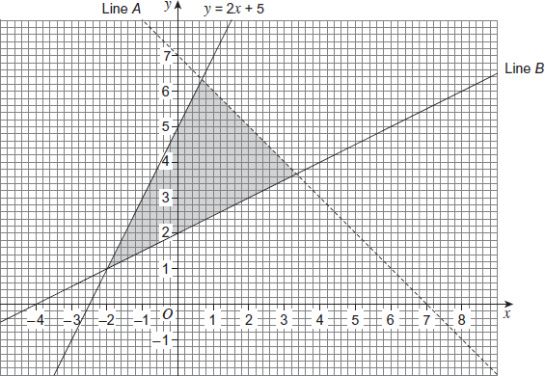

(a) Circle the inequality with boundary line A.

$x + y ≥ 7$ $x + y < 7$ $x + y ≤ 7$ $x + y > 7$
(1)
(b) Circle the inequality with boundary line B.

$2y ≥ x + 4$ $2y ≤ x + 4$ $y ≥ x + 2$ $y ≤ x + 2$
(1)
(Total 2 marks)

5. Put a label, R, in the region on the grid satisfied by all three of these inequalities.

$x ≤ 3$ $y ≥ x$ $y ≤ 2x – 1$

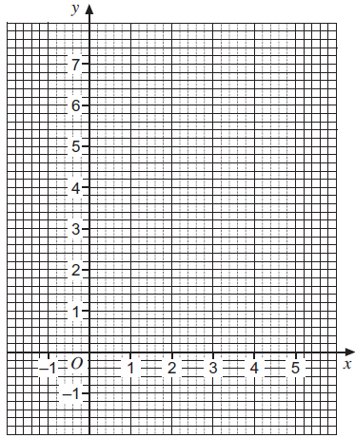
(Total 4 marks)
6. Solve $x^{2}+7x+12<0$

…………………………………………………………………………………………………………

…………………………………………………………………………………………………………

…………………………………………………………………………………………………………

…………………………………………………………………………………………………………

…………………………………………………………………………………………………………

…………………………………………………………………………………………………………

…………………………………………………………………………………………………………

…………………………………………………………………………………………………………
(Total 3 marks)

7. Solve $2x^{2}+x-6≥0$

…………………………………………………………………………………………………………

…………………………………………………………………………………………………………

…………………………………………………………………………………………………………

…………………………………………………………………………………………………………

…………………………………………………………………………………………………………

…………………………………………………………………………………………………………

…………………………………………………………………………………………………………

…………………………………………………………………………………………………………
(Total 3 marks)
(Total for test = 20 marks)

