**Measures (H)**

Post-Intervention Assessment

Name: _______________________________

Class: _______________________________

Date: _______________________________

|  |  |  |
| --- | --- | --- |
| **Question** | **Objective** | **RAG** |
| 1 | Solve problems involving similar lengths, area and volume |  |
| 2 | Interpret velocity-time graphs |  |

**1.** Diagram **NOT** accurately drawn

The two cylinders, A and B, are mathematically similar. The height of cylinder B is twice the height of cylinder A. The total surface area of cylinder A is 180 cm².

Calculate the total surface area of cylinder B.

...........................................................

**2**. The graph shows information about the velocity, *v* m/s, of a parachutist *t* seconds after leaving a plane.

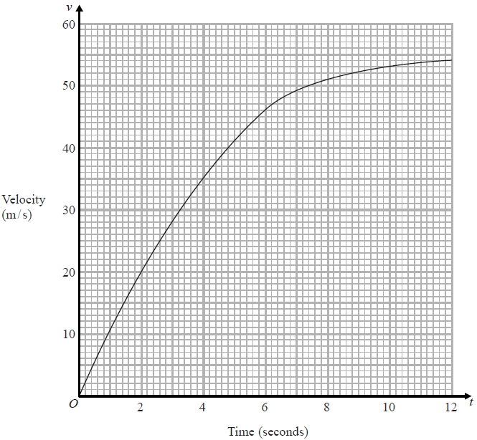

(a)   Work out an estimate for the acceleration of the parachutist at *t* = 6

........................................................... m/s2

(b)   Work out an estimate for the distance fallen by the parachutist in the first   
12 seconds after leaving the plane.   
Use 3 strips of equal width.

........................................................... m

[Glue here]