HCF and LCM RED

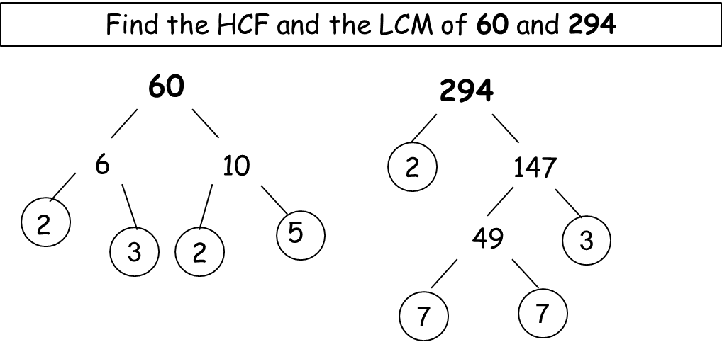

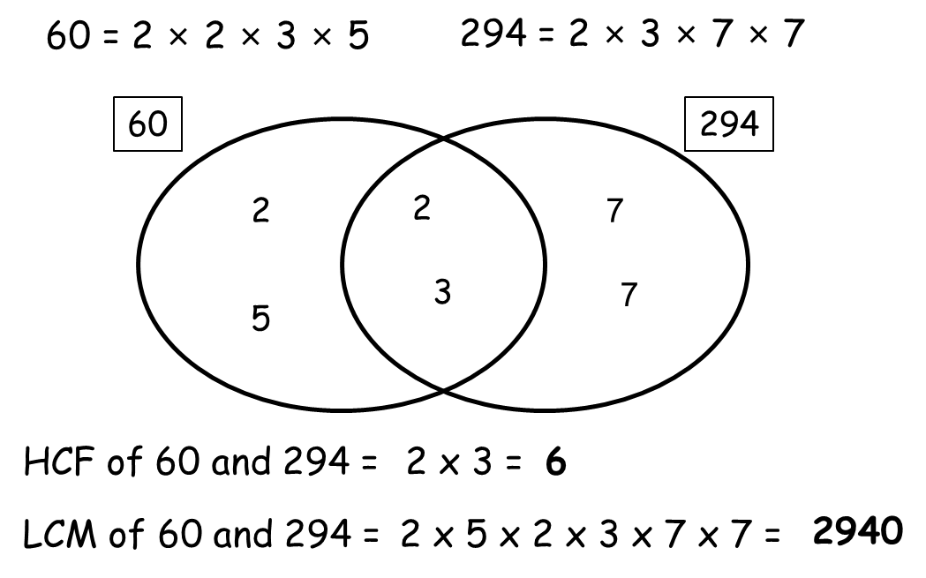

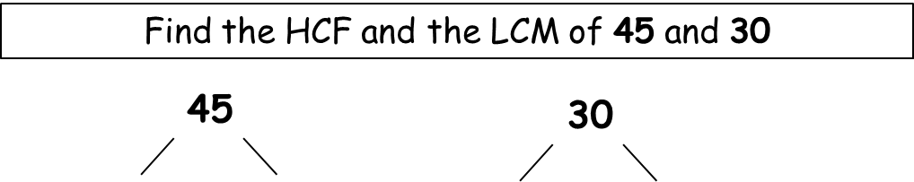

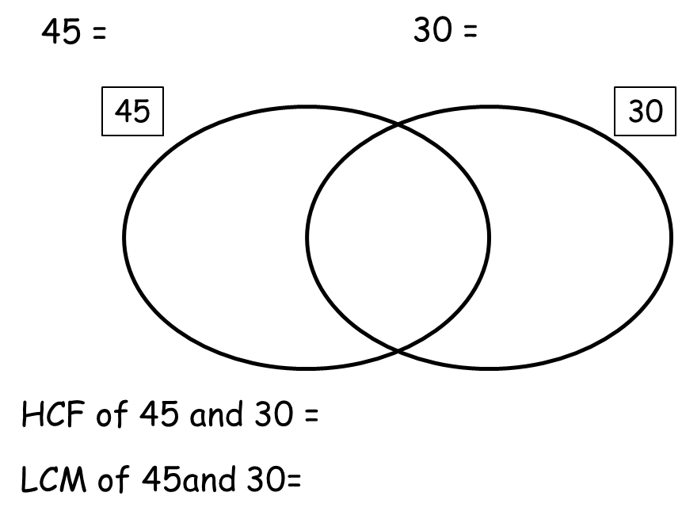

Now try these:

c) 45 and 30
HCF =
LCM =
d) 60 and 15
HCF =
LCM =
e) 55 and 105
HCF =
LCM =
f) 72 and 64
HCF =
LCM =
g) 12 and 27
HCF =
LCM =
h) 14 and 42
HCF =
LCM =

HCF and LCM AMBER

HCF and LCM AMBER

45 and 30 | HCF = 30  LCM = 360
120 and 90 | HCF = 15  LCM = 60
140 and 112 | HCF = 8  LCM = 576
60 and 15 | HCF = 14  LCM = 42
55 and 105 | HCF = 15  LCM = 90
72 and 64 | HCF = 3  LCM = 108
12 and 27 | HCF = 28  LCM = 560
14 and 42 | HCF = 5  LCM = 1155
45 and 30 | HCF = 30  LCM = 360
120 and 90 | HCF = 15  LCM = 60
140 and 112 | HCF = 8  LCM = 576
60 and 15 | HCF = 14  LCM = 42
55 and 105 | HCF = 15  LCM = 90
72 and 64 | HCF = 3  LCM = 108
12 and 27 | HCF = 28  LCM = 560
14 and 42 | HCF = 5  LCM = 1155
HCF and LCM GREEN

Calculate the highest common factor and lowest common multiple of the followig pairs of numbers:

a) 45 and 30
b) 120 and 90
c) 140 and 112
d) 60 and 15
e) 55 and 105
f) 72 and 64
g) 12 and 27
h) 14 and 42

HCF and LCM GREEN

Calculate the highest common factor and lowest common multiple of the followig pairs of numbers:

a) 45 and 30
b) 120 and 90
c) 140 and 112
d) 60 and 15
e) 55 and 105
f) 72 and 64
g) 12 and 27
h) 14 and 42

