Algebra and Shape GREEN

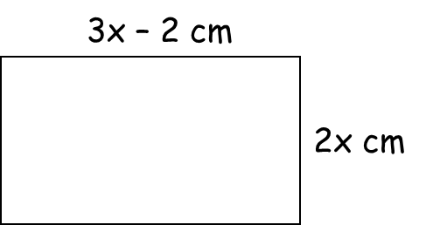
1. The perimeter of this rectangle is 31 cm.
Find the value of x.

x = _________ cm

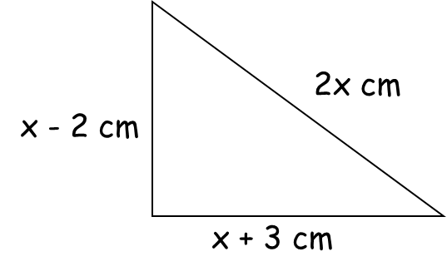
2. The perimeter of this shape is 29 cm.
What is x?

x = _________ cm

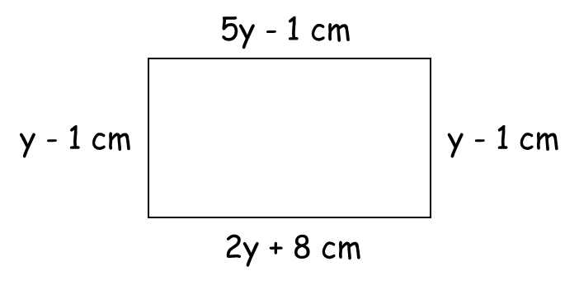
3. A rectangle has the lengths shown
Find the perimeter of the rectangle.

Perimeter = _________ cm

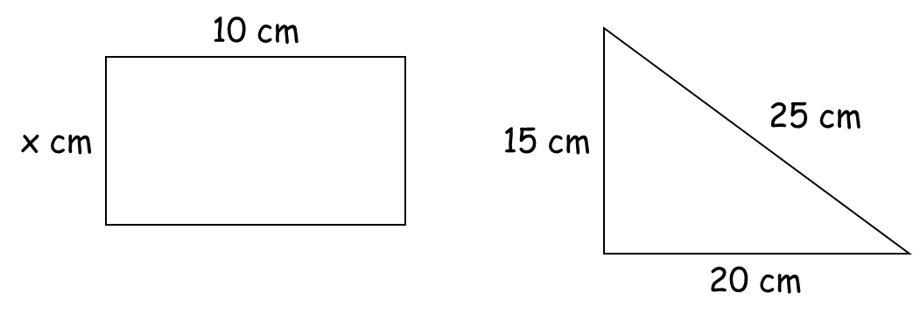
4. The area of the right-angled triangle is equal to the area of the rectangle.
Work out the value of x.

x = _________ cm

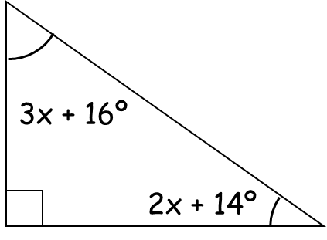
5. The diagram shows a right-angled triangle.
Calculate the value of x.

x = _________ º

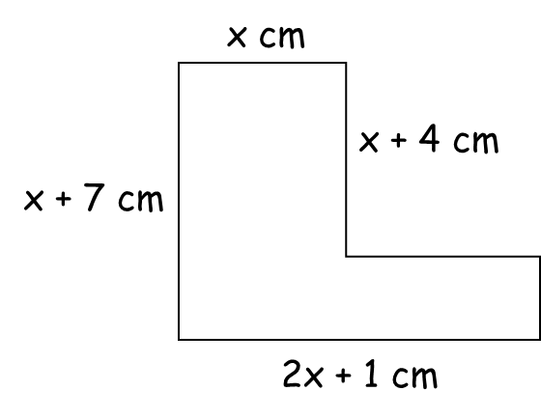
6. The area of this compound shape is 59 cm².
a) Find the value of x.

x = _________ cm

b) Hence calculate the perimeter of the shape.

_________ cm
Algebra and Shape AMBER

1. The perimeter of this rectangle is 31 cm.
Find the value of x.
Perimeter = total distance around the edge of the shape

x = _________ cm

2. The perimeter of this shape is 29 cm.
What is x?

x = _________ cm

3. A rectangle has the lengths shown
Find the perimeter of the rectangle.
Use the fact that opposite sides of a rectangle are equal

Perimeter = _________ cm

4. The area of the right-angled triangle is equal to the area of the rectangle.
Work out the value of x.
Start by calculating the area of the triangle

x = _________ cm

5. The diagram shows a right-angled triangle.
Calculate the value of x.
What do angles in a triangle sum to?

x = _________ º

6. The area of this compound shape is 59 cm².
a) Find the value of x.
Split the shape into two rectangles!

x = _________ cm

b) Hence calculate the perimeter of the shape.

_________ cm
Algebra and Shape RED

1. The perimeter of this rectangle is 31 cm.
Find the value of x.
Perimeter = total distance around the edge of the shape

3x – 2 + 2x + 3x – 2 + 2x = 31

x = _________ cm

2. The perimeter of this shape is 29 cm.
What is x?

x – 2 + 2x + x + 3 = 29

x = _________ cm

3. A rectangle has the lengths shown
Find the perimeter of the rectangle.
Use the fact that opposite sides of a rectangle are equal

5y – 1 = 2y + 8

Perimeter = _________ cm

4. The area of the right-angled triangle is equal to the area of the rectangle.
Work out the value of x.
Start by calculating the area of the triangle

Area = ½ x 15 x 20

x = _________ cm

5. The diagram shows a right-angled triangle.
Calculate the value of x.
What do angles in a triangle sum to?

3x + 16 + 2x + 14 + 90 = _____

x = _________ º

6. The area of this compound shape is 59 cm².
a) Find the value of x.
Split the shape into two rectangles!

x = _________ cm

b) Hence calculate the perimeter of the shape.

_________ cm

