Solving Simultaneous Equations Graphically GREEN

Find graphical solutions to each of these pairs of simultaneous equations.

y = 3x – 2 and y = x - 2 y = 3 – 2x and y = x
x = ____ , y = ____ x = ____ , y = ____
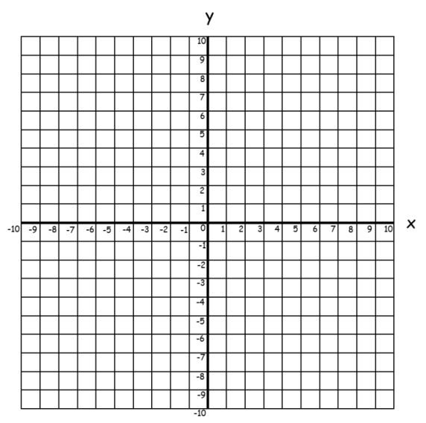

-x + y = 5 and y = 2x - 1 2x + y = 6 and x + y = 0
x = ____ , y = ____ x = ____ , y = ____

y = 3x – 2 and x + y = 2 2x – 3y = 6 and x + 3y = 3
x = ____ , y = ____ x = ____ , y = ____
Solving Simultaneous Equations Graphically AMBER

Find graphical solutions to each of these pairs of simultaneous equations.

y = 2x and x = 4 y = 3x + 1 and y = -6
x = ____ , y = ____ x = ____ , y = ____

y = x + 2 and y = 3 y = ½x - 2 and y = -x + 4
x = ____ , y = ____ x = ____ , y = ____

y = 2x - 3 and y = -x + 3 y = 6 – 2x and y = 4x
x = ____ , y = ____ x = ____ , y = ____
Solving Simultaneous Equations Graphically RED

Find graphical solutions to each of these pairs of simultaneous equations.

y = 2x and x = 4 y = 3x + 1 and y = -6
x = ____ , y = ____ x = ____ , y = ____

y = x + 2 and y = 3 y = ½x - 2 and y = -x + 4
x = ____ , y = ____ x = ____ , y = ____

y = 2x - 3 and y = -x + 3 y = 6 – 2x and y = 4x
x = ____ , y = ____ x = ____ , y = ____

