Inequalities (H)

Pre-Intervention Assessment

Name: _______________________________

Class: _______________________________

Date: _______________________________

Question | Objective | RAG
1 | Represent linear inequalities graphically
2 | Solve quadratic inequalities

1. On the grid show, by shading, the region that satisfies all three of the
inequalities

x + y < 7 y < 2x y > 3

Label the region R.
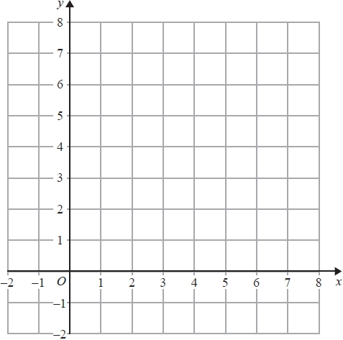

2. Solve the inequality x² ≤ 4(2x + 5)

...........................................................

[Glue here]

