**Area and Perimeter (H)**

Post-Intervention Assessment

Name: _______________________________

Class: _______________________________

Date: _______________________________

|  |  |  |
| --- | --- | --- |
| **Question** | **Objective** | **RAG** |
| 1 | Calculate the area and perimeter of compound shapes |  |
| 2 | Calculate the area and perimeter of circles |  |
| 3 | Calculate the area and perimeter of sectors |  |

**1.** A pattern is made using four identical rectangular tiles.

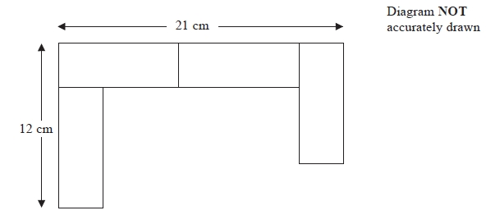

Find the total area of the pattern.

…………………………………………………cm2

**3**. Diagram NOT accurately drawn

The radius of the circle is 9.7 cm.  
Work out the area of the circle.  
Give your answer to 3 significant figures.

…………………………… cm²

**3**. Diagram NOT accurately drawn

The diagram shows a sector of a circle, centre *O*, radius 10 cm.  
The arc length of the sector is 15 cm.

Calculate the area of the sector.

........................................................... cm²

[Glue here]