Venn Diagrams GREEN

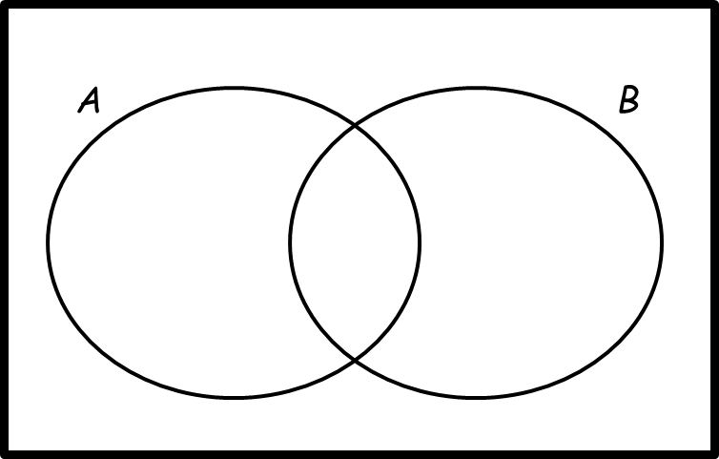
1. $ξ=\{1, 2, 3, 4, 5, 6, 7, 8, 9, 10, 11,$
$$12, 13, 14, 15, 16\}$$
$A=$ multiples of 3
$B=$ multiples of 5
a) Complete the Venn diagram.

One of the numbers is selected at random.
b) Write down $P(A∩B)$

………………………………………………………

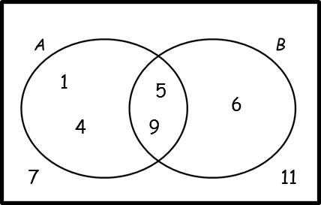
2. Here is a Venn diagram.
Write down the numbers that are in set:

a) $B$

………………………………………………………
b) $A∪B$

………………………………………………………
c) Write down $P(A')$

………………………………………………………

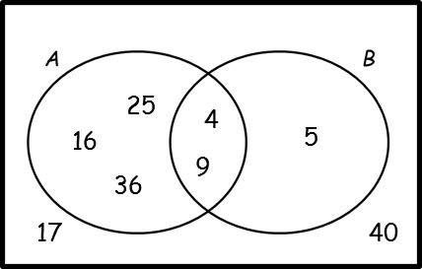
3. Here is a Venn diagram.
Write down the numbers that are in set:

a) $A∩B$

………………………………………………………
b) $A∪B$

………………………………………………………
c) $A'$

………………………………………………………

One of the numbers in the diagram is chosen at random.
d) Find the probability that the number is in set $B'$

………………………………………………………

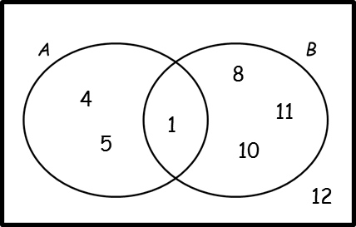
4. Here is a Venn diagram. A number is chosen at random.
a) Write down $P(A∩B')$

………………………………………………………

b) Write down $P(A'∪B')$

………………………………………………………

c) Write down $P(B|A)$

………………………………………………………

Venn Diagrams AMBER

1. $ξ=\{1, 2, 3, 4, 5, 6, 7, 8, 9, 10, 11,$
$$12, 13, 14, 15, 16\}$$
$A=$ multiples of 3
$B=$ multiples of 5
a) Complete the Venn diagram.

One of the numbers is selected at random.
b) Write down $P(A∩B)$
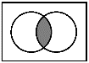

………………………………………………………

2. Here is a Venn diagram.
Write down the numbers that are in set:

a) $B$

………………………………………………………
b) $A∪B$
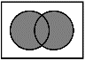
………………………………………………………

c) Write down $P(A')$
………………………………………………………

3. Here is a Venn diagram.
Write down the numbers that are in set:

a) $A∩B$
………………………………………………………
b) $A∪B$
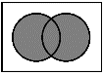
………………………………………………………
c) $A'$

………………………………………………………

One of the numbers in the diagram is chosen at random.
d) Find the probability that the number is in set $B'$

………………………………………………………

4. Here is a Venn diagram. A number is chosen at random.
a) Write down $P(A∩B')$

………………………………………………………

b) Write down $P(A'∪B')$

………………………………………………………

c) Write down $P(B|A)$
“The probability of B, given A”

………………………………………………………
Venn Diagrams RED

1. $ξ=\{1, 2, 3, 4, 5, 6, 7, 8, 9, 10, 11,$
$$12, 13, 14, 15, 16\}$$
$A=$ multiples of 3
$B=$ multiples of 5
a) Complete the Venn diagram.

One of the numbers is selected at random.
b) Write down $P(A∩B)$

………………………………………………………

2. Here is a Venn diagram.
Write down the numbers that are in set:

a) $B$
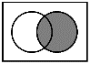
………………………………………………………
b) $A∪B$
………………………………………………………
c) Write down $P(A')$
$P$(?) means “the probability of…”
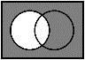
………………………………………………………

3. Here is a Venn diagram.
Write down the numbers that are in set:

a) $A∩B$
………………………………………………………
b) $A∪B$
………………………………………………………
c) $A'$
………………………………………………………

One of the numbers in the diagram is chosen at random.
d) Find the probability that the number is in set $B'$
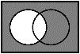
………………………………………………………

4. Here is a Venn diagram. A number is chosen at random.
a) Write down $P(A∩B')$

………………………………………………………

b) Write down $P(A'∪B')$

………………………………………………………

c) Write down $P(B|A)$
“The probability of B, given A”

………………………………………………………

