Cumulative Frequency - GREEN

Jimmy the ice cream man wants to compare the sales of his ice creams for 4 weeks (28 days) in the summer with 4 weeks in the autumn. For the following tables:
a) draw a cumulative frequency graph for each;
b) draw a box plot for each;
c) make comparisons between the two box plots.

Ice creams sold (summer) | Frequency
0 ≤ i < 20 | 1
20 ≤ i < 40 | 2
40 ≤ i < 60 | 4
60 ≤ i < 80 | 6
80 ≤ i < 100 | 8
100 ≤ i < 120 | 7
Minimum sold = 14, Maximum sold = 108

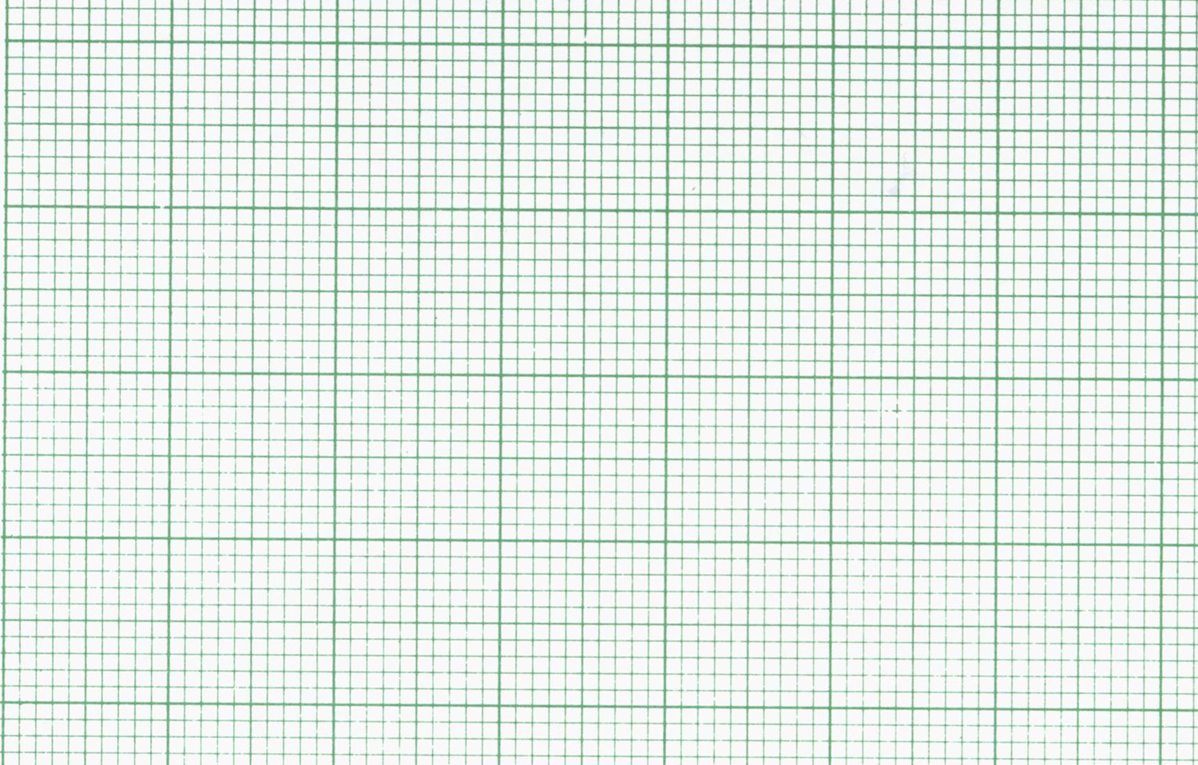

Ice creams sold (autumn) | Frequency
0 ≤ i < 20 | 7
20 ≤ i < 40 | 9
40 ≤ i < 60 | 6
60 ≤ i < 80 | 4
80 ≤ i < 100 | 2
100 ≤ i < 120 | 0
Minimum sold = 0, Maximum sold = 84

Comparisons:

_______________________________________________________________________

_______________________________________________________________________

_______________________________________________________________________

Alice wants to compare the heights of the 120 girls and 120 boys in her year group. For the following tables:
a) draw a cumulative frequency graph for each;
b) draw a box plot for each;
c) make comparisons between the two box plots.

Girls’ heights (cm) | Frequency
90 ≤ h < 100 | 7
100 ≤ h < 110 | 11
110 ≤ h < 120 | 29
120 ≤ h < 130 | 62
130 ≤ h < 140 | 9
140 ≤ h < 150 | 2
Minimum height = 91cm, Maximum height = 148cm

Boys’ heights (cm) | Frequency
90 ≤ h < 100 | 1
100 ≤ h < 110 | 4
110 ≤ h < 120 | 19
120 ≤ h < 130 | 58
130 ≤ h < 140 | 31
140 ≤ h < 150 | 7
Minimum height = 98cm, Maximum height = 145cm

Comparisons:

_______________________________________________________________________

_______________________________________________________________________

_______________________________________________________________________
Cumulative Frequency - AMBER

Jimmy the ice cream man wants to compare the sales of his ice creams for 4 weeks (28 days) in the summer with 4 weeks in the autumn. For the following tables:
a) draw a cumulative frequency graph for each;
b) draw a box plot for each;
c) make comparisons between the two box plots.

Ice creams sold (summer) | Frequency | Cumulative frequency
0 ≤ i < 20 | 1
20 ≤ i < 40 | 2
40 ≤ i < 60 | 4
60 ≤ i < 80 | 6
80 ≤ i < 100 | 8
100 ≤ i < 120 | 7
Minimum sold = 14, Maximum sold = 108

30
Cumu. Freq.
Ice creams sold
120
100
80
60
40
20
0
20
10
0

Median =
LQ =
UQ =

0
20
40
60
80
100
120
Ice creams sold

Ice creams sold (autumn) | Frequency | Cumulative frequency
0 ≤ i < 20 | 7
20 ≤ i < 40 | 9
40 ≤ i < 60 | 6
60 ≤ i < 80 | 4
80 ≤ i < 100 | 2
100 ≤ i < 120 | 0
Minimum sold = 0, Maximum sold = 84

30
Cumu. Freq.
Ice creams sold
120
100
80
60
40
20
0
20
10
0

Median =
LQ =
UQ =

0
20
40
60
80
100
120
Ice creams sold

Comparisons:

_______________________________________________________________________

_______________________________________________________________________

_______________________________________________________________________
Alice wants to compare the heights of the 120 girls and 120 boys in her year group. For the following tables:
a) draw a cumulative frequency graph for each;
b) draw a box plot for each;
c) make comparisons between the two box plots.

Girls’ heights (cm) | Frequency | Cumulative frequency
90 ≤ h < 100 | 7
100 ≤ h < 110 | 11
110 ≤ h < 120 | 29
120 ≤ h < 130 | 62
130 ≤ h < 140 | 9
140 ≤ h < 150 | 2
Minimum height = 91cm, Maximum height = 148cm

Cumu. Freq.
90
130
120
100
140
110
0
150
120
90
60
30
Girls’ heights (cm)

Median =
LQ =
UQ =

90
120
100
110
150
140
130
Girls’ heights (cm)
Boys’ heights (cm) | Frequency | Cumulative frequency
90 ≤ h < 100 | 1
100 ≤ h < 110 | 4
110 ≤ h < 120 | 19
120 ≤ h < 130 | 58
130 ≤ h < 140 | 31
140 ≤ h < 150 | 7
Minimum height = 98cm, Maximum height = 145cm

Cumu. Freq.
90
130
120
100
140
110
0
150
120
90
60
30
Boys’ heights (cm)
Median =
LQ =
UQ =
90
120
100
110
150
140
130
Boys’ heights (cm)

Comparisons:

_______________________________________________________________________

_______________________________________________________________________

_______________________________________________________________________
Cumulative Frequency - RED

Jimmy the ice cream man wants to compare the sales of his ice creams for 4 weeks (28 days) in the summer with 4 weeks in the autumn. For the following tables:
a) draw a cumulative frequency graph for each;
b) draw a box plot for each;
c) make comparisons between the two box plots.

Ice creams sold (summer) | Frequency | Cumulative frequency
0 ≤ i < 20 | 1 | 1
20 ≤ i < 40 | 2 | 1 + 2 = 3
40 ≤ i < 60 | 4 | 3 + 4 = 7
60 ≤ i < 80 | 6 | 7 + 6 =
80 ≤ i < 100 | 8
100 ≤ i < 120 | 7
Minimum sold = 14, Maximum sold = 108

30
Cumu. Freq.
Ice creams sold
120
100
80
60
40
20
0
20
10
0

Median (middle) =
LQ (bottom quarter) =
UQ (top quarter) =

0
20
40
60
80
100
120
Ice creams sold

Ice creams sold (autumn) | Frequency | Cumulative frequency
0 ≤ i < 20 | 7
20 ≤ i < 40 | 9
40 ≤ i < 60 | 6
60 ≤ i < 80 | 4
80 ≤ i < 100 | 2
100 ≤ i < 120 | 0
Minimum sold = 0, Maximum sold = 84

30
Cumu. Freq.
Ice creams sold
120
100
80
60
40
20
0
20
10
0

Median (middle) =
LQ (bottom quarter) =
UQ (top quarter) =

0
20
40
60
80
100
120
Ice creams sold

Comparisons:

Medians? ________________________________________________________________

UQ/LQ? ________________________________________________________________

Min/Max? _______________________________________________________________
Alice wants to compare the heights of the 120 girls and 120 boys in her year group. For the following tables:
a) draw a cumulative frequency graph for each;
b) draw a box plot for each;
c) make comparisons between the two box plots.

Girls’ heights (cm) | Frequency | Cumulative frequency
90 ≤ h < 100 | 7
100 ≤ h < 110 | 11
110 ≤ h < 120 | 29
120 ≤ h < 130 | 62
130 ≤ h < 140 | 9
140 ≤ h < 150 | 2
Minimum height = 91cm, Maximum height = 148cm

Cumu. Freq.
90
130
120
100
140
110
0
150
120
90
60
30
Girls’ heights (cm)

Median (middle) =
LQ (bottom quarter) =
UQ (top quarter) =

90
120
100
110
150
140
130
Girls’ heights (cm)
Boys’ heights (cm) | Frequency | Cumulative frequency
90 ≤ h < 100 | 1
100 ≤ h < 110 | 4
110 ≤ h < 120 | 19
120 ≤ h < 130 | 58
130 ≤ h < 140 | 31
140 ≤ h < 150 | 7
Minimum height = 98cm, Maximum height = 145cm

Cumu. Freq.
90
130
120
100
140
110
0
150
120
90
60
30
Boys’ heights (cm)
Median (middle) =
LQ (bottom quarter) =
UQ (top quarter) =
90
120
100
110
150
140
130
Boys’ heights (cm)

Comparisons:

Medians? ________________________________________________________________

UQ/LQ? ________________________________________________________________

Min/Max? _______________________________________________________________

