Volume and Surface Area (F)

Intervention Booklet

Name: _______________________________

Class: _______________________________

Useful websites:

www.mathswatchvle.com
(Video explanations and questions)
Username: STH…@twgash
Password: stmaths

www.methodmaths.com
(Past papers online that get instantly marked)
Centre ID: wga
Username: firstname
Password: lastname

www.hegartymaths.com
(Online tutorials and quizzes)
Login: first name and last name are case sensitive

www.bbc.co.uk/schools/gcsebitesize/maths

Cubes and Cuboids

Things to remember:
- The volume of a cube or cuboid = base x depth x height.
- To calculate the surface area, work out the area of the surface! (Add together the areas of all 6 faces)

Questions:
1. The diagram shows a cuboid.
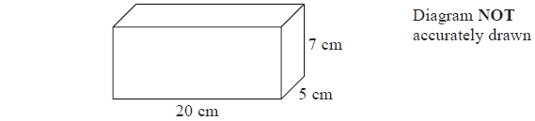
Work out the volume of the cuboid.
...........................................................
(Total for Question is 3 marks)

2. Here is a cuboid.
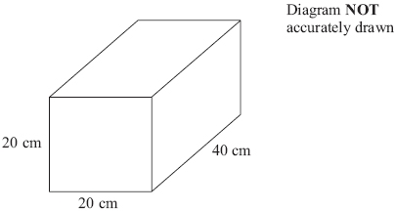
Work out the volume of the cuboid.

...........................................................
(Total for Question is 3 marks)
3.
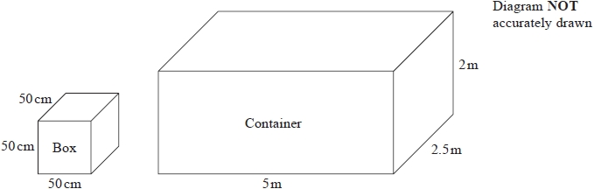
Chao transports microwave ovens from China to the UK.
He puts each microwave oven in a box.
Each box is a cube of side 50cm.
He then puts each box in a container.
Each container is a cuboid of size 5m by 2.5m by 2m.
Chao has 500 boxes.
He has 3 containers.
Will the 500 boxes fit into these 3 containers?

(Total for question = 4 marks)

4.
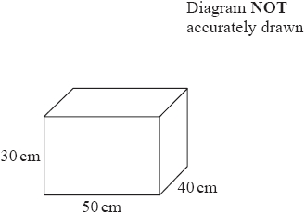
The diagram shows a container for oil.
The container is in the shape of a cuboid.
The container is empty.
Sally has to fill the container with oil.
A bottle of oil costs £ 3.50
There are 3000 cm³ of oil in each bottle.
Sally must not spend more than £ 60 buying the oil.
Can Sally buy enough oil to fill the container?
You must show all your working.

(Total for question = 4 marks)

5.
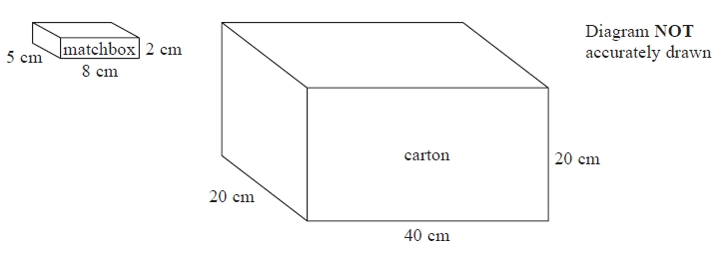
A matchbox is 5 cm by 8 cm by 2 cm.
A carton is 20 cm by 40 cm by 20 cm.
The carton is completely filled with matchboxes.
Work out the number of matchboxes in the carton.

...........................................................
(Total for Question is 3 marks)

6.
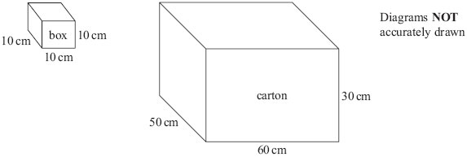
Terry fills a carton with boxes.
Each box is a cube of side 10 cm.
The carton is a cuboid with
Length 60 cm
Width 50 cm
Height 30 cm
Work out the number of boxes Terry needs to fill one carton completely.

...........................................................
(Total for Question is 3 marks)

7. Marc drives a truck. The truck pulls a container.
The container is a cuboid 10 m by 4 m by 5 m.
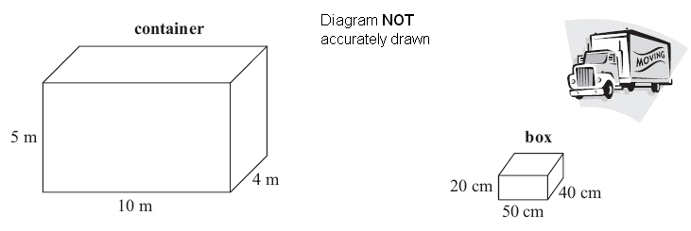
Marc fills the container with boxes.
Each box is a cuboid 50 cm by 40 cm by 20 cm.
Show that Marc can put no more than 5000 boxes into the container.

(Total for Question is 4 marks)

8. A company makes building bricks for children.
The bricks are all 5 cm cubes.
The bricks are going to be packed in boxes.
John designs a box for the bricks.
The box is a cuboid.
The size of the box is 25 cm by 15 cm by 12 cm.
Will the box be big enough for 36 bricks?
You must give reasons for your answer.
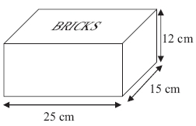

(Total for Question is 4 marks)
9. Jane makes cheese. The cheese is in the shape of a cuboid.
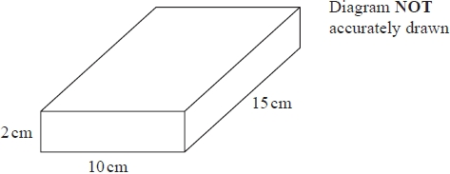

Jane is going to make a new cheese.
The new cheese will also be in the shape of a cuboid.
The cross section of the cuboid will be a 5cm by 5cm square.

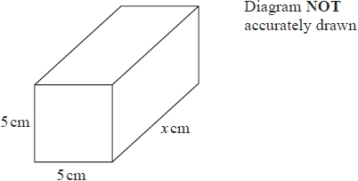

Jane wants the new cuboid to have the same volume as the 2cm by 10cm by 15cm cuboid.
Work out the value of x.

...........................................................
(Total for question = 3 marks)

10. The diagram shows a cuboid.
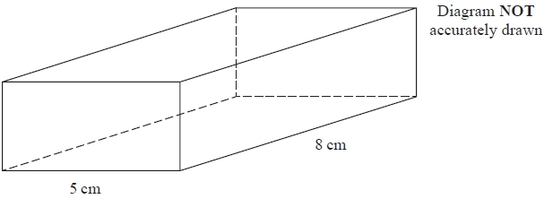
The width of the cuboid is 5 cm.
The length of the cuboid is 8 cm.
The volume of the cuboid is 120 cm³.
Work out the height of the cuboid.

........................................................... cm
(Total for question = 2 marks)

Prisms (Including Cylinders)

Things to remember:
- Volume of a prism = area of cross section x vertical height
- Area of triangle = b x h
- Area of circle = π r²
- To calculate the surface area, work out the area of the surface!

Questions:
1. Work out the volume of the triangular prism.

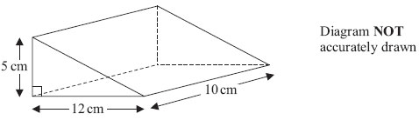

...........................................................cm³
(Total for Question is 2 marks)

2. Here is a triangular prism.
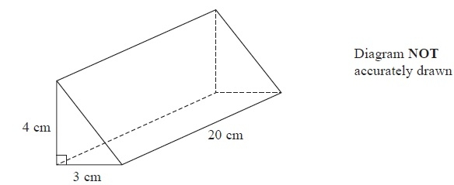
Work out the volume of this triangular prism.
...........................................................
(Total for Question is 4 marks)
3. The diagram shows a prism.

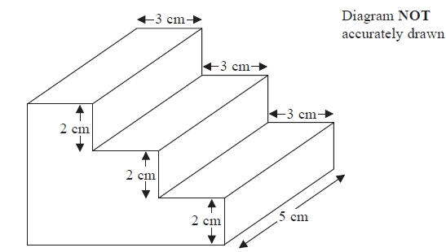

All the corners are right angles.
Work out the volume of the prism.
...........................................................cm³
(Total for question = 3 marks)

4. Here is a prism.
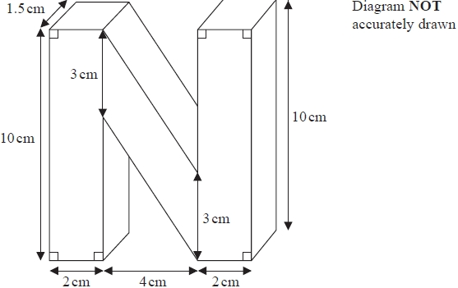
Work out the volume of the prism.

...........................................................cm³
(Total for question = 4 marks)

5. Here is a solid prism.
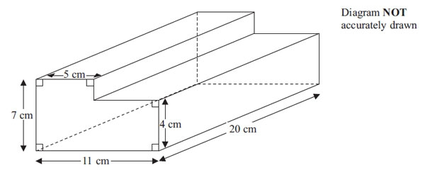

Work out the volume of the prism.

...........................................................cm³
(Total for Question is 3 marks)

6. The diagram shows a triangular prism.
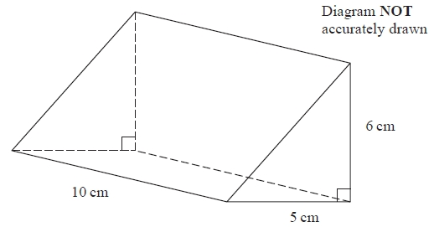
Work out the volume of the prism.

...........................................................
(Total for question = 3 marks)

7. The diagram shows a large tin of pet food in the shape of a cylinder.
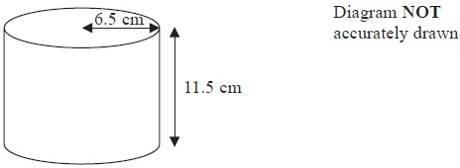
The large tin has a radius of 6.5 cm and a height of 11.5 cm.
A pet food company wants to make a new size of tin.
The new tin will have a radius of 5.8 cm.
It will have the same volume as the large tin.
Calculate the height of the new tin.
Give your answer correct to one decimal place.

........................................................... cm
(Total for Question is 3 marks)

8. Ella is designing a glass in the shape of a cylinder.
The glass must hold a minimum of ½ litre of liquid.
The glass must have a diameter of 8 cm.
Calculate the minimum height of the glass.

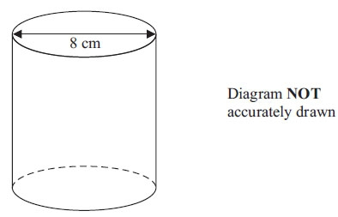

........................................................... cm
(Total for Question is 5 marks)

9. Here is a vase in the shape of a cylinder.
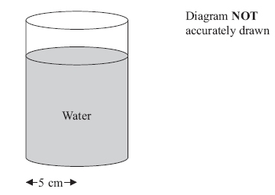

The vase has a radius of 5 cm.
There are 1000 cm³ of water in the vase.
Work out the depth of the water in the vase.
Give your answer correct to 1 decimal place.

........................................................... cm
(Total for Question is 3 marks)

10. The diagram shows a prism.
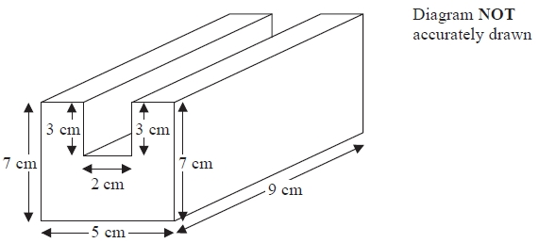
All the corners are right angles.
Work out the volume of the prism.

...........................................................
(Total for question = 4 marks)

11. The diagram represents a shed.
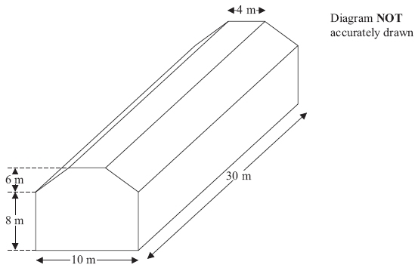
The shed is in the shape of a prism.
The cross section of the prism is a hexagon.
The hexagon has one line of symmetry.
The walls of the shed are vertical.
Calculate the volume of the shed.

........................................................... m³
(Total for Question is 4 marks)

12. The diagram shows an L-shaped prism.
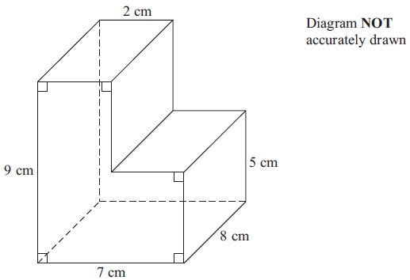

Calculate the volume of the prism.

........................................................... cm³
(Total for Question is 3 marks)

13. Here is the cross section of a steel girder.
The cross section has two lines of symmetry.
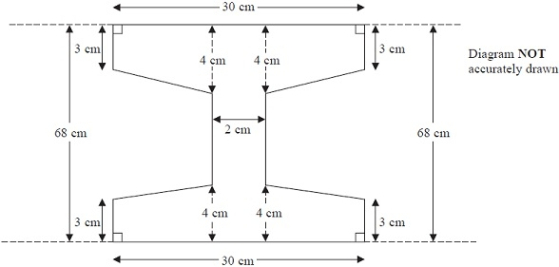
The girder is a prism.
The length of the girder is 200 cm.
Work out the volume of the girder.

........................................................... cm³
(Total for Question is 5 marks)

