Multiplication GREEN

Match up the questions and answers. Show all your working in your book!

120 $×$ 46 | 3565
37 $×$ 7 | 1300
132 $×$ 14 | 259
713 $×$ 5 | 32184
536 $×$ 8 | 1239
413 $×$ 3 | 1848
224 $×$ 27 | 9108
361 $×$ 6 | 6048
25 $×$ 52 | 5520
41 $×$ 82 | 4288
894 $×$ 36 | 3362
23 $×$ 396 | 2166

Multiplication AMBER

Match up the questions and answers. Show all your working in your book!

57 $×$ 3 | 280
35 $×$ 8 | 150
25 $×$ 21 | 168
22 $×$ 27 | 186
24 $×$ 7 | 1066
25 $×$ 6 | 6208
41 $×$ 12 | 23576
31 $×$ 26 | 525
71 $×$ 54 | 492
41 $×$ 26 | 594
56 $×$ 421 | 171
32 $×$ 194 | 3834

Multiplication RED

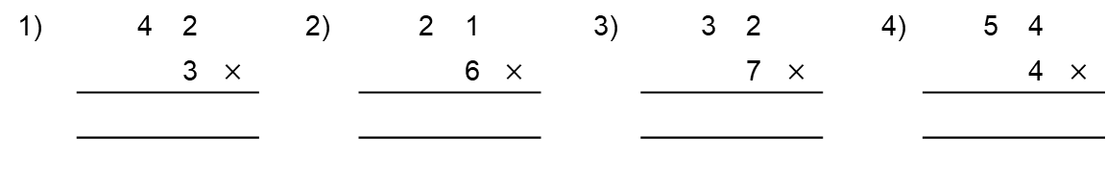

42 $×$ 3 = 21 $×$ 6 = 32 $×$ 7 = 54 $×$ 4 =

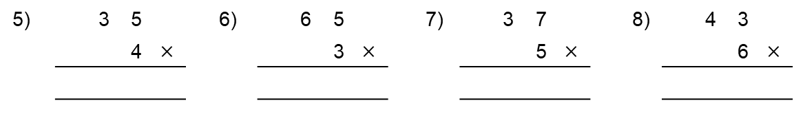

35 $×$ 4 = 65 $×$ 3 = 37 $×$ 5 = 43 $×$ 6 =

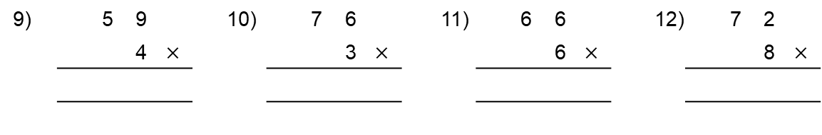

59 $×$ 4 = 76 $×$ 3 = 66 $×$ 6 = 58 $×$ 6 =

