Transformations (F)

Intervention Booklet

Name: _______________________________

Class: _______________________________

Useful websites:

www.mathswatchvle.com
(Video explanations and questions)
Username: STH…@twgash
Password: stmaths

www.methodmaths.com
(Past papers online that get instantly marked)
Centre ID: wga
Username: firstname
Password: lastname

www.hegartymaths.com
(Online tutorials and quizzes)
Login: first name and last name are case sensitive

www.bbc.co.uk/schools/gcsebitesize/maths
Transformations

Things to remember:
- Reflection – the shape is flipped in a mirror line
- Rotation – the shape is turned a number of degrees, around a centre, clockwise or anti-clockwise
- Translation – the shape is moved by a vector $\left(\begin{matrix}x \\ y\end{matrix}\right)$
- Enlargement – the shape is made bigger or smaller by a scale factor from a centre.

Questions:
1. (a) On the grid, draw an enlargement of the rectangle with scale factor 2
(1)
(b) On the grid, rotate the triangle 90° clockwise about the point O.
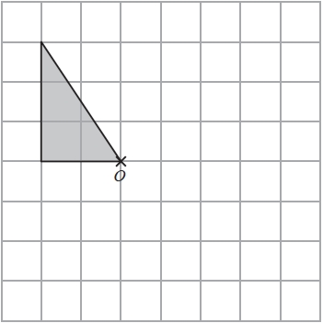
(2)
(Total for question = 3 marks)

2. Reflect the shaded shape in the mirror line.
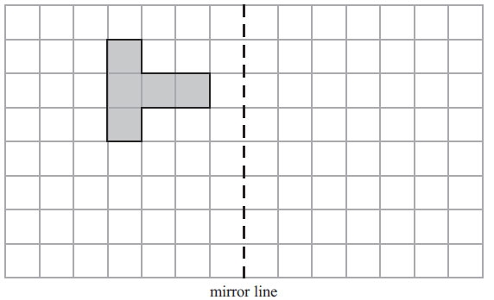
(Total for Question is 2 marks)

3. (a) Reflect triangle A in the x-axis.

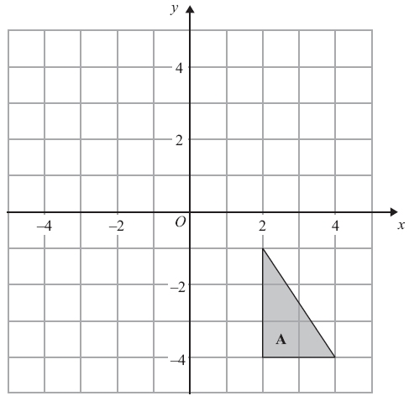
(2)
(b) Draw an enlargement, scale factor 3, of shape B.
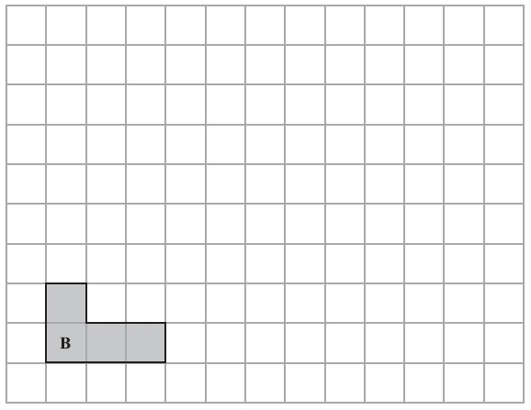
(2)
(Total for Question is 4 marks)

4. On the grid, rotate shape A 180° about the point (1, 1).
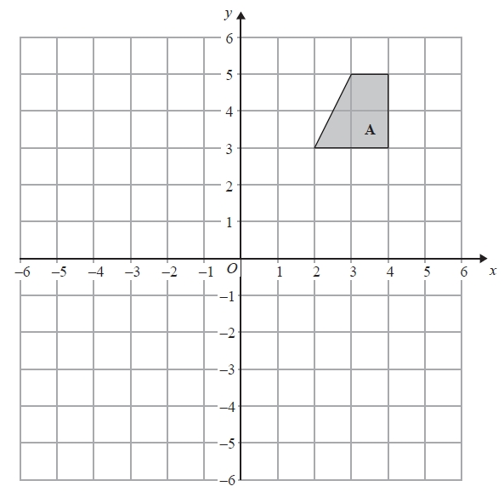
Total for Question is 2 marks)
5. (a) On the grid above, translate shape A by the vector 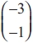
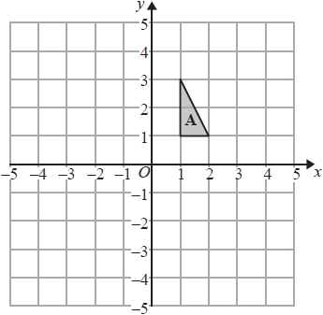
(2)

(b) Describe fully the single transformation that maps shape B onto shape C.
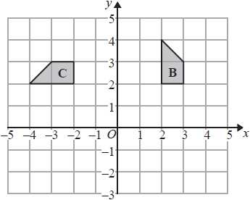
.............................................................................................................................................

.............................................................................................................................................
(3)
(Total for question = 5 marks)
6. Translate the triangle by 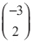.

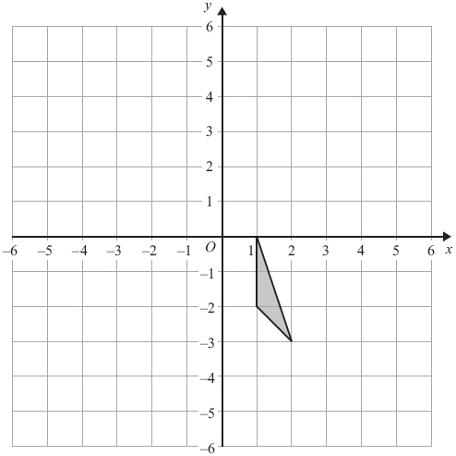
(Total for Question is 2 marks)

Describing Transformations

Things to remember:
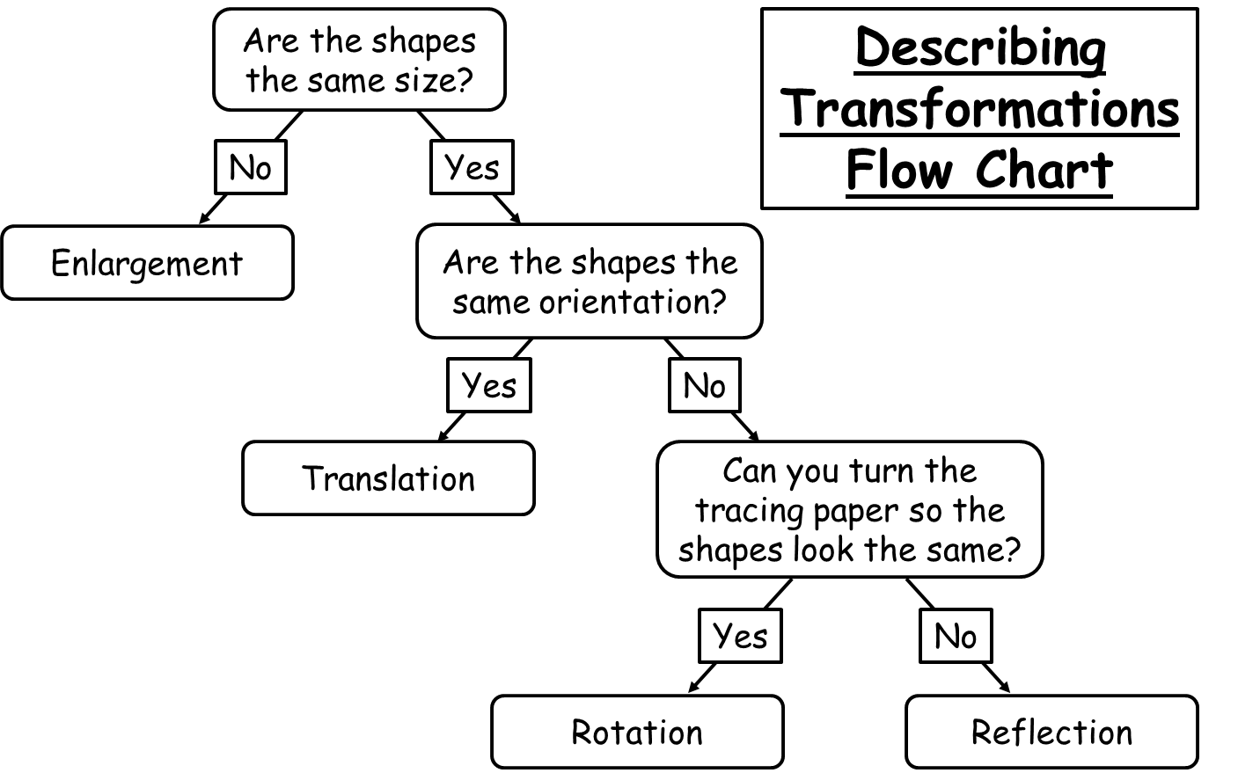

Questions:
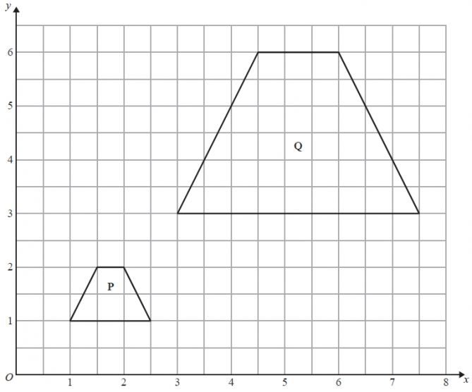
1. Describe fully the single
transformation that maps shape P onto shape Q.

…………………………………

…………………………………

…………………………………
(Total for Question is 3 marks)

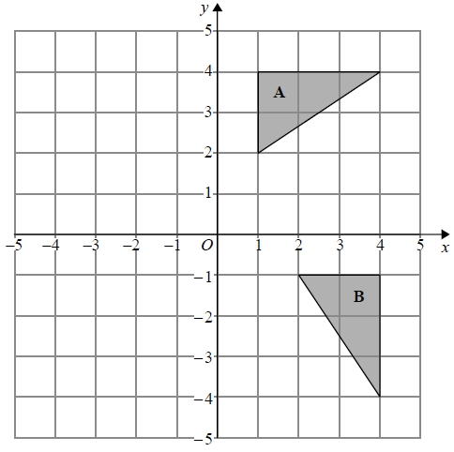

2. Describe fully the single transformation
that maps triangle A onto triangle B.

…………………………………

…………………………………

…………………………………
(Total for question = 2 marks)

3. Describe the single transformation that
maps shape A onto shape B.

…………………………………

…………………………………
(Total for question = 2 marks)

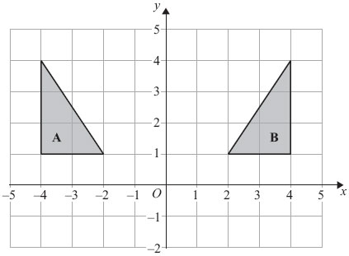
4. Describe fully the single
transformation that maps shape A onto shape B.

…………………………………

…………………………………
(Total for Question is 2 marks)

5. Describe fully the single
transformation that maps shape B onto shape C.

…………………………………

…………………………………

…………………………………
(Total for question = 3 marks)

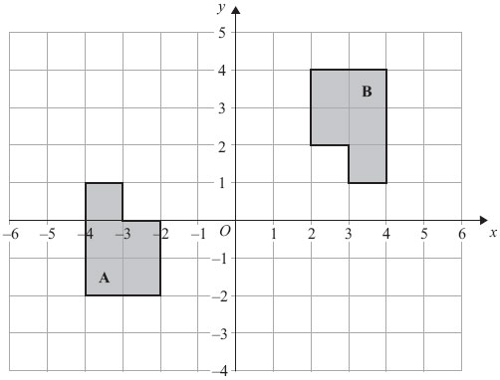
6. Describe fully the single
transformation that maps shape A onto shape B.

…………………………………

…………………………………

…………………………………
(Total for Question is 3 marks)

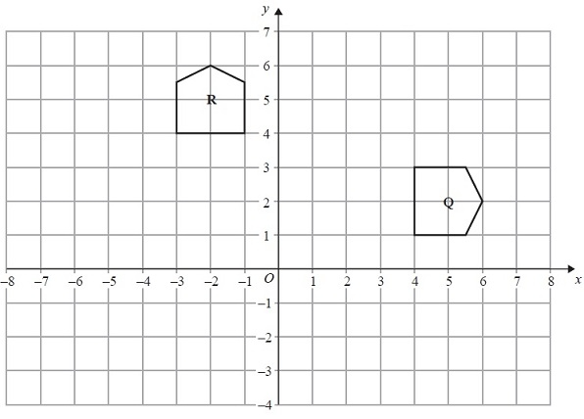
7. Describe fully the single
transformation that maps shape Q onto shape R.

…………………………………

…………………………………

…………………………………
(Total for Question is 3 marks)

