Band 5 – Test 2 Answers

1. | 12.75 ÷ 0.75 = £17 | 1 mark for correct multiplier  1 mark for ÷  1 mark for correct answer | 3
2. | T α R  T = kR  32 = k x 120  k = 4  15  T = 4R  15  T = 4 x 150 = 40  15 | 1 mark for calculating k  1 mark for correct formula  1 mark for substituting R  1 mark for correct answer | 4
3. | 27^{2/3} = ${\sqrt[3]{27}}^{2}$ = $3^{2}$ = 9 | 1 mark for $\sqrt[3]{}$  1 mark for squaring answer | 2
4. | (5 x 10⁴) x (6 x 10⁹)  = 5 x 6 x 10¹³  = 30 x 10¹³  = 3 x 10¹⁴ | 1 mark for 3 or 30 seen  1 mark for correct answer | 2

5. | x -2 -1 0 1 2  y -12 -4 -2 0 8  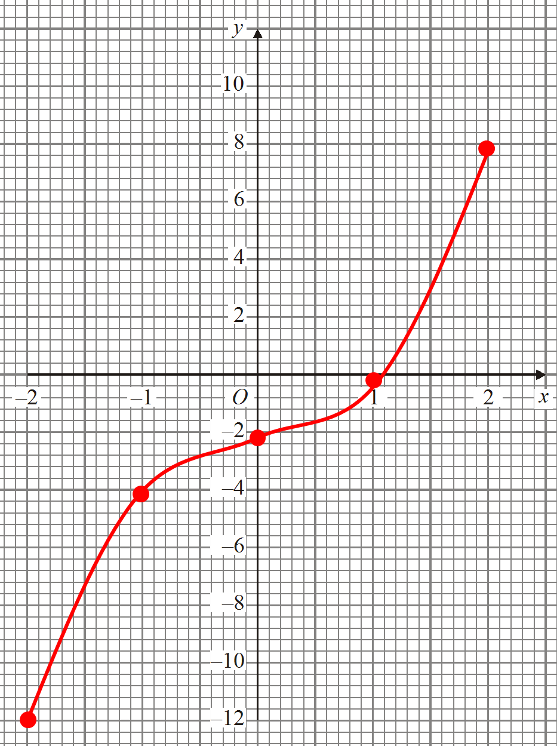 | 1 mark for 2 y values correct  Or 2 marks for all y values correct  1 mark for correct coordinates plotted  1 mark for correct graph drawn | 4

6. |  | m = 6/3 = 2  L₂: y = 2x + c  5 = 2(0) + c  c = 5  y = 2x + 5 |  | 1 mark for calculating gradient  1 mark for substituting to find c  1 mark for correct answer |  | 3
7. |  | (x – 8)(x + 7)  x = 8 or -7 |  | 1 mark for 7 or 8 seen  1 mark for correct factorisation  1 mark for correct answer |  | 3
8. |  | 4x + 2y = 8 x2  2x – 5y = 10 x4  8x + 4y = 16  8x – 20y = 40 -_  24y = -24  y = -1___  4x + 2y = 8  4x – 2 = 8  4x = 10  x = 2.5 | 4x + 2y = 8 x5  2x – 5y = 10 x2  20x + 10y = 40  4x – 10y = 20 +  24x = 60  x = 2.5____  4x + 2y = 8  10 + 2y = 8  2y = -2  y = -1 | 1 mark for scaling up correctly  1 mark for calculating 1 variable  1 mark for correct substitution  1 mark for calculating other variable  0 marks if non-algebraic method used |  | 4
9. |  | 5(x – 3) = y(4 – 3x)  5x – 15 = 4y – 3xy  5x + 3xy = 4y + 15  x(5 + 3y) = 4y + 15  x = 4y + 15  5 + 3y |  | 1 mark for expanding brackets  1 mark for getting all xs to one side  1 mark for factorising  1 mark for correct answer |  | 4
10. |  | 4p – 8 < 7 – p  5p – 8 < 7  5p < 15  p < 3 |  | 1 mark for 3  1 mark for correct inequality symbol used |  | 2
11. |  | PQ = SR as opposite sides of parallelogram are equal  QR = PS as opposite sides of parallelogram are equal  QS shared by both triangles  SSS proves congruence |  | 1 mark for PQ = SR & QR = PS  1 mark for QS  1 mark for SSS oe in words |  | 3
12. |  | 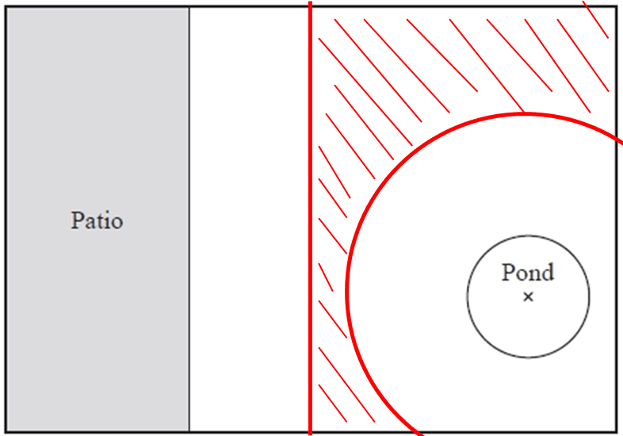 |  | 1 mark for line 1.5 cm from patio  1 mark for circle radius 3 from pond  1 mark for correct region shaded |  | 3
13. | x = 10 x sin40 = 6.42787… = 6.43 cm |  |  |  | 1 mark for use of sin  1 mark for correct working  1 mark for correctly rounded answer |  | 3
14. | 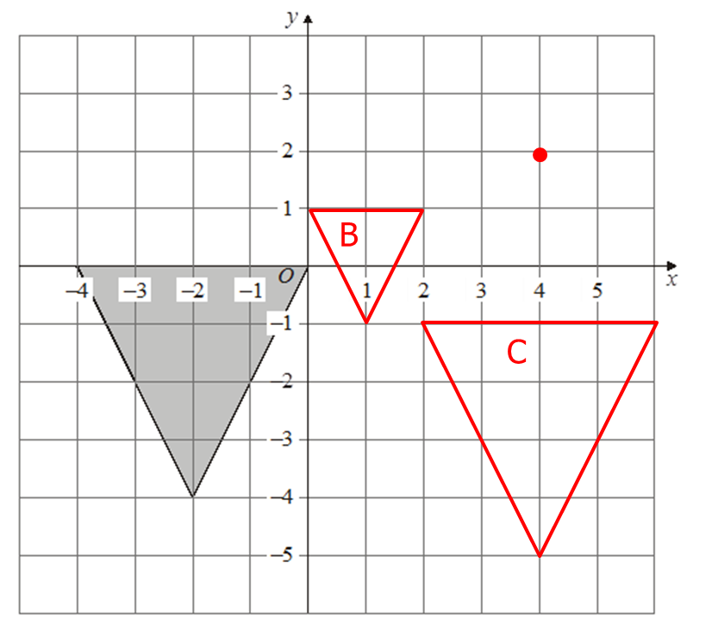 |  |  |  | 1 mark for identifying C of E  1 mark for correct enlargement of ½  1 mark for enlargement in correct place  1 mark for correct x movement  1 mark for correct y movement |  | 5
15. | 150 x 13² x π = 221.22… 221 cm²  360 |  |  |  | 1 mark for correct fraction  1 mark for correct working  1 mark for correct answer |  | 3
16. | $\frac{\frac{4}{3} x π x 3^{3}}{2}$ + $π x 3^{2} x 30$ = 18π + 270π = 904.7786… = 905 cm³ |  |  |  | 1 mark for volume of cylinder  1 mark for volume of hemisphere  1 mark for correct answer |  | 3
17. | 5 x 2.5 = 12.5 cm  4.8 x 2.5 – 4.8 = 12 – 4.8 = 7.2 cm |  |  |  | 1 marks for each correct working  1 mark for each correct answer |  | 4
18. | Number of cups of coffee Frequency M x f  2 1 2  3 3 9  4 5 20  5 8 40  6 5 30  Mean = 101 = 4.59090… = 4.6 cups  22 |  |  |  | 1 mark for correct third column  1 mark for Σmf  Σf  1 mark for correct answer rounded correctly |  | 3
19. | _88_ x 50 = 17.05426… 17 students  258 |  |  |  | 1 mark for correct working  1 mark for correct answer |  | 2
20. | 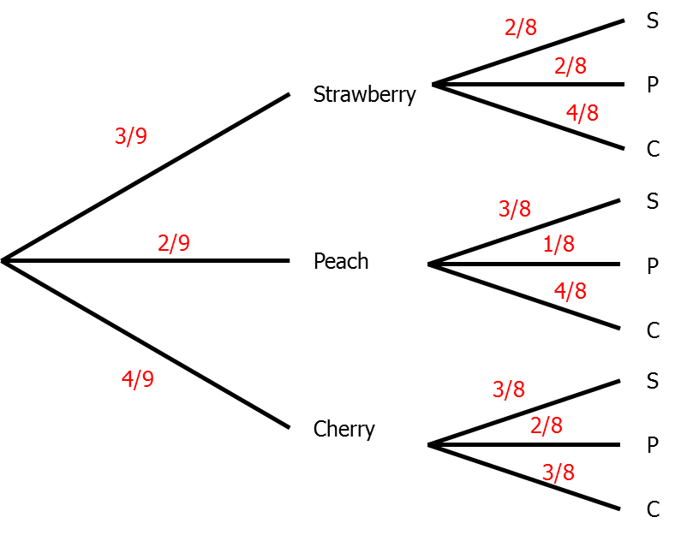  P(S and S or P and P or C and C)  = 3 x 2 + 2 x 1 + 4 x 3 = 6 + 2 + 12 = 20  9 8 9 8 9 8 72 72 72 72 |  |  |  | 1 mark for 1st yoghurt correct  1 mark for 2nd yoghurt correct  1 mark for correct working  1 mark for correct answer |  | 4

