Sine Rule GREEN

Use the sine rule to find side $x$ in each of the following triangles
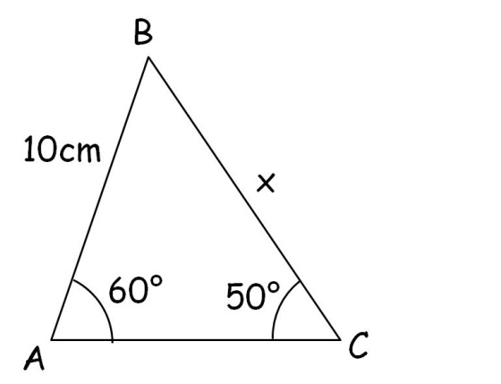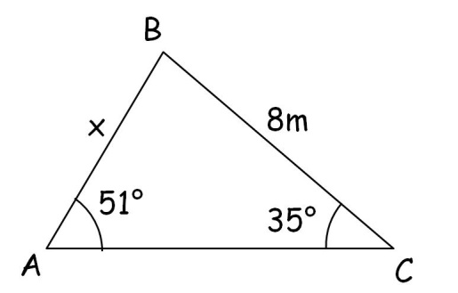

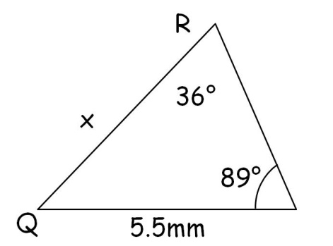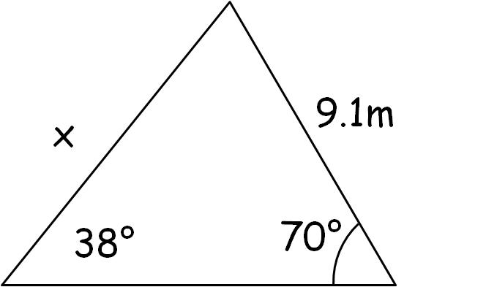

Use the sine rule to find angle $X$ in each of the following triangles
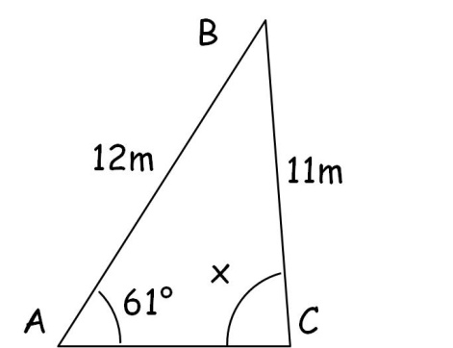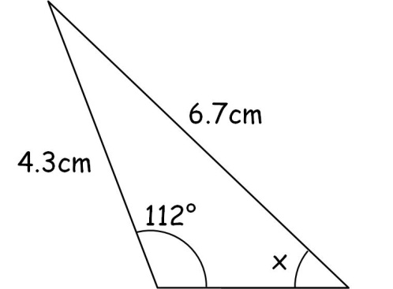

Sine Rule AMBER

Use the sine rule to find side $x$ in each of the following triangles

$$\frac{a}{\sin{A}}=\frac{b}{\sin{B}}=\frac{c}{\sin{C}}$$

Use the sine rule to find angle $X$ in each of the following triangles

$$\frac{\sin{A}}{a}=\frac{\sin{B}}{b}=\frac{\sin{C}}{c}$$

Sine Rule RED

Use the sine rule to find side $x$ in each of the following triangles

$$\frac{a}{\sin{A}}=\frac{b}{\sin{B}}=\frac{c}{\sin{C}}$$

$\frac{x}{\sin{60}}=\frac{10}{\sin{50}}$

$x=\frac{10×\sin{60}}{\sin{50}}=$

Use the sine rule to find angle $X$ in each of the following triangles

$$\frac{\sin{A}}{a}=\frac{\sin{B}}{b}=\frac{\sin{C}}{c}$$

$\frac{\sin{X}}{12}=\frac{\sin{61}}{11}$

$X=\sin^{-1}\left(\frac{12×\sin{61}}{11}\right)=$

