Vectors GREEN

1. Group the following into sets of parallel vectors. Justify your decisions.

$2a + b$ $2p + q$ $2a- b$ $4b + 8a$

$10a-5b$ $-b-2a$ $\frac{1}{2}q +p$

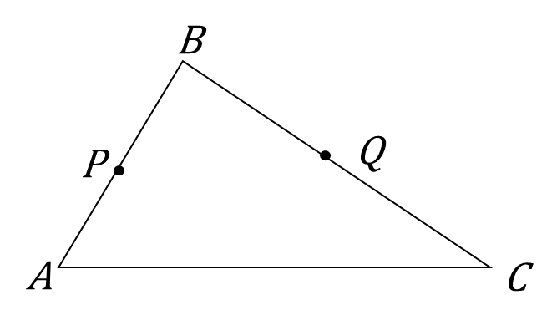
2. In triangle $ABC$, $\vec{AB}=a$ and $\vec{AC}=b$. $P$ is the midpoint of $AB$ and $Q$ is the midpoint of $BC$.

a) Write in terms of $a$ and $b$:

i) $\vec{BC}$ ii) $\vec{AP}$ iii) $\vec{AQ}$ iv) $\vec{PQ}$

________ ________ ________ ________

b) Show that $PQ$ is parallel to $AC$.

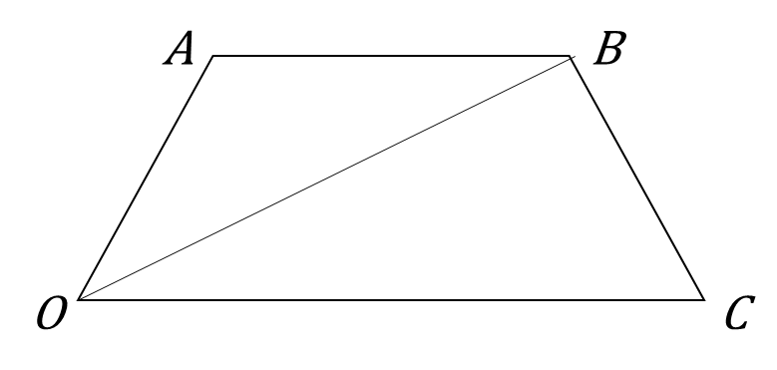
3. $OABC$ is a quadrilateral. $\vec{OA}=a$, $\vec{OC}=3b$ and $\vec{OB}=a+2b$.

a) Find, in terms of $a$ and $b$:

i) $\vec{AB}$ ii) $\vec{CB}$

________ ________

b) Show that $AB$ is parallel to $OC$.

4. The vectors $2a + kb$ and $5a + 3b$ are parallel. Find the value of $k$.

Vectors AMBER

1. Group the following into sets of parallel vectors. Justify your decisions.
Start by factorising any vectors that can be factorised

$2a + b$ $2p + q$ $2a- b$ $4b + 8a$

$10a-5b$ $-b-2a$ $\frac{1}{2}q +p$

2. In triangle $ABC$, $\vec{AB}=a$ and $\vec{AC}=b$. $P$ is the midpoint of $AB$ and $Q$ is the midpoint of $BC$.
Try sketching and labelling a larger version of this diagram

a) Write in terms of $a$ and $b$:

i) $\vec{BC}$ ii) $\vec{AP}$ iii) $\vec{AQ}$ iv) $\vec{PQ}$

________ ________ ________ ________
Look for a common factor
b) Show that $PQ$ is parallel to $AC$.

3. $OABC$ is a quadrilateral. $\vec{OA}=a$, $\vec{OC}=3b$ and $\vec{OB}=a+2b$.
Try sketching and labelling a larger version of this diagram
a) Find, in terms of $a$ and $b$:

i) $\vec{AB}$ ii) $\vec{CB}$

________ ________
Look for a common factor
b) Show that $AB$ is parallel to $OC$.

4. The vectors $2a + kb$ and $5a + 3b$ are parallel. Find the value of $k$.
Factorise both vectors and compare

Vectors RED

1. Group the following into sets of parallel vectors. Justify your decisions.
Start by factorising any vectors that can be factorised

$2a + b$ $2p + q$ $2a- b$ $4b + 8a$

$10a-5b$ $-b-2a$ $\frac{1}{2}q +p$

2. In triangle $ABC$, $\vec{AB}=a$ and $\vec{AC}=b$. $P$ is the midpoint of $AB$ and $Q$ is the midpoint of $BC$.
Try sketching and labelling a larger version of this diagram

a) Write in terms of $a$ and $b$:

i) $\vec{BC}$ ii) $\vec{AP}$ iii) $\vec{AQ}$ iv) $\vec{PQ}$

________ ________ ________ ________
Look for a common factor
b) Show that $PQ$ is parallel to $AC$.

$\vec{PQ}=$ __________ = __ ( _________ )

$\vec{BC}=$ __________ = __ ( _________ )
3. $OABC$ is a quadrilateral. $\vec{OA}=a$, $\vec{OC}=3b$ and $\vec{OB}=a+2b$.
Try sketching and labelling a larger version of this diagram
a) Find, in terms of $a$ and $b$:

i) $\vec{AB}$ ii) $\vec{CB}$

________ ________
Look for a common factor
b) Show that $AB$ is parallel to $OC$.

$\vec{AB}=$ __________ = __ ( _________ )

$\vec{OC}=$ __________ = __ ( _________ )

4. The vectors $2a + kb$ and $5a + 3b$ are parallel. Find the value of $k$.
Factorise both vectors and compare

