Venn diagrams

Use the two pieces of tracing paper to help you
$A∩B$ – only where both shaded parts overlap
$A ∪B$ – all of the shaded parts

$A'∩ B$ $A∩B$
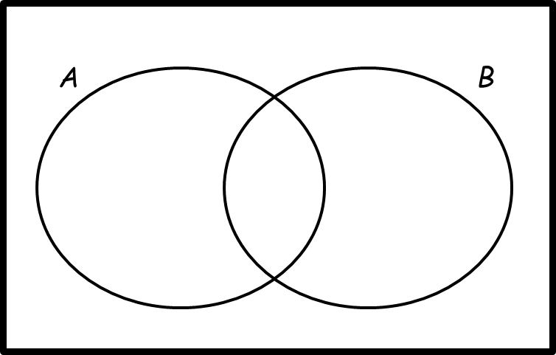

$A∪B'$ $A^{'}∪B'$

$A'∩B'$ $A∩B'$

$A∪B$ $A^{'}∪B$

