Parallel and Perpendicular Graphs

Sketch the following graphs on the same set of axes.
1) $y=-2x+4$
2) $y=\frac{1}{2}x+1$
3) $y=-2x-3$
4) $y=3x+1$

What do you notice?

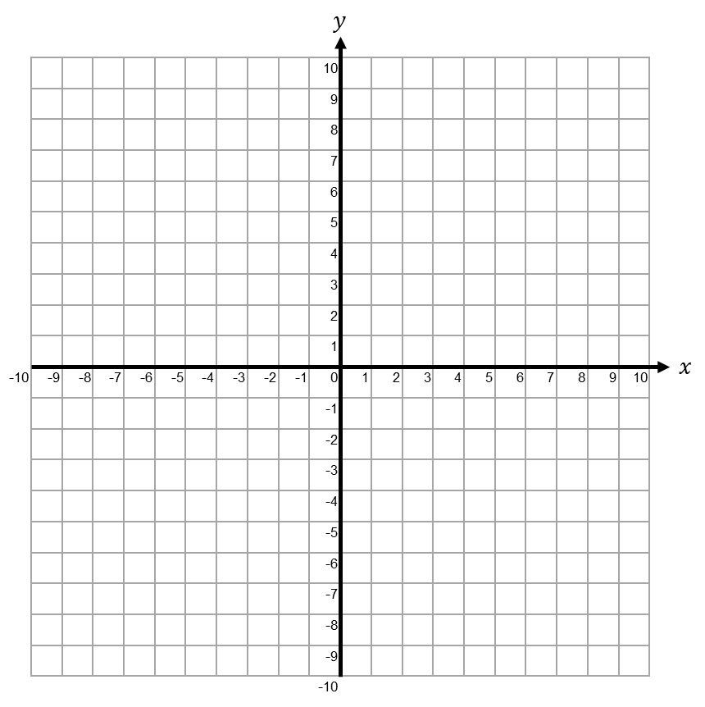
Parallel and Perpendicular Graphs

Sketch the following graphs on the same set of axes.
1) $y=-2x+4$
2) $y=\frac{1}{2}x+1$
3) $y=-2x-3$
4) $y=3x+1$

What do you notice?

