Life Game Houses

£110 000  2 bedroom flat  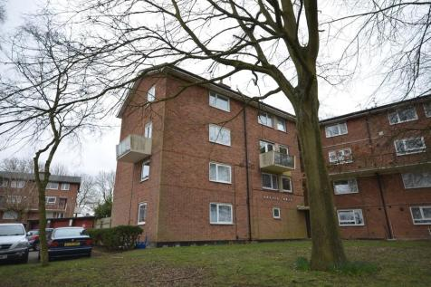  Overlooking the park, the property boasts a stylish and modern finish This property would be an excellent starter home.  Energy costs per month: £45  Water bills per month: £20 | £120 000  2 bedroom terraced house  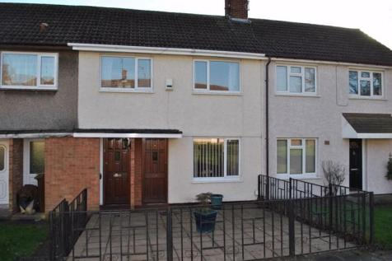  This established mid terraced property is well located for the town centre facilities.  Energy costs per month: £49  Water bills per month: £26 | £90 000  1 bedroom apartment  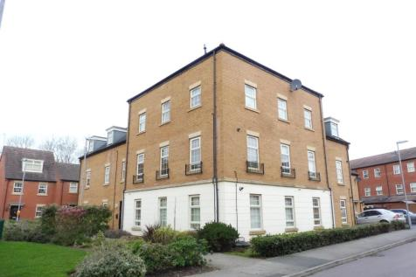  Urban living at its best! This spacious second floor apartment boasts communal gardens and off-road parking.  Energy costs per month: £43  Water bills per month: £18

