Drawing Histograms - GREEN

Draw a labeled Histogram for each set of data. Ensure this is done accurately! Remember to think carefully about how you label the x-axis…

1. Money Spent in a clothes shop.

Money Spent (£) | Frequency
0 ≤ £ < 20 | 40
20 ≤ £ < 30 | 50
30 ≤ £ < 40 | 55
40 ≤ £ < 50 | 40
50 ≤ £ < 100 | 50

2. Kilometres travelled by bike.

Distance Travelled (km) | Frequency
0 ≤ x < 50 | 55
5 ≤ x < 10 | 45
10 ≤ x < 15 | 30
15 ≤ x < 30 | 30
30 ≤ x < 50 | 25

3. People’s earnings in the UK.

Earnings (₤) | Frequency
0 ≤ x < 10,0000 | 5,000
10,000 ≤ x < 20,000 | 120,000
20,000 ≤ x < 25,000 | 50,000
25,000 ≤ x < 30,000 | 32,000
30,000 ≤ x < 40,000 | 12,000
40,000 ≤ x < 50,000 | 5,000
50,000 ≤ x < 100,000 | 10,000

Drawing Histograms - AMBER

Draw a labeled Histogram for each set of data. Ensure this is done accurately! Remember to think carefully about how you label the x-axis…

1. Money Spent in a clothes shop.

Money Spent (£) | Frequency | Frequency Density
0 ≤ £ < 20 | 40
20 ≤ £ < 30 | 50
30 ≤ £ < 40 | 55
40 ≤ £ < 50 | 40
50 ≤ £ < 100 | 50

2. Kilometres travelled by bike.

Distance Travelled (km) | Frequency | Frequency Density
0 ≤ x < 50 | 55
5 ≤ x < 10 | 45
10 ≤ x < 15 | 30
15 ≤ x < 30 | 30
30 ≤ x < 50 | 25

3. People’s earnings in the UK.

Earnings (₤) | Frequency | Frequency Density
0 ≤ x < 10,0000 | 5,000
10,000 ≤ x < 20,000 | 120,000
20,000 ≤ x < 25,000 | 50,000
25,000 ≤ x < 30,000 | 32,000
30,000 ≤ x < 40,000 | 12,000
40,000 ≤ x < 50,000 | 5,000
50,000 ≤ x < 100,000 | 10,000

Drawing Histograms - RED

Draw a labeled Histogram for each set of data. Ensure this is done accurately!

1. Money Spent in a clothes shop.

Money Spent (£) | Frequency | Frequency Density
0 ≤ £ < 20 | 40
20 ≤ £ < 30 | 50
30 ≤ £ < 40 | 55
40 ≤ £ < 50 | 40
50 ≤ £ < 100 | 50

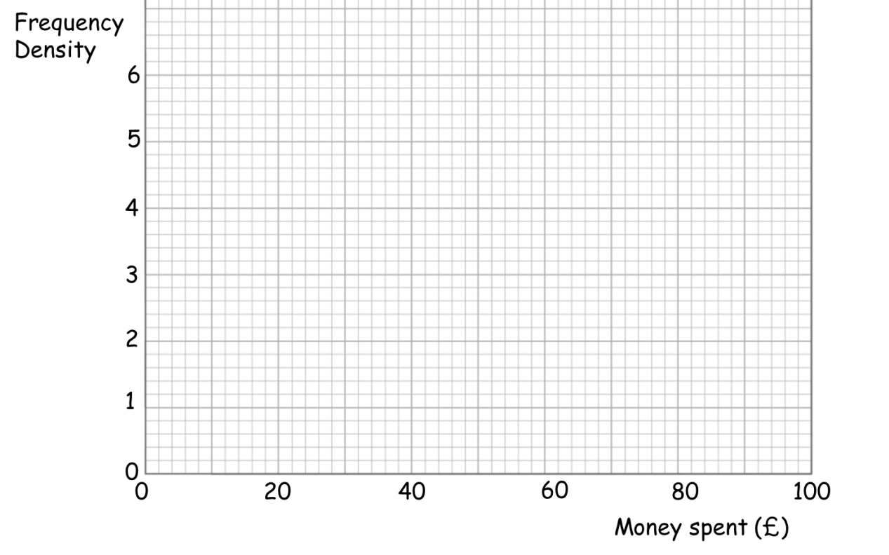
2. Kilometres travelled by bike.

Distance Travelled (km) | Frequency | Frequency Density
0 ≤ x < 50 | 55
5 ≤ x < 10 | 45
10 ≤ x < 15 | 30
15 ≤ x < 30 | 30
30 ≤ x < 50 | 25

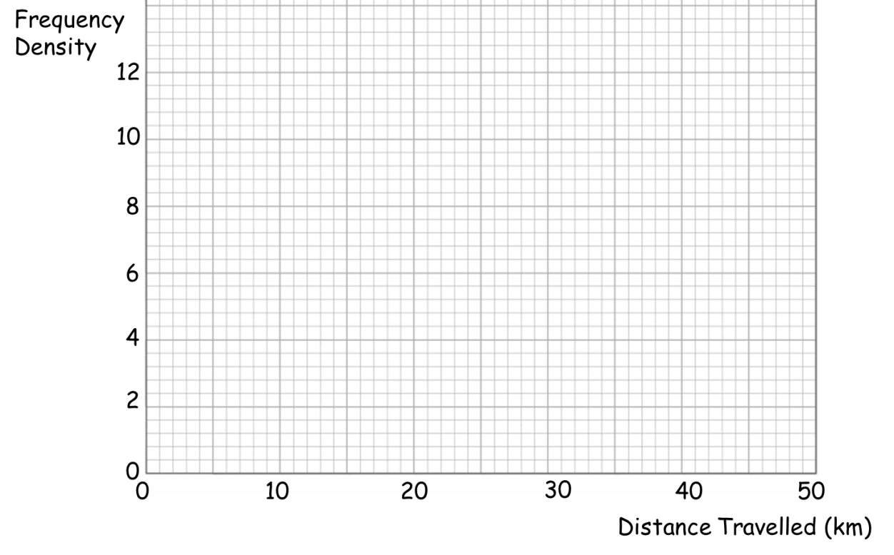
3. People’s earnings in the UK.

Earnings (₤) | Frequency | Frequency Density
0 ≤ x < 10,0000 | 5,000
10,000 ≤ x < 20,000 | 120,000
20,000 ≤ x < 25,000 | 50,000
25,000 ≤ x < 30,000 | 32,000
30,000 ≤ x < 40,000 | 12,000
40,000 ≤ x < 50,000 | 5,000
50,000 ≤ x < 100,000 | 10,000

