Pythagoras’ Theorem RED

4² + 3² = 16 + 9 8² + 6² = 64 + 36 12² + 5² = ____ + ____ ____² + ____² =
= 25 = 100 =
√25 = 5cm √_____ =

Pythagoras’ Theorem AMBER

Pythagoras’ Theorem GREEN

Pythagoras’ Theorem EXTENSION

4. A man walks 10km north then 24km east. How far is he from his starting position? (Draw a diagram to help you).

5. A rectangular door measures 2.5m by 1m. How long is the diagonal of the door? Give your answer to 1 decimal place.

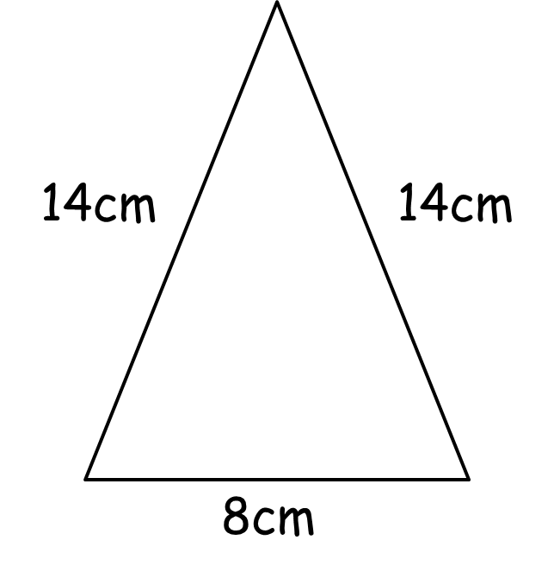
6. To the right is an isosceles triangle. Use Pythagoras’ Theorem to calculate the height of the triangle. Give your answer to 1 decimal place. (Hint: you will need to cut the triangle in half to get a right-angled triangle first).

7. A cylindrical container has diameter 8cm and height 15cm. My pencil measures 18cm. Can the pencil fit completely inside the container?

8. An equilateral triangle has sides of length 5cm. Calculate the height of the triangle, then calculate its area. Give your answers to 1 decimal place.

