Mathematics Assessment

Bands 4-6 Problem Solving – Test 2
Calculators allowed on questions with this symbol:

Name: ______________________________

Class: ______________________________

Teacher: ______________________________

Remember:
- The test is 1 hour long.
- You will need: pen, pencil, rubber and a ruler.
- Try to answer all questions.
- Write all your answers and working in the spaces provided in this test paper – do not use any rough paper. Marks may be awarded for working.
- Check your work carefully.
- Don’t spend too long on one question. Leave it and try the next one.

Formulae Sheet
Perimeter, area, surface area and volume formulae
Sphere | Cone
Volume = $\frac{4}{3}$ πr³  Surface Area = 4πr² | Volume = $\frac{1}{3}$ πr²h  Curved Surface Area = πrl

1. | 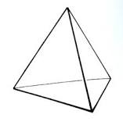  This chocolate box is in the shape of a tetrahedron. Each face is an equilateral triangle with side length 24 cm. Construct an accurate net for the box. Use a scale of 1 cm to 8 cm. | / 6
2. | 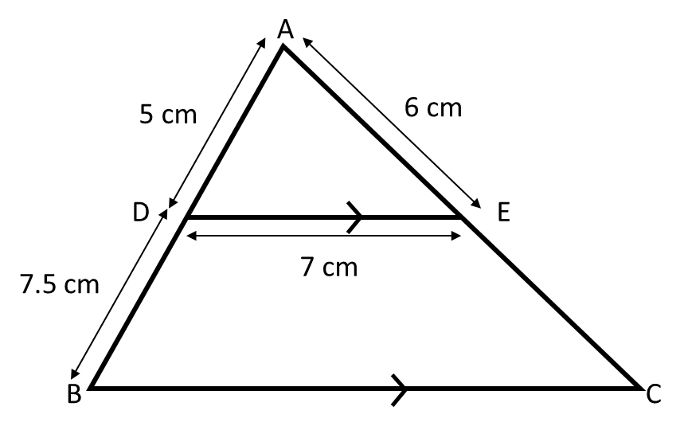  ABC is a triangle. DE and BC are parallel. Calculate the perimeter of trapezium DBCE.  ____________ cm | / 6
3. | 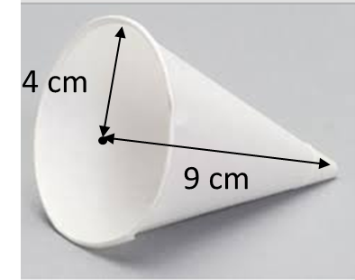  Work out the area of card needed to make this disposable cup. Give your answer correct to 1 decimal place.  _____________ cm² | / 5
4. | There are 5 boxes of cornflakes and 7 boxes of puffed wheat. Mike and Reece both choose a box at random. Work out the probability that they do not choose the same type of cereal.  _____________ | / 5
5. | The distance between Manchester airport and Luton airport is 215 km. The bearing of Luton airport from Manchester airport is 135°. Make an accurate scale map of their locations using a scale of 1 cm to 40 km. | / 3
6. | A telephone company charges £ x per month for a basic line rental and then £ y per 100 minutes. Justin pays £18 for 200 minutes. Teresa pays £21 for 300 minutes. Work out the cost of the monthly rental.  £ ____________ | / 5
7. | Find a quadratic equation that has solutions x = 0 and x = 5  Give your answer without brackets.  ________________________  Find a quadratic equation that has two solutions x = 7  Give your answer without brackets.  ________________________ | / 4
8. | A naturalist captures 30 bats in a cave and tags them. There are approximately 600 bats in the cave. The naturalist returns a month later and captures 40 bats. How many bats would he expect to be tagged?  ______________ | / 3
9. | One sheet of paper is 9 x 10⁻³ cm thick. Mark wants to put 500 sheets of paper in the paper tray of his printer. The paper tray is 4 cm deep. Is the paper tray deep enough for 500 sheets of paper? | / 4
10. | The diagram shows two right-angled triangles ABC and DEB. Find the length of the line AC.  ______________ cm | / 6

