End of Unit Test Name: ____________________________
Pythagoras’ Theorem and Trigonometry - HIGHER

Calculator allowed

1) (a) Work out the size of angle x.

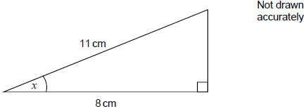

…………………………………………………………………………………………………..

…………………………………………………………………………………………………..

…………………………………………………………………………………………………..

…………………………………………………………………………………………………..

Answer ......................................................................degrees
(2)
(b) Work out length y.

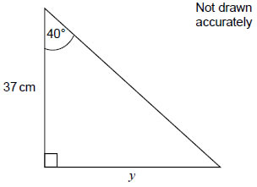

…………………………………………………………………………………………………..

…………………………………………………………………………………………………..

…………………………………………………………………………………………………..

…………………………………………………………………………………………………..

Answer ..............................................................................cm
(2)
(Total 4 marks)
2) In the triangle, angle y is obtuse.

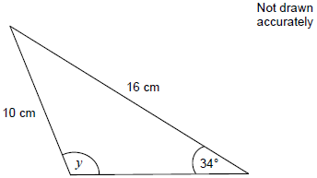
Work out the size of angle y

…………………………………………………………………………………………………………

…………………………………………………………………………………………………………

…………………………………………………………………………………………………………

…………………………………………………………………………………………………………

…………………………………………………………………………………………………………

Answer ............................................ degrees
(Total 3 marks)
3) Work out the size of angle x. Not drawn accurately

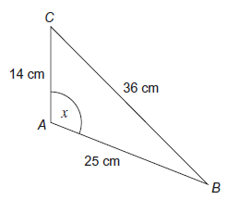
…………………………………………………………………………………………………………

…………………………………………………………………………………………………………

…………………………………………………………………………………………………………

…………………………………………………………………………………………………………

…………………………………………………………………………………………………………

Answer .................................................................... degrees
(Total 3 marks)
4) The diagram shows a sector of a circle, centre O, radius 18 cm. Not drawn accurately.

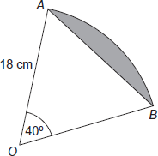

Work out the area of the shaded segment.

…………………………………………………………………………………………………………

…………………………………………………………………………………………………………

…………………………………………………………………………………………………………

…………………………………………………………………………………………………………

…………………………………………………………………………………………………………

…………………………………………………………………………………………………………

…………………………………………………………………………………………………………

…………………………………………………………………………………………………………

…………………………………………………………………………………………………………

…………………………………………………………………………………………………………

…………………………………………………………………………………………………………

…………………………………………………………………………………………………………

Answer ............................................................... cm²
(Total 5 marks)

5) The area of this triangle is 18cm²

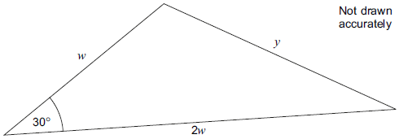

Work out y.

…………………………………………………………………………………………………………

…………………………………………………………………………………………………………

…………………………………………………………………………………………………………

…………………………………………………………………………………………………………

…………………………………………………………………………………………………………

…………………………………………………………………………………………………………

…………………………………………………………………………………………………………

…………………………………………………………………………………………………………

…………………………………………………………………………………………………………

…………………………………………………………………………………………………………

…………………………………………………………………………………………………………

…………………………………………………………………………………………………………

…………………………………………………………………………………………………………

…………………………………………………………………………………………………………

y = ....................................................... cm
(Total 5 marks)

(Total for test = 20 marks)

