Drawing on Isometric Paper GREEN

Copy the 3D shapes using a pencil and ruler:

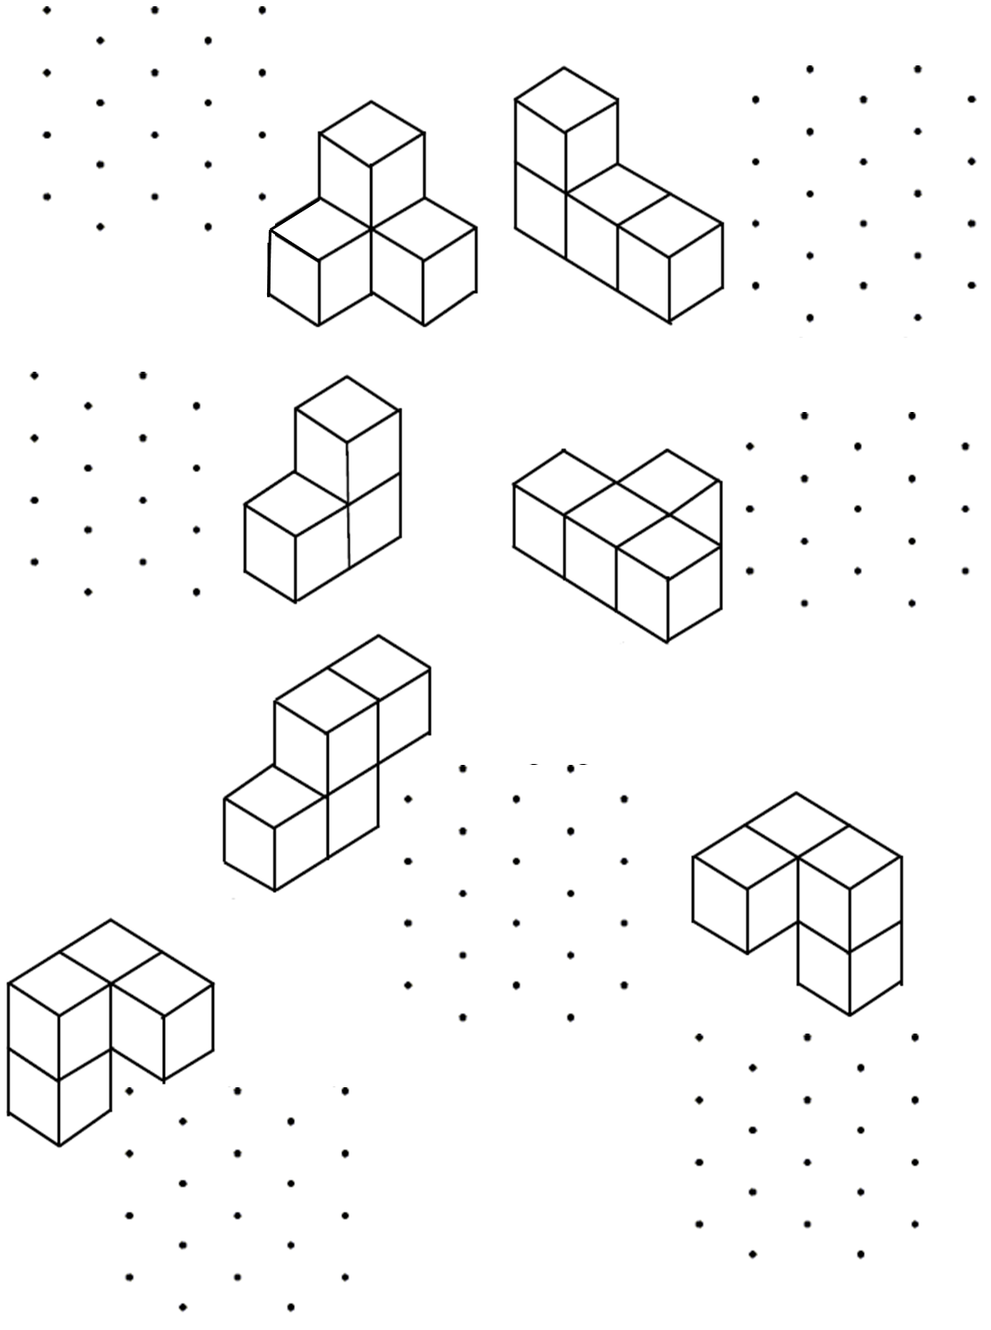

Drawing on Isometric Paper AMBER

Complete the 3D shapes using a pencil and ruler:
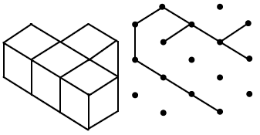
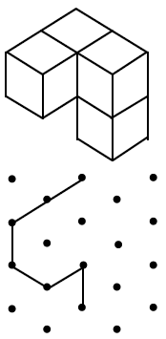
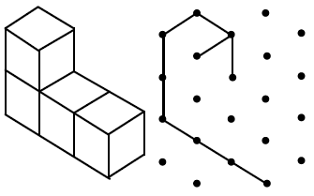
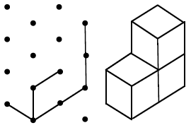
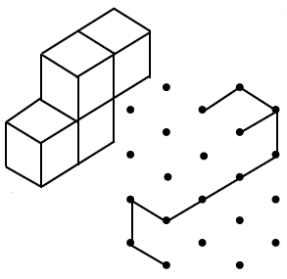
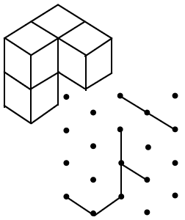
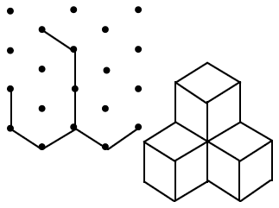

Drawing on Isometric Paper RED

Create the shapes below with multi-link cubes and use the physical objects to help you complete the 3D shapes using a pencil and ruler:

