Band 4 – Test 3 Answers

1. | 60 – 48 = 12  12 ÷ 48 x 100 = 25% | 1 mark for calculating change value  1 mark for change x 100  original  1 mark for correct answer | 3
2. | 200 x 1.4 = €280 | 1 mark for multiplying by exchange rate  1 mark for correct answer | 2
3. | 123.4mm 122.5mm 123.48mm 124mm 123.5mm | Correct answer | 1
4. | 20 x 4 = 80 = 400  0.2 0.2 | 1 mark for rounding one value to 1 significant figure  1 mark for rounding all values to 1 significant figure  1 mark for correct answer | 3
5. | m¹⁰ | Correct answer | 1
6. | 3 x 10⁷ 0.002 | 1 mark for each correct answer | 2
7. | 4gh(3g – 4h)  2t² - 12t + 5t – 30  2t² - 7t - 30 | 1 mark for partially factorised  Or 2 marks for fully factorised  1 mark for expanding correctly  1 mark for simplifying correctly | 4

8. | 4(2x + 1) = 2(3 – x)  8x + 4 = 6 – 2x  10x + 4 = 6  10x = 2  x = 2 = 1  10 5 | 1 mark for correctly expanding brackets  1 mark for 10x = 2  1 mark for correct answer | 3
9. | p = 2q + 10  p – 10 = 2q  p – 10 = q  2 | 1 mark for -10 or ÷2  1 mark for correct answer | 2
10. | 3x + 2 > -7  3x > -9  x > -3 | 1 mark for 2  1 mark for correct inequality symbol used | 2
11. | Exterior angle = 180 – 156 = 24º  360 ÷ 24 = 15 sides | 1 mark for calculating exterior angle  1 mark for 360 ÷ exterior angle  1 mark for correct answer | 3
12. | Correct angle bisector with all construction lines present | 1 mark for correct answer  1 mark for construction lines | 2
13. | 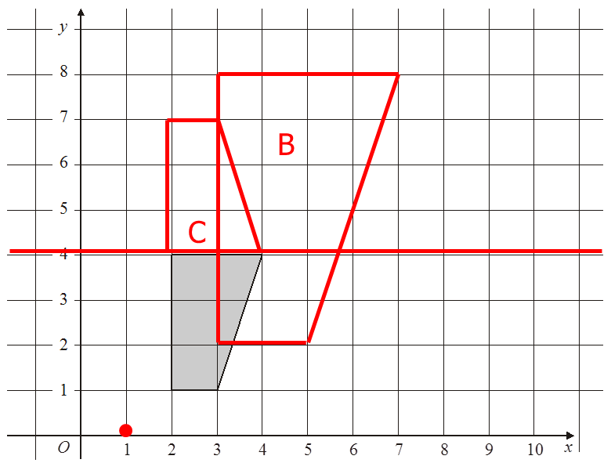 | 1 mark for identifying C of E  1 mark for an enlargement of scale factor 2  1 mark for fully correct enlargement  1 mark for identifying y = 4  1 mark for fully correct reflection | 5
14. | $\sqrt{{157}^{2}+{168}^{2}}= \sqrt{24649+28224}= \sqrt{52873}$ = 230 km | 1 mark for 1.7² and 3.2²  1 mark for adding and square rooting  1 mark for correctly rounded answer | 3

15. | 15 mins  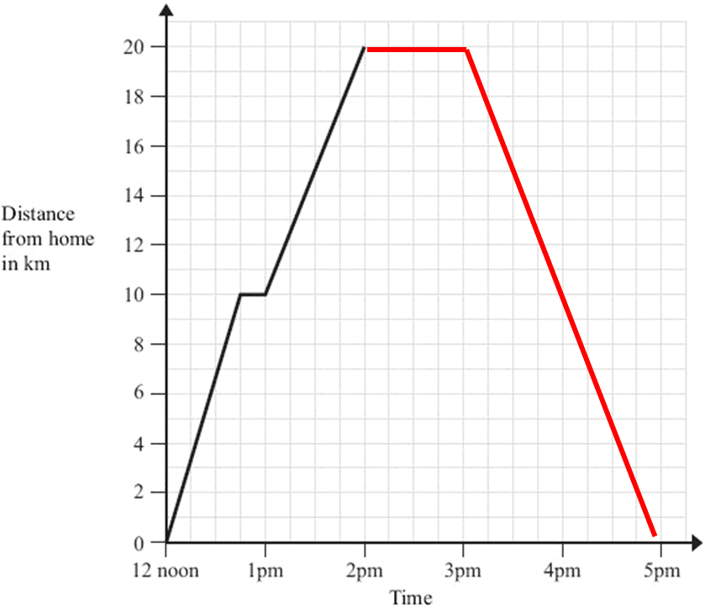 | 1 mark for correct answer  1 mark for correct rest line  1 mark for correct line representing the journey home | 3
16. | (5 x 7) + (3 x 7) + (4 x 7) + 2(½ x 4 x 3)  = 35 + 21 + 28 + 12  = 96 cm² | 1 mark for area of at least 2 faces  1 mark for all areas calculated  1 mark for correct answer rounded correctly | 3
17. | Describe stratified sampling method  Describe relative frequency method | 1 mark for each correct answer | 2
18. | Negative correlation  Correct line segment that can be used as a line of best fit  Accept answers between 3 and 4 | 1 mark for each correct answer | 3
19. | Options overlap OR no timeframe OR not exhaustive  Same age/not varied enough | 2 marks for 2 correct  1 mark for correct answer | 3
20. | 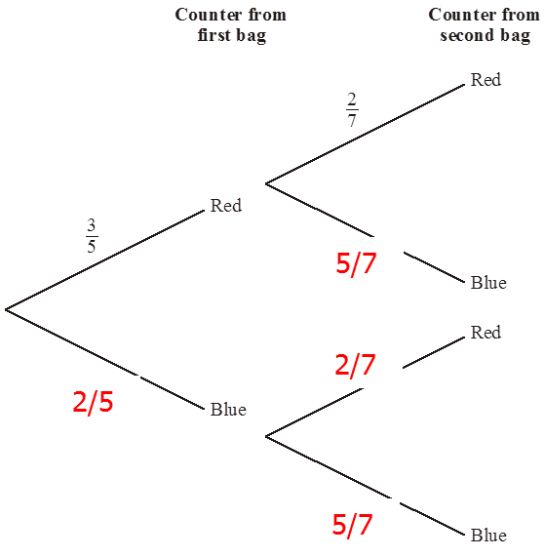 | 1 mark for correct answer for first bag  1 mark for correct answers for second bag | 2

