Problem Solving with Shape, Space and Measure

Name: _____________________________________
Class: _____________________________________

Time: 1 hour 20 mins
Total marks available: 70 | Total marks achieved: _____
Q1.
* The diagram shows the floor plan of Mary's conservatory.
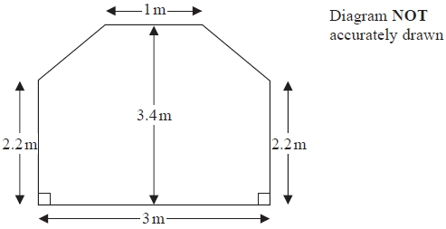
Mary is going to cover the floor with tiles.
The tiles are sold in packs.
One pack of tiles will cover 2m²
A pack of tiles normally costs £24.80
Mary gets a discount of 25% off the cost of the tiles.
Mary has £100
Does Mary have enough money to buy all the tiles she needs?
You must show all your working.

(Total for question = 5 marks)

Q2.
Gary drove from London to Sheffield. It took him 3 hours at an average speed of 80km/h.
Lyn drove from London to Sheffield.
She took 5 hours.
Assuming that Lyn
drove along the same roads as Gary
and did not take a break,
(a) work out Lyn's average speed from London to Sheffield.

........................................................... km/h
(3)
(b) If Lyn did not drive along the same roads as Gary, explain how this could affect your answer to part (a).
.............................................................................................................................................
.............................................................................................................................................
(1)

(Total for question = 4 marks)

Q3.
David drives to the supermarket on his way home from work.
The table shows some information about his journey.
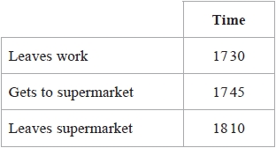
(a) How many minutes is David at the supermarket?
........................................................... minutes
(1)
David leaves the supermarket at 1810
He drives 20 miles to his home.
The speed limit for the journey is 30 mph.
David drives within the speed limit.
*(b) Can David get home before 1900?
Give reasons for your answer.
(3)

(Total for question = 4 marks)

Q4.
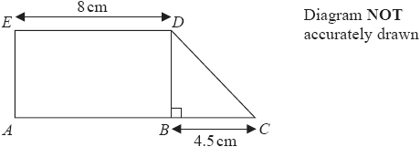
ABDE is a rectangle.
ED is 8cm.
BDC is a right-angled triangle.
BC is 4.5cm.
ABC is a straight line.
The area of the rectangle ABDE is 40cm².
Work out the area of the triangle BDC.
...........................................................cm²

(Total for question = 3 marks)

Q5.
Here is a scale drawing of an office.
The scale is 1 cm to 2 metres.
A photocopier is going to be put in the office.
The photocopier has to be closer to B than it is to A.
The photocopier also has to be less than 8 metres from C.
Show, by shading, the region where the photocopier can be put.

(Total for question = 3 marks)

Q6.
A pattern is made using identical rectangular tiles.
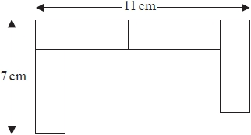
Find the total area of the pattern.

........................................................... cm²

(Total for question is 4 marks)

Q7.
Axel and Lethna are driving along a motorway.
They see a road sign.
The road sign shows the distance to Junction 8
It also shows the average time drivers take to get to Junction 8
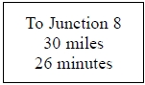
The speed limit on the motorway is 70 mph.
Lethna says
"We will have to drive faster than the speed limit to drive 30 miles in 26 minutes."
Is Lethna right?
You must show how you get your answer.

(Total for question = 3 marks)

Q8.
* ABCD and PQRS are two rectangles.
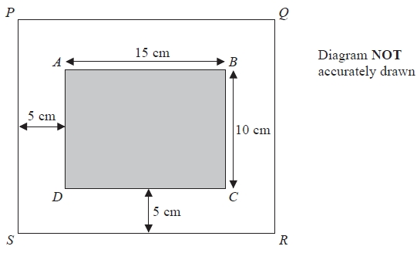
Rectangle ABCD is 15 cm by 10 cm.
There is a space 5 cm wide between rectangle ABCD and rectangle PQRS.
Are rectangle ABCD and rectangle PQRS mathematically similar?
You must show how you got your answer.

(Total for question = 3 marks)

Q9.
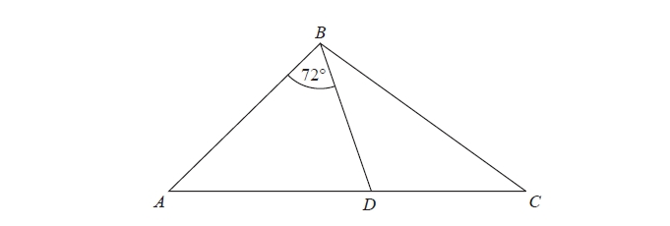
ABC is an isosceles triangle with BA = BC.
D lies on AC.
ABD is an isosceles triangle with AB = AD.
Angle ABD = 72º
Show that the triangle BCD is isosceles.
You must give a reason for each stage of your working.

(Total for question = 5 marks)

Q10.
The plan, front elevation and side elevation of a solid prism are drawn on a centimetre grid.
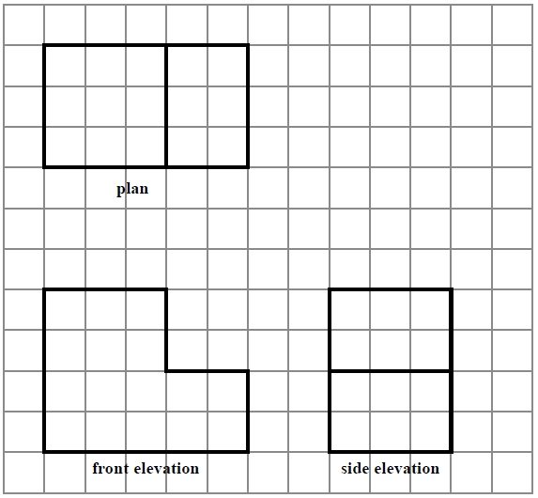
In the space below, draw a sketch of the solid prism.
Write the dimensions of the prism on your sketch.

(Total for question = 2 marks)
Q11.
* The diagram shows the plan of a floor.
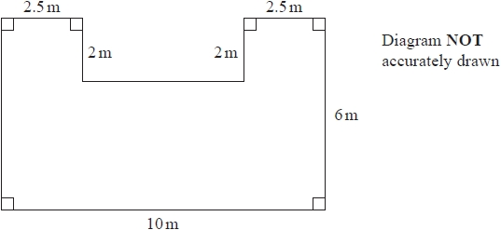
Angie is going to varnish the floor.
She needs 1 litre of varnish for 5 m² of floor.
There are 2.5 litres of varnish in each tin of varnish.
Angie has 3 tins of varnish.
Does she have enough varnish for all the floor?
You must show all your working.

(Total for question = 5 marks)

Q12.
*The diagram shows the distances by road between five towns A, B, C, D and E.
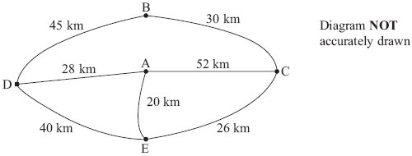
Amir delivers computers.
He starts at town A.
He delivers computers to each of four towns B, C, D and E.
He finishes at town A.
Amir wants to drive the shortest distance to deliver all the computers.
Work out the shortest distance.
You must show all your working.

(Total for Question is 4 marks)

Q13.
* Jean is going to the beach.
It takes her 25 minutes to get from her home to the beach.
It takes her 25 minutes to get from the beach to her home.
Jean leaves home at 2.40 pm.
She has to get home by 6 pm.
What is the greatest length of time Jean can stay at the beach?

...........................................................
(Total for Question is 4 marks)

Q14.
The diagram shows a sand pit.
The sand pit is in the shape of a cuboid.
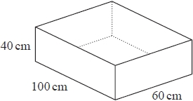
Sally wants to fill the sand pit with sand.
A bag of sand costs £2.50
There are 8 litres of sand in each bag.
Sally
"The sand will cost less than £70"
Show that Sally is wrong.

(Total for question is 5 marks)

Q15.
* Here is a diagram of a wall.
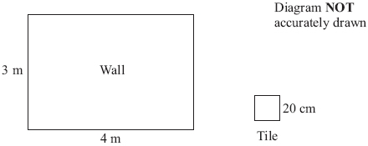
Halima wants to cover all of the wall with tiles.
The tiles are squares with sides of length 20 cm.
The tiles are sold in packs.
There are 10 tiles in each pack.
Each pack of tiles costs £34.99
Halima only has £1000
Can she buy enough packs of tiles to cover the wall?

(Total for Question is 6 marks)

Q16.
Here is a diagram showing a rectangle, ABCD, and a circle.
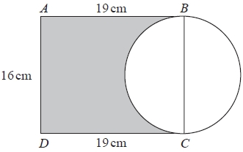
BC is a diameter of the circle.
Calculate the percentage of the area of the rectangle that is shaded.
Give your answer correct to 1 decimal place.
...........................................................%

(Total for question is 4 marks)

Q17.
The diagram shows a garden with 4 flower beds.
The garden is a rectangle, 23 m by 17 m.
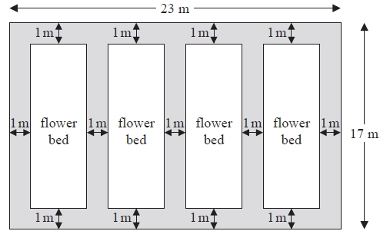
Diagram NOT accurately drawn
Each flower bed is a rectangle with the same length and the same width.
Work out the length and the width of a flower bed.
length =...........................................................m
width =...........................................................m
(Total for Question is 3 marks)

Q18.
The diagram shows a rectangular floor.
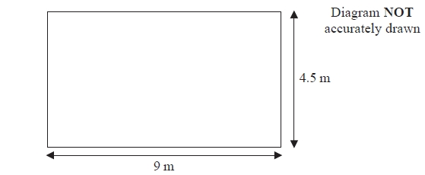
Toji is going to cover the floor with floor boards.
Each floor board is 0.1 m wide and 1.5 m long.
Work out the smallest number of floor boards Toji needs.
...........................................................

(Total for question = 3 marks)

