**Drawing Enlargements GREEN**

Enlarge by s.f. 2 from (-3, -4) Enlarge by s.f. 3 from (4, 1)

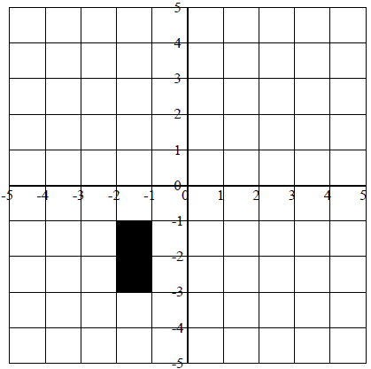 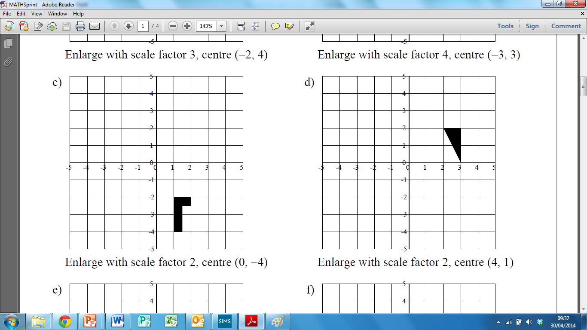

Enlarge by s.f. 2 from (4, 5) Enlarge by s.f. 2 from (5, 2)

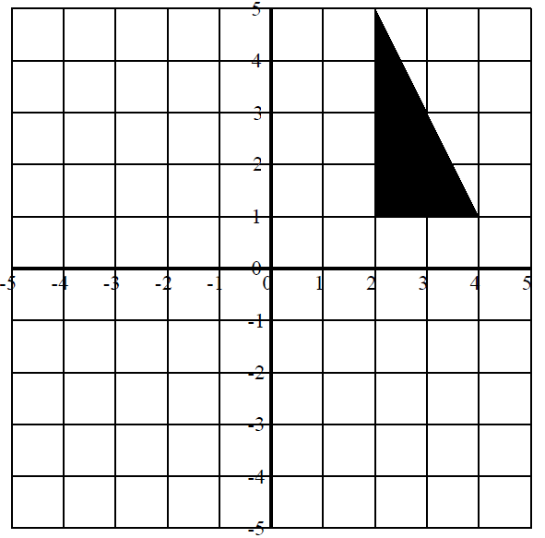 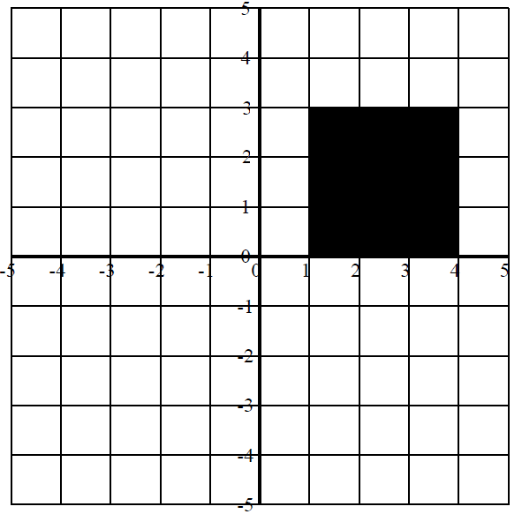

Enlarge by s.f. 3 from (-5, 5) Enlarge by s.f. 5 from (-5, -5)

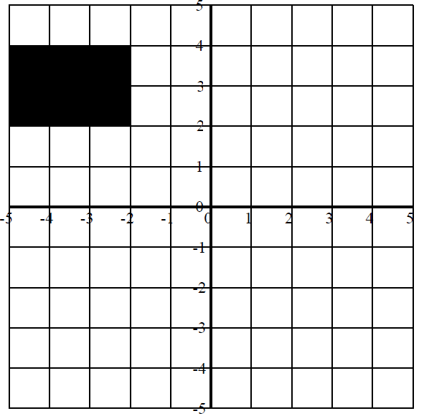 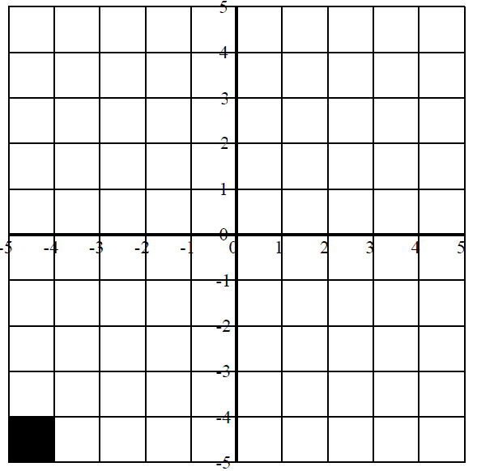

**Drawing Enlargements AMBER**

Enlarge by s.f. 2 from (-3, -4) Enlarge by s.f. 3 from (4, 1)

1) Identify the centre of enlargement ()

2) Calculate the distance from the centre to the shape.

3) Multiply this distance by the scale factor.

4) Multiply every side length by the scale factor and draw in the new shape.

 

Enlarge by s.f. 2 from (4, 5) Enlarge by s.f. 2 from (5, 2)

 

Enlarge by s.f. 3 from (-5, 5) Enlarge by s.f. 5 from (-5, -5)

 

**Drawing Enlargements RED**

Enlarge by s.f. 3 from (-3, -4) Enlarge by s.f. 2 from (-4, 5)

1) Identify the centre of enlargement ()

2) Calculate the distance from the centre to the shape.

3) Multiply this distance by the scale factor.

4) Multiply every side length by the scale factor and draw in the new shape.

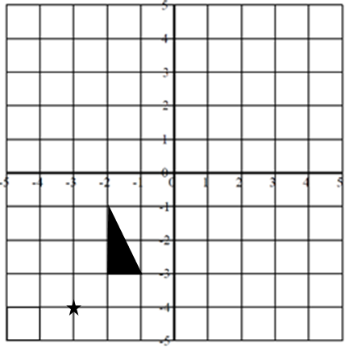 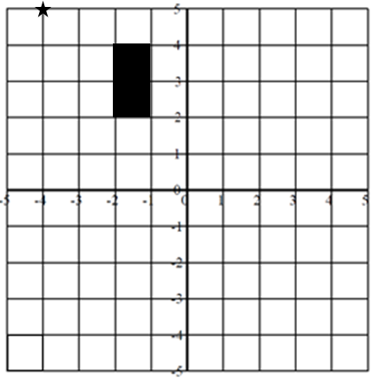

Enlarge by s.f. 4 from (4, -5) Enlarge by s.f. 3 from (0, 5)

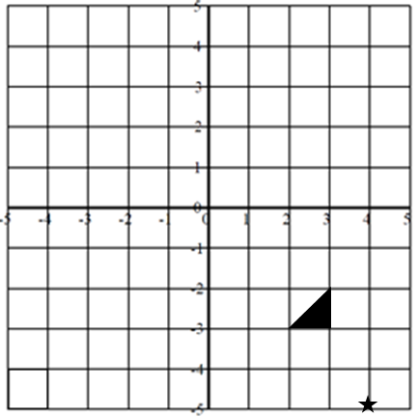 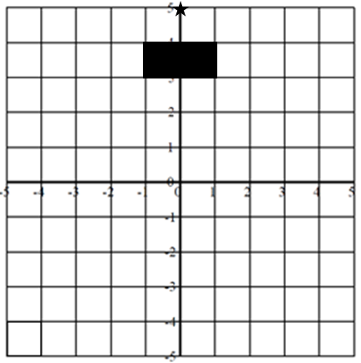

Enlarge by s.f. 2 from (-3, -4) Enlarge by s.f. 3 from (4, 1)

 