Band 3 – Test 3 Answers

1. | $\frac{1}{3}$ + $\frac{2}{5}$ = $\frac{5}{15}$ + $\frac{6}{15}$ = $\frac{11}{15}$  3 $\frac{1}{4}$ x 2 $\frac{3}{5}$ = $\frac{13}{4}$ x $\frac{13}{5}$ = $\frac{169}{20}$ = 8 $\frac{9}{20}$ | 1 mark for a correct common denominator  1 mark for correct answer  1 mark for correct improper fractions  1 mark for correct multiplication of fractions  1 mark for correct answer | 5
2. | 24 = 240 = 120  0.2 2 | 1 mark for correct fraction  1 mark for correct equivalent fraction  1 mark for correct answer | 3
3. | 10% = £4.50  5% = £2.25  15% = £6.75  £45 + £6.75 = £51.75 | 1 mark for calculating 15%  1 mark for adding 15% to £45  1 mark for correct answer | 3
4. | 65% $\frac{3}{4}$ 0.72 $\frac{2}{3}$ $\frac{3}{5}$  0.65 0.75 0.72 0.67 0.6  $\frac{3}{5}$ 65% $\frac{2}{3}$ 0.72 $\frac{3}{4}$ | 1 mark for 3 correct equivalent FDPs  1 mark for correct order | 2
5. | 210 ÷ 3 = 70 km  3 + 4 + 4 = 11 parts  70 x 11 = 770 km | 1 mark for identifying value of 1 part  1 mark for calculating number of parts  1 mark for correct answer | 3
6. | 9.7 x 12.3 = 119.31 0.97 x 123000 = 119310 | 1 mark for each correct answer | 2
7. | 2.004875737 2.00 | 2 marks for correct calculation  1 mark for correct rounding | 3
8. | t¹⁰ p³ | 1 mark for each correct answer | 2
9. | 1/5 | Correct answer | 1
10. | 5t² - 10t | Correct answer | 1
11. | 7p + 2 = 5p + 8  2p + 2 = 8  2p = 6  p = 3 | 1 mark for 2r = -22  1 mark for correct answer | 2
12. | C = 10(n + 3) | 1 mark for n + 3  1 marks for x10 | 2
13. | x ≤ 3 | Correct answer | 1

14. | x -2 -1 0 1 2  y -1 1 3 5 7  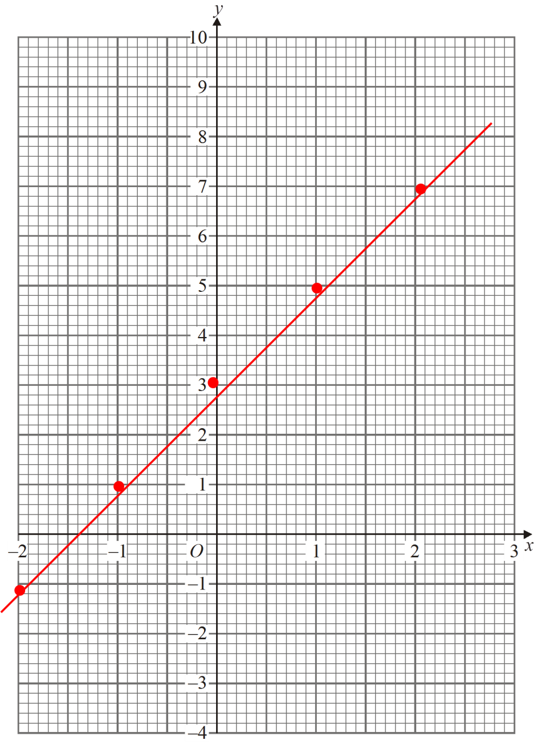 | 1 mark for at least 2 y values correct  Or 2 marks for all 3 values correct  1 mark for coordinates plotted correctly  1 mark for straight line segment through coordinates | 4

15. | 38º  Alternate angles are equal  109º  Base angles in an isosceles triangle are equal OR angles in a triangle sum to 180º OR angles on a straight line sum to 180º | 1 mark for each correct answer  1 mark for each correct reason | 4
16. | 076º  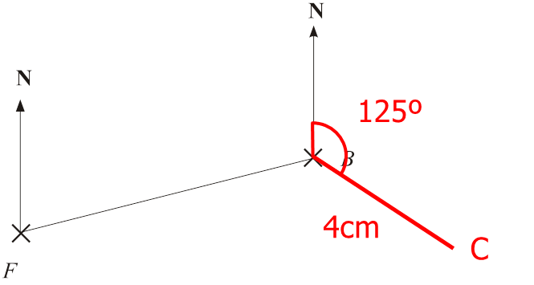 | 1 mark for correct answer  1 mark for correct angle  1 mark for C correctly located | 3
17. | (12 x 10 x ½) – (3 x 5) = 60 – 15 = 45 cm² | 1 mark for correct area of triangle  1 mark for correct area of rectangle  1 mark for correct total area | 3
18. | 4 x 4 x 4 = 64 cm³ | 1 mark for volume ÷ 50  1 mark for correct answer | 2
19. | 87 ÷ 36 = 2.41666… = 2 hours and 25 minutes  09 25 | 1 mark for distance ÷ speed  1 mark for correct answer | 2

20. | Choice Frequency Angle  Full meal 150 75º  Hot snack 240 120º  Cold snack 220 110º  Packed lunch 110 55º  Total 720 360º  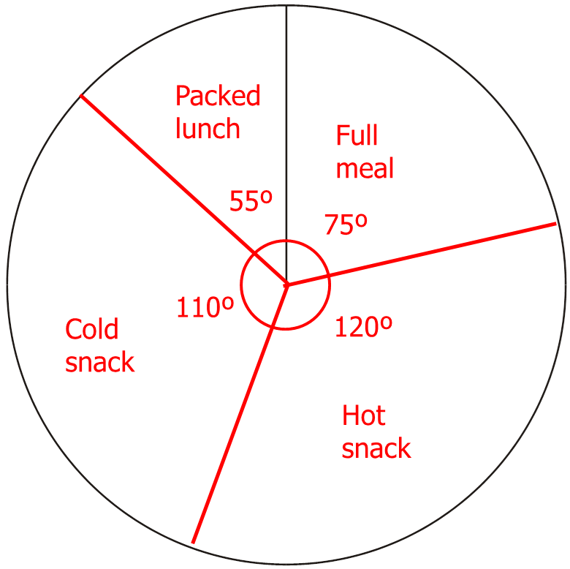 | 1 mark for ÷ 2 seen  1 mark for correctly calculating angles  1 mark for correctly drawn pie chart with labels | 3

21. | Coin Dice  1 2 3 4 5 6  1 2 3 4 5 6 7  2 3 4 5 6 7 8  3 4 5 6 7 8 9  4 5 6 7 8 9 10  5 6 7 8 9 10 11  6 7 8 9 10 11 12  P(9) = 4/36 | 1 mark for correctly completing sample space diagram  1 mark for identifying 36 possible outcomes  1 mark for 4 9s. | 3

