**Translations GREEN**

Translate each of these by the given vector.















Starting at the black square, move according to the given vectors (you do **NOT** return to the black square each time but should start from the last position you get to). The first three are done for you (U-S-E)

**A**

**B**

**C**

**D**

**E**

**F**

**G**

**H**

**I**

**J**

**K**

**L**

**M**

**N**

**O**

**P**

**Q**

**R**

**S**

**T**

**U**

**V**

**W**

**X**

**Y**

**Z**

**_**



|  |
| --- |
| USE |
|  |

Translate each shape by the vector on the shape, they should fit together to make an image.



**Translations AMBER**

Translate by Translate by

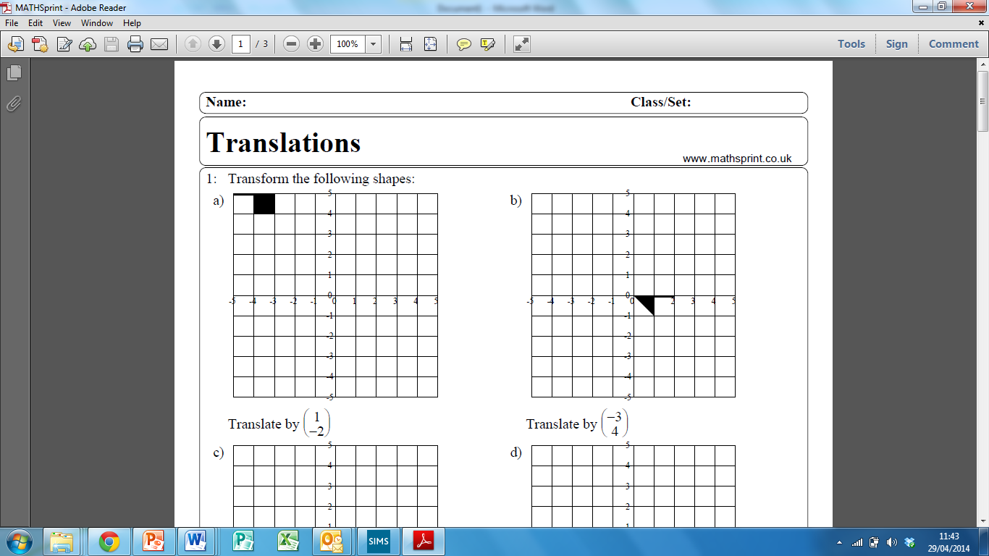 

Translate by Translate by

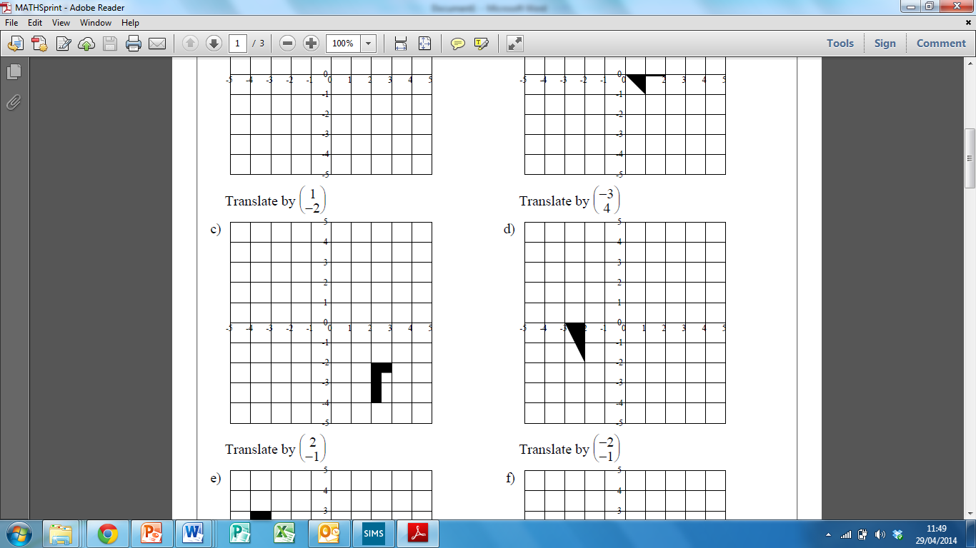 

Translate by Translate by

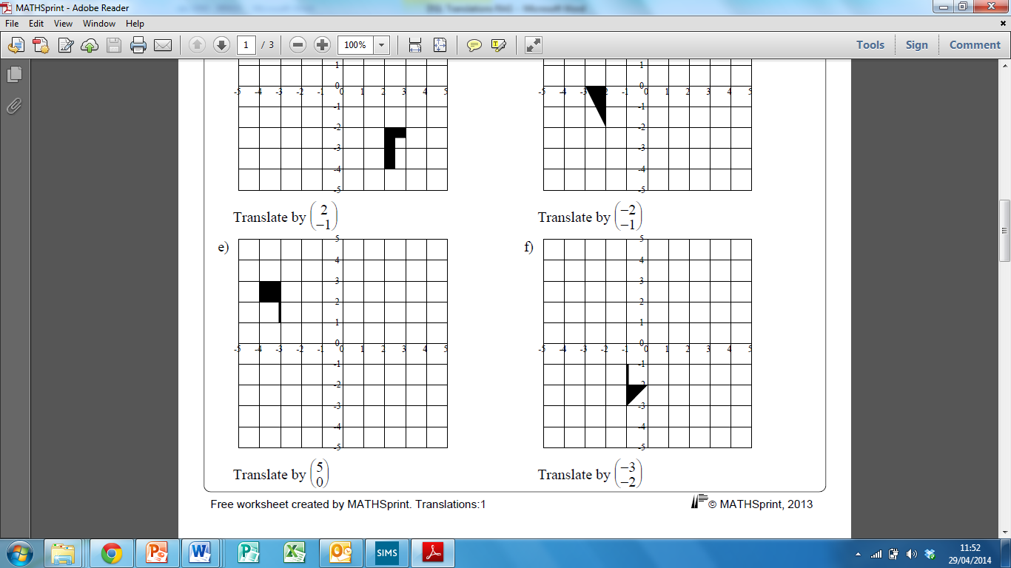 

What translations map the grey shape onto the black shape?

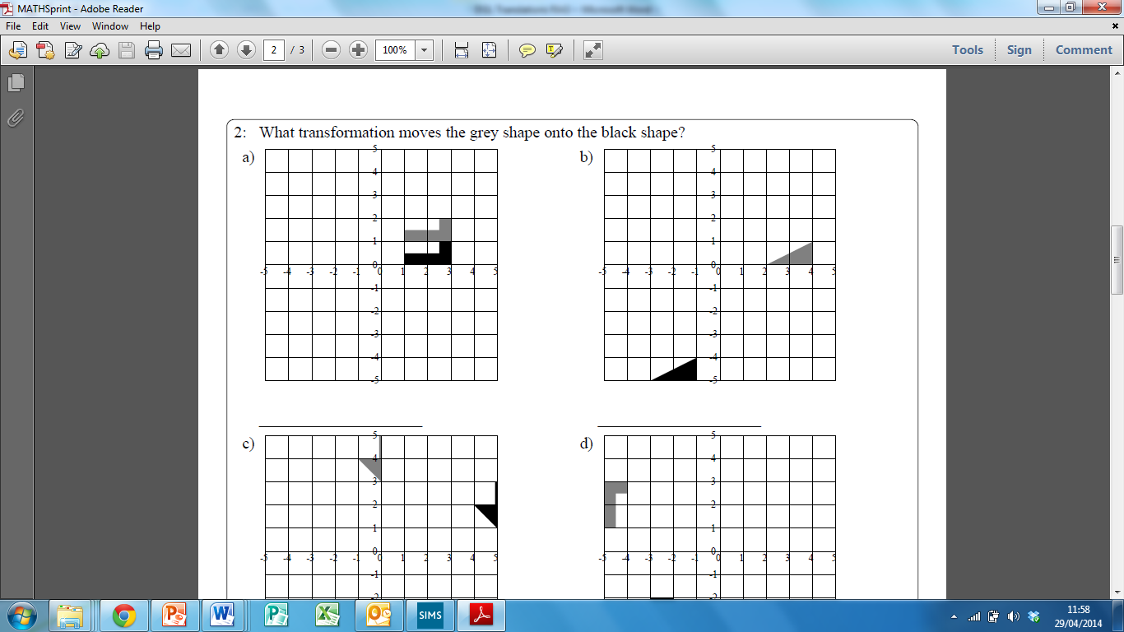 

Translated by  Translated by 

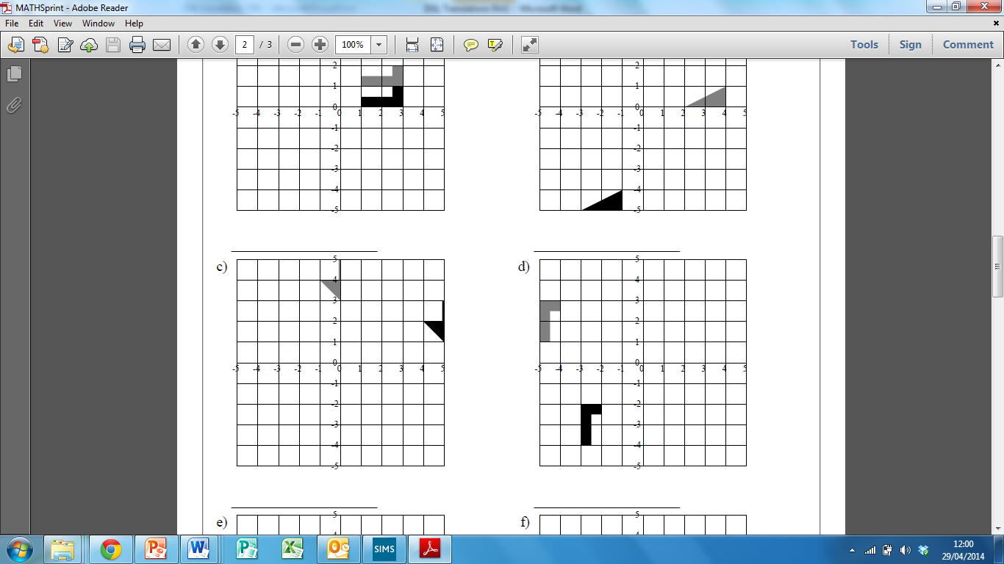 

Translated by  Translated by 

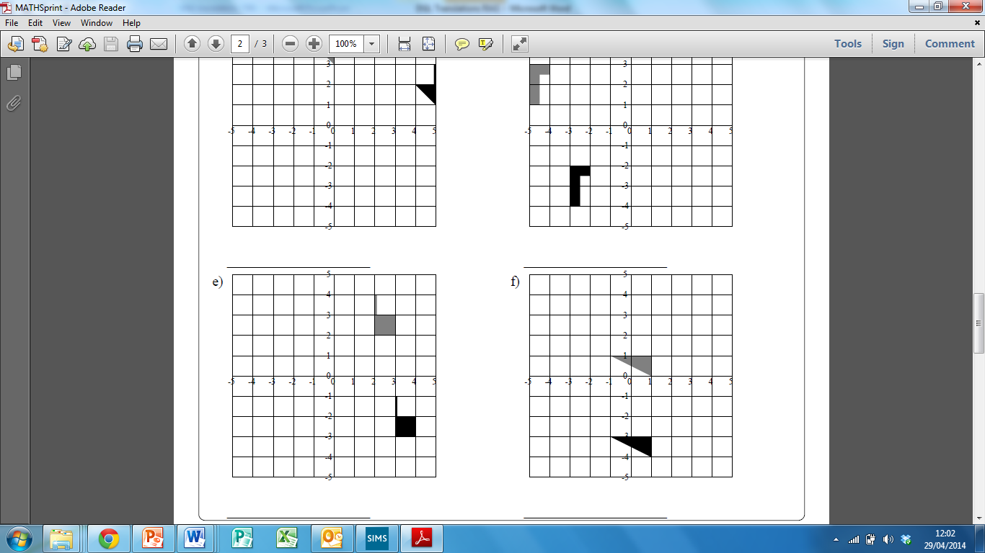 

Translated by  Translated by 

**Translations RED**

1 right

2 down

3 left

4 up

Translate by Translate by

 

1) Pick a vertex to begin with.

2) Translate the vertex by the given column vector.

3) Translate the other vertices by the same vector.

4) Join the vertices to create the translated shape.

Translate by Translate by

 

Translate by Translate by

 

What translations map the grey shape onto the black shape?

 

1) Pick a vertex to begin with.

2) Identify the movement.

3) Identify the movement.

4) Write as a column vector.

Translated by  Translated by 

 

Translated by  Translated by 

 

Translated by  Translated by 