**Transformations (H)**

Pre-Intervention Assessment

Name: _______________________________

Class: _______________________________

Date: _______________________________

|  |  |  |
| --- | --- | --- |
| **Question** | **Objective** | **RAG** |
| 1 | Describe transformations |  |
| 2 | Enlarge shapes (fractional or negative scale factor) |  |
| 3 | Solve problems involving vectors |  |

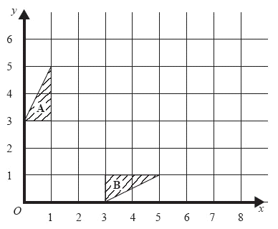**1.** Triangle **A** and triangle **B** have been

drawn on the grid.

Describe fully the single transformation which will map triangle **A** onto triangle **B**

…………………………………………

…………………………………………

**2.** 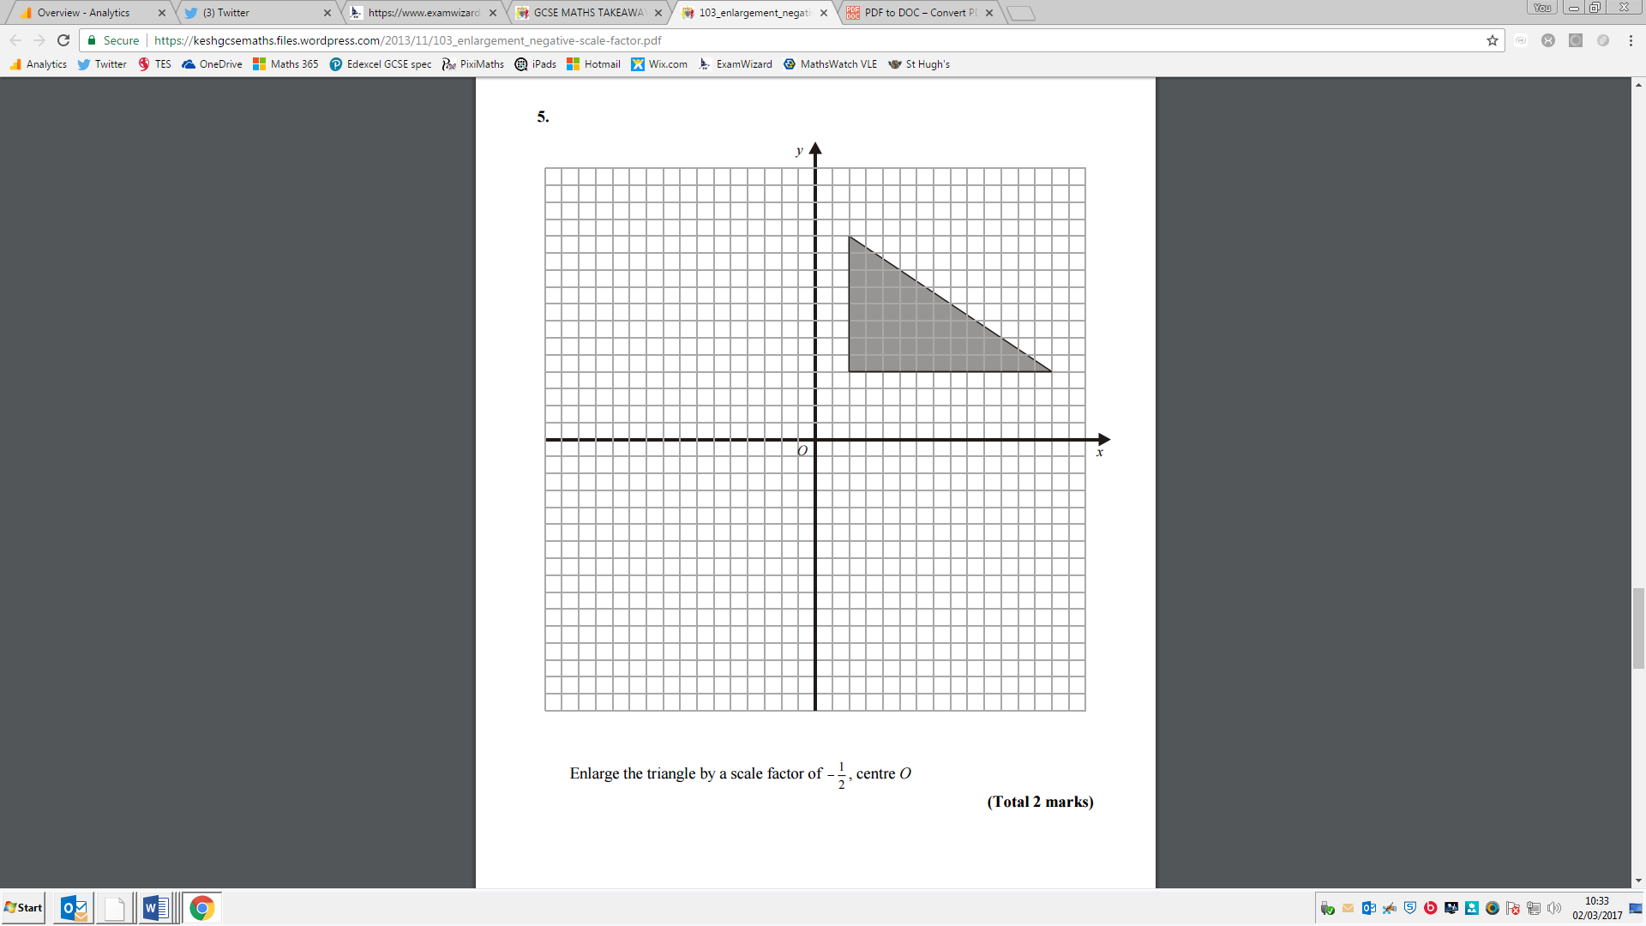Enlarge the triangle by a scale factor of –½, centre *O.*

**3.** *OPQR* is a trapezium with *PQ* parallel to *OR*.

 = 2**b  =** 2**a**  = 6**a**

*M* is the midpoint of *PQ* and *N* is the midpoint of *OR*.

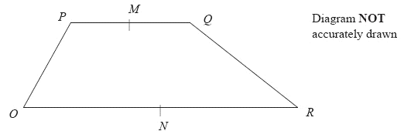

(a) Find the vector  in terms of **a** and **b**.

= ...........................................................



*X* is the midpoint of *MN* and *Y* is the midpoint of *QR.*

(b) Prove that *XY* is parallel to *OR.*

[Glue here]