Numeracy across the Curriculum

A Guide for all Faculties

Contents

Consistency of practice 3
Transfer of skills 4
What students should know 9
- Year 6 9
- Year 9 10
Number 11
- Reading and writing numbers 11
- Order of operations 11
- Calculators 12
- Mental calculations 13
- Written calculations 13
- Percentages 18
Algebra 20
- Compound measures 20
- Plotting coordinates 21
- Axes 21
Data Handling 22
- Bar charts 22
- Line graphs 23
- Pie charts 23
- Using data (averages) 26
- Scatter graphs 28
- Spreadsheets, computer drawn graphs and diagrams 29
Shape, Space and Measures 35
- Shapes 35
- Area 37
- Plans/Elevations 38
- Angles 38
- Bearings 38
- Scale drawing 39
- Units of measure 39
- Transformations 39
Maths glossary 41

Consistency of Practice

The Mathematical Association recommend that teachers of Mathematics and teachers of other subjects co-operate on agreed strategies.
In particular that:

Teachers of mathematics should:

- be aware of the mathematical techniques used in other subjects and provide assistance and advice to other departments, so that a correct and consistent approach is used in all subjects.

- provide information to other subject teachers on appropriate expectations of students and difficulties likely to be experienced in various age and ability groups.

- through liaison with other teachers, attempt to ensure that students have appropriate numeracy skills by the time they are needed for work in other subject areas.

- seek opportunities to use topics and examination questions from other subjects in mathematics lessons

Teachers of subjects other than mathematics should:

- ensure that they are familiar with correct mathematical language, notation, conventions and techniques, relating to their own subject, and encourage students to use these correctly.

- be aware of appropriate expectations of students and difficulties that might be experienced with numeracy skills.

- provide information for mathematics teachers on the stage at which specific numeracy skills will be required for particular groups.

4. provide resources for mathematics teachers to enable them to use examples of applications of numeracy relating to other subjects in mathematics lessons

Transfer of Skills

“It is vital that as the skills are taught, the applications are mentioned and as the applications are taught the skills are revisited.”

The transfer of skills is something that many pupils find difficult. It is essential to start from the basis that pupils realise it is the same skill that is being used; sometimes approaches in subjects differ so much that those basic connections are not made.

Subject areas are more aware of the underlying maths skills and approaches that go with the applications that they use. Some mathematical opportunities across the curriculum are listed below.

Subject | Ideas | Websites
Arts | - Use standard measures to find length  - Form repeating patterns (tessellations), making use of reflection, rotation and translation.  - Use of paint mixing as a ratio context.  - Many patterns and constructions in our own and other cultures are based on spatial ideas and properties of shapes, including symmetry.  - Calculating the golden ratio in pictures/drawings (Mona Lisa)  - Perspective and scale  - Drawing in 3 dimensions
Business Studies | - Estimation from spreadsheets  - Use of mathematical vocabulary e.g. sum, profit  - Sketching graphs to show change over time  - Accurate graph drawing including labelling axes  - Sampling and surveying in market research  - Designing data collection sheets  - Producing and interpreting averages and charts  - Costings  - Ratio  - Formulae  - Awareness of sensible answers – approximate calculation including percentages, fractions, multiplication, division etc.
Design Technology | - Use standard measures (metric and imperial) to find length, mass, time, force, temperature area or capacity.  - Use mathematical symbols and notation, construct and interpret graphs and charts.  - Use scale and ratio to produce drawings.  - Using ruler, compass, protractor correctly  - Using recipes as a ratio/proportion context  - Estimation of quantities or of results of calculations  - Sampling and surveying  - Reading scales on equipment  - Converting between units  - Drawing in 2 dimension or 3 dimensions, including plans and elevations  - Time planning including Gantt charts, timelines etc.  - Pricing the cost of a meal/product
English | - Comparison of 2 data sets on word and sentence length.  - Graph sketching e,g, tension throughout an act of a play  - Use of fractions and percentages in persuasive writing including misleading graphs  - Reading and writing numbers, identifying centuries  - Coding, secret codes  - Grouping/categorising ideas/words
Geography | - Use mathematical symbols and notation, construct and interpret graphs and charts.  - Use grids to identify position (links to co-ordinates and grid references).  - Use negative numbers to interpret below sea level.  - Use standard measures (metric and imperial) to find length, mass, time, force, temperature area or capacity, especially distance and area.  - Discussing evidence in history or geography may involve measurement, estimation and approximation skills, and making inferences.  - Pupils will make statistical enquiries, for example, in analysing population data to explore and compare lifestyles; they will also use a wide range of measurements and rates of change.  - The study of maps includes the use of coordinates and ideas of angle, direction, position, scale and ratio. | http://motivate.maths.org/content/node/110
Global Education | - Use mathematical symbols and notation, construct and interpret graphs and charts.  - Use standard measures (metric and imperial) to find length, mass, time, force, temperature area or capacity.  - Use timelines and interpret negative numbers.  - Consider infinity and the meaning of this conceptually  - Reflect on logic and the process of constructing a sound argument  - Belief and likelihood in religious education, or risk assessment in PSHE, relate well to work in mathematics. The discussion of moral and social issues is likely to lead to the use of primary and secondary data and the interpretation of graphs, charts and tables, helping pupils to make reasoned and informed decisions and to recognise biased data and misleading representations. By applying mathematics to problems set in financial and other real-life contexts, pupils will develop their financial capability and awareness of the applications of mathematics in the workplace.
History | - Use timelines and interpret negative numbers. (AD and BC)  - Use fractions and percentages to express and compare proportions  - Use scale to interpret maps and diagrams  - Use mathematical symbols and notation, construct and interpret graphs and charts. | http://motivate.maths.org/content/resources/maths-history
ICT | - Use mathematical symbols and notation (sigma for sum), construct and interpret graphs and charts.  - Use formulae to calculate and to interpret data in spreadsheets.  - In ICT lessons, pupils will collect and classify data, enter them into data-handling software, produce graphs and tables, and interpret and explain their results. Their work in control will include the measurement of distance and angle.  - Spreadsheet skills, used in modelling and simulations, rely on the numeric, algebraic and graphical skills involved in constructing formulae and generating sequences, functions and graphs. | http://motivate.maths.org/content/resources/maths-ICT
MFL | - Use dates, sequences and counting in other languages;  - Use basic graphs and surveys to practise foreign language vocabulary and reinforce interpretation of data.  - Use of and calculation with money  - Conversion/exchange rates  - Directions
Music | - Use addition of fractions in bar music  - Use counting for beats  - Use sound waves, frequency and oscillations  - Use graph sketching to demonstrate change over time e.g. in dynamics over a piece | http://motivate.maths.org/content/node/130
PE | - Use time, height and distance in measurements.  - Telling the time, timekeeping  - Reading from scales using measuring equipment  - Calculation of speed, acceleration, deceleration and graphing of these over time during an action/event  - Use fractions to identify time.  - Design data collection sheets.  - Collect and record real data, find the averages, compare and draw conclusions.  - Sequencing results (decimals, lengths etc)  - Scoring  - Athletic activities use measurement of height, distance and time, and data-logging devices to quantify, explore, and improve performance.  - Ideas of counting, time, symmetry, movement, position and direction are used extensively in music, dance, gymnastics, athletics and competitive games. E.g. angles, rotation, planes, axes | http://motivate.maths.org/content/node/131
Science | - Use formulae to calculate work, power, mass, density  - Rearrange formulae  - Use graphs to represent data, interpretation of graphs  - Estimating quantities or results of calculations  - Use standard measures to find length, mass, time, force, temperature, area or capacity;  - Hypothesise before an experiment, consider limitations to findings afterwards  - Manipulate numerical data from their experiments and do calculations including averages;  - Record results in tables – choose appropriate form and design data collection sheets  - Use mathematical symbols and notation, construct and interpret graphs and charts.  - Constructing graphs, extrapolating, recognising patterns  - Take readings from scales.

At the beginning of year 7, pupils should:

- have a sense of the size of a number and where it fits in the number system

- know number bonds by heart e.g. tables, doubles and halves

- use what they know by heart to work out answers mentally

- calculate accurately & efficiently using a variety of strategies, both written & mental

- recognise when AND when not to use a calculator; using it efficiently if needs be

- make sense of number problems, including non-routine problems, and recognise the operations needed to solve them

- explain their methods and reasoning using correct mathematical terms

- judge whether their answers are reasonable, and have strategies for checking

- suggest suitable units for measuring

- make sensible estimates for measurements

- explain and interpret graphs, diagrams, charts and tables

- use the numbers in graphs, diagrams, charts and tables to predict.

At the beginning of year 9, pupils should:

- have a sense of the size of a number and where it fits into the number system;

- recall mathematical facts confidently;

- calculate accurately and efficiently, both mentally and with pencil and paper, drawing on a range of calculation strategies;

- use proportional reasoning to simplify and solve problems;

- use calculators and other ICT resources appropriately and effectively to solve mathematical problems, and select from the display the number of figures appropriate to the context of a calculation;

- use simple formulae and substitute numbers in them;

- measure and estimate measurements, choosing suitable units and reading numbers correctly from a range of meters, dials and scales;

- calculate simple perimeters, areas and volumes, recognizing the degree of accuracy that can be achieved;

- understand and use measures of time and speed, and rates such as £ per hour or miles per litre;

- draw plane figures to given specifications and appreciate the concept of scale in geometrical drawings and maps;

- understand the difference between the mean, median and mode and the purpose for which each is used;

- collect data, discrete and continuous, and draw, interpret and predict from graphs, diagrams, charts and tables;

- have some understanding of the measurement of probability and risk;

- explain their methods, reasoning and conclusions, using correct mathematical terms;

- judge the reasonableness of solutions and check them when necessary;

- give their results to a degree of accuracy appropriate to the context.

Section 1 – Number

Reading and writing numbers

Pupils must be encouraged to write numbers simply and clearly. The symbol for zero with a line through it (∅), ones which could be mistaken for 7 (1) and continental sevens ( 7) should be discouraged.
Most pupils are able to read, write and say numbers up to a thousand, but often have difficulty with larger numbers. It is now common practice to use spaces rather than commas between each group of three figures. eg. 34 000 not 34,000 though the latter will still be found in many text books and cannot be considered incorrect.

In reading large figures pupils should know that the final three figures are read as they are written as hundreds, tens and units.
Reading from the left, the next three figures are thousands and the next group of three are millions.

eg. 3 027 251 is three million, twenty seven thousand and fifty one.

Order of Operations

It is important that pupils follow the correct order of operations for arithmetic calculations. Most will be familiar with the mnemonic: BIDMAS.

Brackets, Indices, Division, Multiplication, Addition, Subtraction

Not: Indices is another word for powers. It includes squares, cubes, roots, and other higher, fractional and negative powers.

This shows the order in which calculations should be completed. eg
5 + 3 x 4
NOT 5 + 3 x 4
means 8 x 4
means
5 + 12
= 17 = 32 x

The important facts to remember are that the Brackets are done first, then the Indices, Multiplication and Division and finally, Addition and Subtraction.

eg(i) ( 5 + 3 ) x 4
= 8 x 4
= 32

eg (ii) 5 + 6² ÷ 3 – 4
= 5 + 36 ÷ 3 – 4
= 5 + 12 – 4
= 17 – 4
= 13

Care must be taken with Subtraction.

eg 5 + 12 – 4 or 5 + 12 – 4
= 17 – 4 = 5 + 8
= 13 = 13 x

eg 5 –12 + 4 but 5 –12 + 4 ¹
= -7 + 4 = 5 – 16
= -3 = -11 x

For this to be correct it would have to be written: 5 – (12 + 4) so that the bracket is worked out first.

Calculators

Some pupils are over-dependent on the use of calculators for simple calculations. Wherever possible pupils should be encouraged to use mental or pencil and paper methods. It is, however, necessary to give consideration to the ability of the pupil and the objectives of the task in hand. In order to complete a task successfully it may be necessary for pupils to use a calculator for what you perceive to be a relatively simple calculation. This should be allowed if progress within the subject area is to be made. Before completing the calculation pupils should be encouraged to make an estimate of the answer. Having completed the calculation on the calculator they should consider whether the answer is reasonable in the context of the question.

Mental Calculations

Most pupils should be able to carry out the following processes mentally though the speed with which they do it will vary considerably.

- recall addition and subtraction facts up to 20

- recall multiplication and division facts for tables up to 12 x 12.

Pupils should be encouraged to carry out other calculations mentally using a variety of strategies but there will be significant differences in their ability to do so. It is helpful if teachers discuss with pupils how they have made a calculation. Any method which produces the correct answer is acceptable.

eg 53 + 19 = 53 + 20 – 1

284 – 56 = 284 – 60 + 4

32 x 8 = 32 x 2 x 2 x 2

76 ÷ 4 = (76 ÷ 2) ÷ 2

Written Calculations

Pupils often use the ‘ = ‘ sign incorrectly. When doing a series of operations they sometimes write mathematical sentences which are untrue.

eg 5 x 4 = 20 + 3 = 23 – 8 = 15 since 5 x 4 15

It is important that all teachers encourage pupils to write such calculations correctly.

eg 5 x 4 = 20
20 + 3 = 23
23 – 8 = 15

The ‘ = ‘ sign should only be used when both sides of an operation have the same value. There is no problem with a calculation such as:

43 + 57 = 40 + 3 + 50 + 7 = 90 + 10 = 100

since each part of the calculation has the same value.
The ‘≈‘ (approximately equal to) sign should be used when estimating answers.

eg 2 378 – 412 ≈ 2 400 – 400

2 400 – 400 = 2 000

All pupils should be able to use some pencil and paper methods involving simple addition, subtraction, multiplication and division. Some less able pupils will find difficulty in recalling multiplication facts to complete successfully such calculations. In these circumstances it may be more useful to use a calculator in your subject to complete the task.

Before completing any calculation, pupils should be encouraged to estimate a rough value for what they expect the answer to be. This should be done by rounding the numbers to one significant figure and mentally calculating the approximate answer.

After completing the calculation they should be asked to consider whether or not their answer is reasonable in the context of the question.

There is no necessity to use a particular method for any of these calculations and any with which the pupil is familiar and confident should be used. Many families of schools are now discussing and beginning to agree common methods across schools.

The following methods are some with which pupils may be familiar.

Addition Estimate

3 456 + 975 3 500 + 1 000 = 4 500

3 456
+ 975
4 431
¹ ¹ ¹

Subtraction
Estimate
₇ ₉ ₉ ₁ 8 000 – 3 000 = 5000
eg 8 0 0 3
-2 5 6 9
5 4 3 4

Addition and subtraction of decimals is completed in the same way but reminders may be needed to maintain place value by keeping decimal points in line underneath each other.

Multiplication and Division by 10,100,1000…

When a number is multiplied by 10 its value has increased tenfold and each digit will move one place to the left so multiplying its value by 10. When multiplying by 100 each digit moves two places to the left, and so on… Any empty columns will be filled with zeros so that place value is maintained when the numbers are written without column headings.
The decimal point does not move - the numbers do.

eg. 46 x 100 = 4 600

Th | H | T | U
 |  | 4 | 6
4 | 6 | 0 | 0

The same method is used for decimals.

eg. 5.34 x 10 = 53.4

H | T | U | . | t | h
 |  | 5 | . | 3 | 4
 | 5 | 3 | . | 4

Empty spaces after the decimal point are not filled with zeros. The place value of the numbers is unaffected by these spaces.

When dividing by 10 each digit is moved one place to the right so making it smaller.

eg. 350 ÷ 10 = 35

H | T | U | . | t | h
3 | 5 | 0 | .
 | 3 | 5 | .

eg. 53 ÷ 100 = 0.534

H | T | U | . | t | h
 | 5 | 3 | .
 |  | 0 | . | 5 | 3

When the calculation results in a decimal the units column must be filled with a zero to maintain the place value of the numbers.
Multiplication

3 2 7
x 5 3
9 8₂ 1 327 x 3
1 6₁3₃ 5 0 327 x 50
1 7 3 3 1

Conventional multiplication as set out above may not suit all pupils and teachers should be aware that other methods may be employed by some pupils.

eg(i) 327 x 53 Estimate: 300 x 50 = 15 000

X | 300 | 20 | 7 | Total
50 | 15 000 | 1000 | 350 | 16 350
3 | 900 | 60 | 21 | 981
Total | 15900 | 1060 | 371 | 17331

eg(ii) 456 X 24 Estimate: 450 x 20 = 9 000

- 456 9120
x 20 x 4 + 1824
9120 + 1824 10 924
1 1 2 2

Division

 |  |  | 2 | 7
1 | 3 | 3 | 5 | 1
 | - | 2 | 6 | 0
 |  |  | 9 | 1
 | - |  | 9 | 1
 |  |  |  | 0

Chunking
is a method for Long Division with which some pupils will be familiar and is based on recall of multiplication of numbers by 5,10, 20 etc. followed by continuous subtraction.

eg 351 ÷ 13

 |  |  | 2 | 7
1 | 3 | 3 | 5 | 1
 | - | 1 | 3 | 0 | 1 | 0
 |  | 2 | 2 | 1
 | - | 1 | 3 | 0 | 1 | 0
 |  |  | 9 | 1
 |  | - | 5 | 2 |  | 4
 |  |  | 3 | 9
 |  | - | 3 | 9 |  | 3
 |  |  |  | 0 | 2 | 7

Any remainders in this type of calculation should be written as a fraction by dividing the remainder by the number by which the calculation has been divided.

Multiplying Decimals

- As always, estimate the answer.
- Complete the calculation as if there were no decimal points.
- In the answer insert a decimal point so that there are the same number of decimal places in the answer as there were in the original question.
- Check to see if the answer is reasonable
eg (i) 1.2 x 0.3 ≈ 1 x 0.3 = 0.3

Ignoring the decimal points, this will be calculated as 12 x 3 = 36 and will now need two decimal places in the answer.

∴1.2 x 0.3 = 0.36

Similarly:
eg (ii) 43.14 x 3.5 ≈ 40 x 4 = 160

 | 4 |  | 3 | . | 1 | 4 | (2 decimal places)
x |  |  |  | 3 | . | 5 | (1 decimal place)
 | 2 |  | 1 | 5 | 7 | 0
1 | 2 |  | 9 | 4 | 2 | 0
1 | 5 | 0. |  | 9 | 9 | 0 | (3 dp needed in the answer)

Percentages

Whilst pupils should be familiar with many operations involving percentages in mathematics lessons it is not proposed to elaborate on all of them in this booklet. The following is a sample of operations which pupils will be expected to use in other areas. It is important to reiterate that “per cent” means “out of 100” (compare to century, Cents in a dollar etc).

Calculating percentages of a quantity

Methods for calculating percentages of a quantity vary depending upon the percentage required. Pupils should be aware that fractions, decimals and percentages are different ways of representing part of a whole and know the simple equivalents

eg 10% = ¹/₁₀ 12% = 0.12

Where percentages have simple fraction equivalents, fractions of the amount can be calculated.

eg. i) To find 50% of an amount, halve the amount.
ii)To find 75% of an amount, find a quarter by dividing
by four and then multiply it by three.

Most other percentages can be found by finding 10%, by dividing by 10, and then finding multiples or fractions of that amount

eg. To find 30% of an amount first find 10% by dividing the
amount by 10 and then multiply this by three.
30% = 3x10%
Similarly: 5% = half of 10% and 15% = 10% + 5%
Most other percentages can be calculated in this way.

When using the calculator it is usual to think of the percentage as a decimal. Pupils should be encouraged to convert the question to a sentence containing mathematical symbols. (‘of’ means X)
eg. Find 27% of £350 becomes
0.27 X £350 =
and this is how it should be entered into the calculator.

Calculating the amount as a percentage

In every case the amount should be expressed as a fraction of the original amount and then converted to a percentage in one of the following ways:

- What is 15 as a percentage of 60?
(using simple fractions)

15 | = | 1 | = | 25%
60 |  | 4

- What is 27 out of 50 as a percentage?
(using equivalent fractions)

27 x 2 | = | 54 | = | 54%
50 x 2 |  | 100

- What is 39 as a percentage of 57?
(Using a calculator)

39 | = 39 ÷ 57 = 0.684 (to 3 d.p.) = 68.4%
57
Section 2 – Algebra

The most common use of algebra across the curriculum will be in the use of formulae.

When transforming formulae pupils will be taught to use the ‘balancing’ method where they do the same to both sides of an equation.
eg (i) A = lb Make b the subject of the formula
[÷l] A = b
l
However , in some cases triangles can be useful for specific cases.

Compound Measures

For example with Mass, Density and Volume:

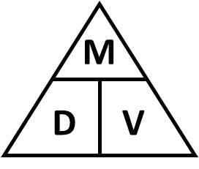

Density = Mass , Mass = Density x Volume , Volume = Mass
Volume Density

Similarly with Distance, Speed and Time:

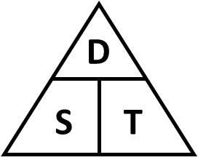

Speed = Distance , Distance = Speed x Time , Time = Distance
Time Speed

Plotting Points Coordinates

When drawing a diagram on which coordinates have to be plotted some pupils will need to be reminded that the numbers written on the axes must be on the lines not in the spaces.

eg
0 1 2 3 4 5 6

NOT
0 1 2 3 4 5 x

Axes

When drawing graphs to represent experimental data it is usual to use the horizontal axis for the variable which has a regular class interval.

eg In an experiment in which temperature is taken every 5 minutes the horizontal axis would be used for time and the vertical axis for temperature.

Having plotted coordinates pupils can sometimes be confused as to whether or not they should join them. If the results are from an experiment then a ‘line of best fit’ will usually be needed. Further details appear in the following section on Data Handling.

Section 3 – Data Handling

It is important that graphs and diagrams are drawn on the appropriate paper:
- bar charts and line graphs on squared or graph paper.
- pie charts on plain paper.

Any such work needs to be embedded in the data handling cycle.

If learners understand this cycle, then they will see how the work they are doing at home is a part of something bigger, something that will give them the chance to answer questions that they are interested in. Hence the starting point is not ‘Let’s gather some data’ but ‘Have we got a problem we want to investigate?

Bar Charts

These are the diagrams most frequently used in areas of the curriculum other than mathematics. The way in which the graph is drawn depends on the type of data to be processed.

Graphs should be drawn with gaps between the bars if the data categories are not numerical (colours, makes of car, names of pop star, etc). There should also be gaps if the data is numeric but can only take a particular value – DISCRETE DATA (shoe size, KS3 level, etc). In cases where there are gaps in the graph the horizontal axis will be labelled beneath the columns.

The labels on the vertical axis should be on the lines.

eg.

Where the data are CONTINUOUS, eg. lengths, the horizontal scale should be like the scale used for a graph on which points are plotted.

eg
0 10 20 30 40 50 60

NOT
0 10 20 30 40 50 x

Line Graphs

Line graphs should only be used with data in which the order in which the categories are written is significant.

Points are joined if the graph shows a trend or when the data values between the plotted points make sense to be included. For example the measure of a patient’s temperature at regular intervals shows a pattern but not a definitive value.

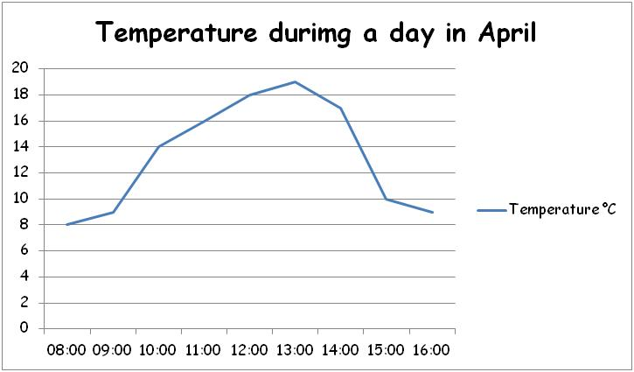

Pie Charts

Pie charts should be used to show how the data is split up between the different categories. The area of the whole circle represents the total number of items.

The way in which pupils should be expected to work out angles for a pie chart will depend on the complexity of the question. If the numbers involved are simple it will be possible to calculate simple fractions of 360°.

eg. The following table shows the results of a survey of 30 pupils travelling to school. Show this information on a pie chart.

Mode of Transport | Frequency | Fraction | Angle
Walk | 10 |  | 120º
Train | 3 |  | 36º
Car | 5 |  | 60º
Bus | 6 |  | 72º
Other | 6 |  | 72º
Total | 30 | 1 | 360º

However, with more difficult numbers which do not readily convert to a simple fraction pupils should first work out the share of 360° to be allocated to one item and then multiply this by its frequency.

eg. 180 pupils were asked their favourite core subject.

Each pupils has 360 ÷ 180 = 2° of the pie chart.

Subject | Number of pupils | Pie Chart Angle
English | 63 | 63 x 2 = 126º
Mathematics | 75 | 75 x 2 = 150º
Science | 42 | 42 x 2 = 84º
Total | 180 | 360º

If the data is in percentage form each item will be represented by 3.6° on the pie. To calculate the angle pupils will need to multiply the frequency by 3.6.

eg. 43% will be represented by 43 X 3.6 = 154.8°
≈ 155°

Any calculations of angles should be rounded to the nearest degree only at the final stage of the calculation. If the number of items to be shown is 47 each item will need:

360 ÷ 47 = 7.659574468°

This complete number should be used when multiplying by the frequency and then rounded to the nearest degree.

Care needs to be taken when using a pair of compasses. Students should hold the pivot (not the arms) when drawing a circle to ensure precision. The pencil must be level with the point of the compass.

Ensure when using a protractor that students measure from 0º, not 180º (compare to a ruler – you wouldn’t measure a line starting from 30cm!)

Using Data

Range

The range of a set of data is the difference between the highest and the lowest data values.

eg. If in an examination the highest mark is 80% and the lowest
mark is 45%, the range is 35% because 80% - 45% = 35%

The range is always a single number , so it is NOT 45% - 80%

Averages

Three different averages are commonly used:
- Mean – is calculated by adding up all the values and dividing by the number of values.
- Median – is the middle value when a set of values has been arranged in order.
- Mode - is the most common value. It is sometimes called the modal group.

eg. for the following values: 3, 2, 5, 8, 4, 3, 6, 3, 2,
Mean = 3 + 2 + 5 + 8 + 4 + 3 +6 + 3 + 2 = 36 = 4
9 9
Median – is 3 because 3 is in the middle when the values are put in order.
2, 2, 3, 3, 3, 4, 5, 6, 8
Mode - is 3 because 3 is the value which occurs most often.

Averages from a frequency table

It is often convenient to put data into frequency tables.
- The mode can still be identified as the value with the highest frequency.
- The median can be identified by locating the ($\frac{n+1}{2}$)^{th} value in the frequency table, and which category it falls into.
- The mean can be found using the formula $\frac{Σfx}{Σf}$, where f is the frequency, x is the variable and Σ means “the sum of”.

Number of goals (x) | Frequency (f) | Goals x frequency (fx)
0 | 8 | 0
1 | 15 | 15
2 | 12 | 24
3 | 7 | 21
4 | 3 | 12
5 | 1 | 5
Total (Σ) | 46 | 77
Eg.

Mean = $\frac{Σfx}{Σf}$ = $\frac{77}{46}$ = 1.67 goals
Mode = 1 goal (highest frequency)
Median = The total frequency is 46 so the median will be the 23.5th value, that is halfway between the 23rd and 24th value.
There were 8 games with no goals scored.
There were 15 + 8 = 23 games with 0 or 1 goals scored.
This means that the 23rd value is 1, the 24th value is 2, so the median is 1.5 goals.

Averages from a grouped frequency table

Similar rules apply for continuous data and grouped frequency tables, although our results will be less accurate. We can only find the modal class and the median class rather than an accurate mode and median, and we can only calculate an estimate for the mean. As the variable (x) is now a group, it is necessary to use the middle value of each class interval.

Eg.
Speed (s mph) | Frequency (f) | Class width (x) | Speed x frequency (fx)
20 ≤ s < 25 | 4 | 22.5 | 90
25 ≤ s < 30 | 10 | 27.5 | 275
30 ≤ s < 35 | 12 | 32.5 | 390
35 ≤ s < 40 | 315 | 37.5 | 562.5
40 ≤ s < 45 | 9 | 42.5 | 382.5
Total (Σ) | 50 |  | 1700

Estimate for the mean = $\frac{Σfx}{Σf}$ = $\frac{1700}{50}$ = 34 mph
The modal class is 35 ≤ s < 40.
The median falls in the class 30 ≤ s < 35.

Scattergraphs

These are used to compare two sets of numerical data. The two values are plotted on two axes labelled as for continuous data. If possible a ‘line of best fit’ should be drawn.

The degree of correlation between the two sets of data is determined by the proximity of the points to the ‘line of best fit’

The above graph shows a positive correlation between the two variables. However you need to ensure that there is a reasonable connection between the two, e.g. ice cream sales and temperature. Plotting use of mobile phones against cost of houses will give two increasing sets of data but are they connected?

Negative correlation depicts one variable increasing as the other decreases, no correlation comes from a random distribution of points. See diagrams below.

Speadsheets, Computer Drawn Graphs & Diagrams

Pupils throughout the school should be able to use Excel or other spreadsheets to draw graphs to represent data. Because it is easy to produce a wide variety of graphs there is a tendency to produce diagrams that have little relevance. Pupils should always be encouraged to write a comment explaining their observations from the graph.

Formulas

Every formula that you use in Excel must start with “=”
Each entry into the spreadsheet has a cell reference, eg. cell B13 which has a value of £55.
The advantage of using formulas in Excel rather than writing in the values is that the answer changes if the original data does. All calculations are then done automatically for you.
Simple formulas

To work out the total price of G and E (column D), which will be £45 +£34, you need to find out the cell reference for each part of the equation. £45 is B2 and £34 is C2. You are going to write the formula in D2.
So the formula that you will input into cell D2 is “=B2+C2”, which will produce the answer.
You are going to use the same formula for the whole of column D.

If you click on the little black dot in the corner of cell D2 and drag it down to cell D13, the formula will replicate, saving you from inputting the formula into every cell.

The following formulas have the same format as the addition formula.
Subtraction example: “=B2-C2”
Multiplication example: “=B2*C2”
Division example: “=B2/C2”

To work out the Total Price of Gas used that year. You need to use the formula
“=SUM(B2:B13)”
To work out the Total price of electric that year
“=SUM(C2:C13)”

Average, Minimum and Maximum Formulas

To work out the minimum value of a set of data you need to use “=MIN(_:_)”.
Eg. To find the minimum value for electric that year, you use the formula “=MIN(C2:C13)”

To work out the maximum value of a set of data you need to use “=MAX(_:_)”
Eg. To find out the maximum value for gas that year, you use the formula “=MAX(B2:B13)”

To work out the average value for a set of data you need to use “=AVERAGE(_:_)”
Eg. To find out the average value for gas used that year, you use the formula “=AVERAGE(B2,B13)”

Creating graphs in Excel

To create a graph in Excel you need to highlight the data that you wish to have in your graph. You do this by holding the left hand button on the mouse and dragging over the data.
Eg. You want to create a graph that shows you the gas and electric prices all the months in the year.

2. Select the graph you wish to create.
- Once you have selected the data, you need to click on insert on the toolbar.

Once you have selected the graph type, the graph will automatically come up on your spreadsheet.
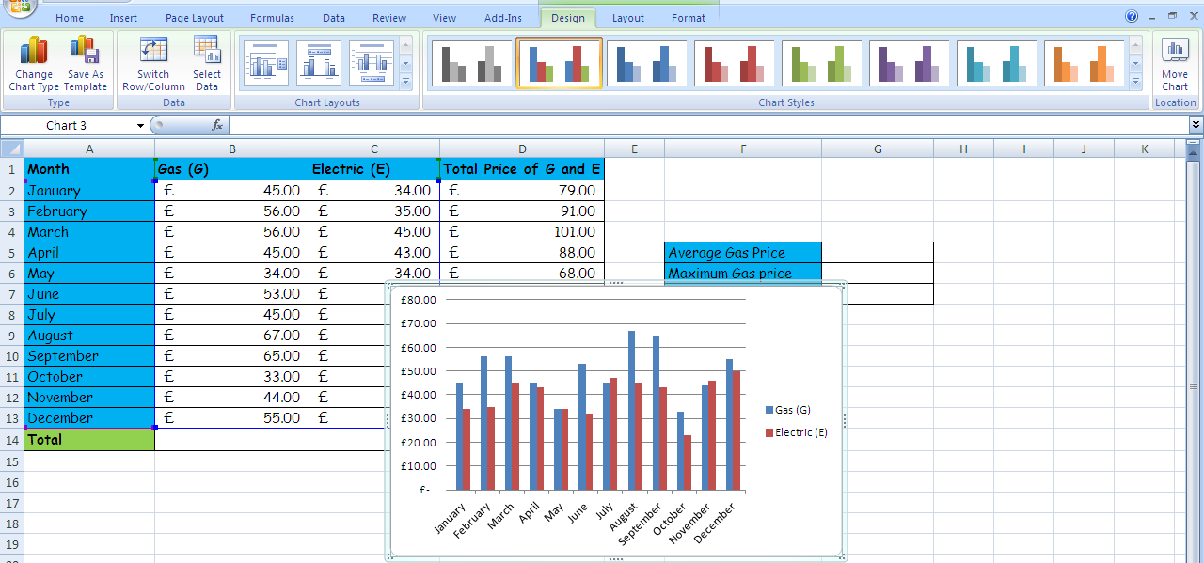

To label the axis, and change the colours of the graph you need to click on the following buttons in the toolbar.

Clicking on the layout button on the toolbar will enable you to label your graph and axis.
Clicking on the design button will enable you to change the colours of the graph.

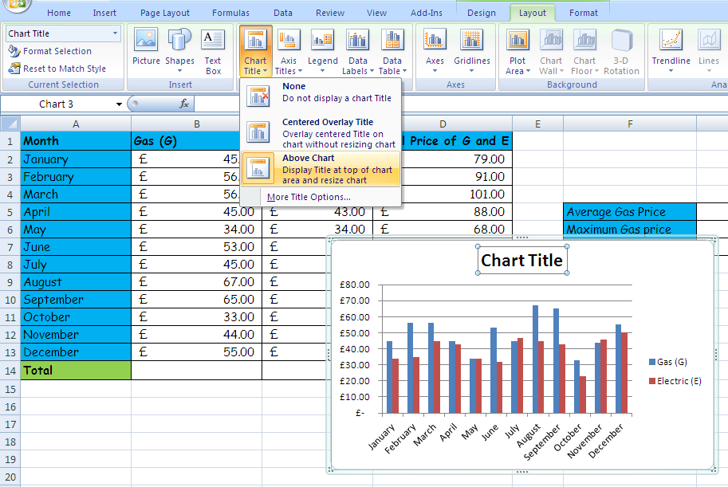
2. Double click on ‘Chart title’ and enter your title.
- Select chart Title and select where you want your title to go on the graph

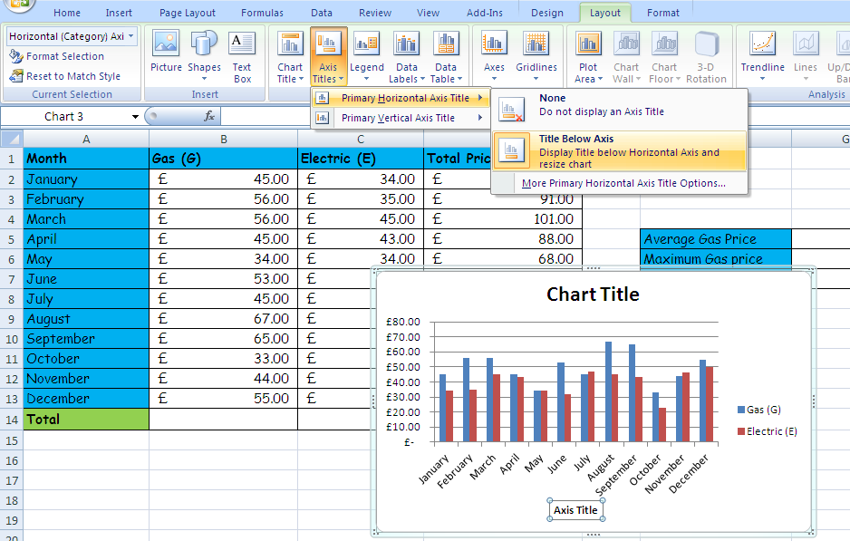

2. Double click on ‘axis title’ and enter your axis title.
Select axis title from the toolbar and select which axis you wish to label, then select where you want to put the label.

Section 4 – Shape, Space and Measure

Shapes

It is important to use correct names of shapes. 2D and 3D shapes and their properties are below.

2D Shapes

A polygon is a 2D shape consisting of 3 or more straight sides. A regular polygon has all sides and angles the same size. Specific names of polygons are shown below the table.

Number of sides | Name of polygon
3 | Triangle
4 | Quadrilateral
5 | Pentagon
6 | Hexagon
7 | Heptagon
8 | Octagon
9 | Nonagon
10 | Decagon

Some triangles have special names:

Equilateral triangle Isosceles triangle Scalene triangle
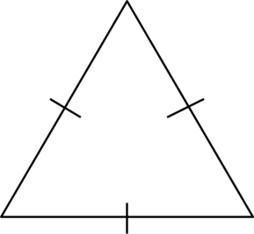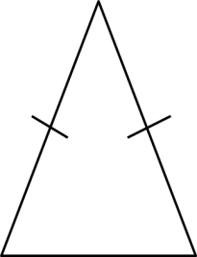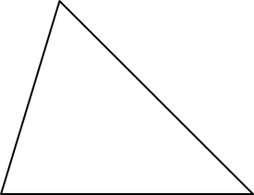
All sides and angles Two sides and two All sides and angles are
are equal. angles are equal. different.

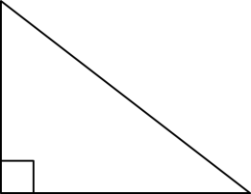
Right-angled triangle
One angle is a right angle (90º)

Some quadrilaterals have special names:

Square Rectangle Parallelogram
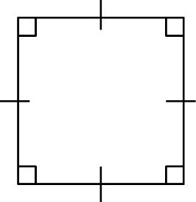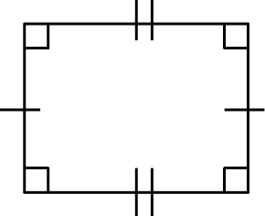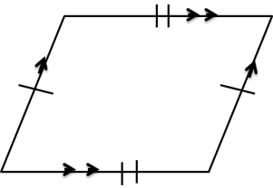
All sides are the Opposite sides are the Opposite sides are parallel
same length and same length and all and the same length.
all angles are 90º angles are 90º Opposite angles are
the same.

Trapezium Kite Rhombus (NOT diamond)
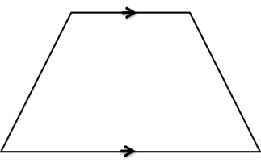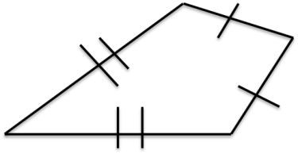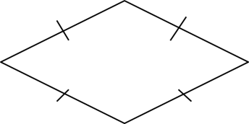
One pair of opposite Two pairs of adjacent All sides are the same
sides are parallel. sides are equal. length.
One pair of opposite Opposite angles are equal.
angles are equal.

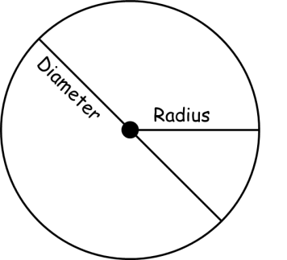
A circle has a radius which goes from the centre to the edge, and the diameter which is twice the length of the radius, and goes from side to side passing through the centre.

3D shapes

The flat surfaces of a 3D shape are called faces. The lines where two faces meet are called edges. The point (corner) at which edges meet is called a vertex. The plural of vertex is vertices. Some 3D shapes and their properties are below.

Cube Cuboid Cylinder
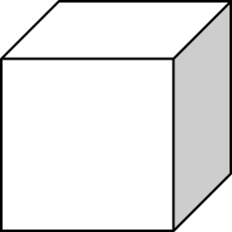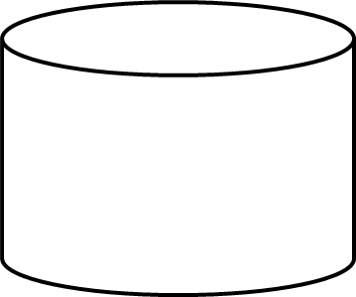
6 faces, 12 edges 6 faces, 12 edges 3 faces, 2 edges and
and 8 vertices. and 8 vertices. no vertices.
Sphere Cone Tetrahedron
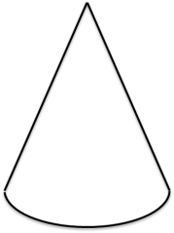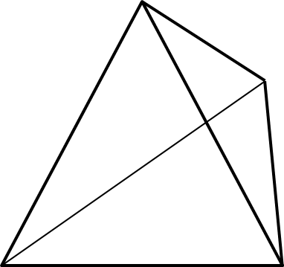
1 face, no edges 2 faces, 1 edge 4 faces, 6 edges
and no vertices. and 1 vertex. and 4 vertices.

Square-based pyramid Triangular prism Hexagonal prism
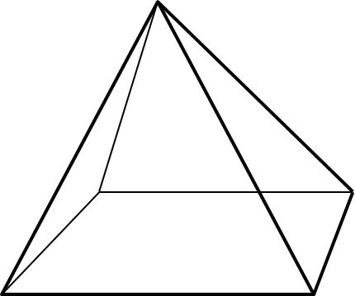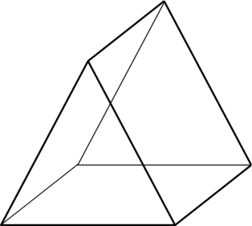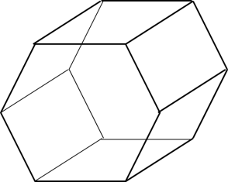
5 faces, 8 edges 5 faces, 9 edges 8 faces, 18 edges
And 5 vertices. and 6 vertices. and 12 vertices.

Area

Area of Squares and Rectangles Area of Triangles
= base x height = ½ x base x height

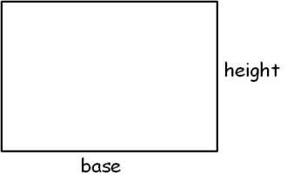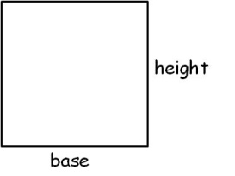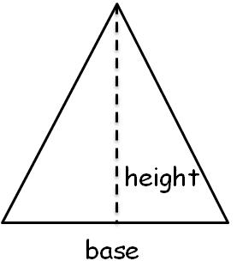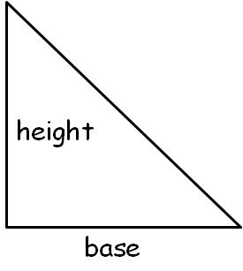

Area of Parallelograms Area of Trapeziums
= base x height = ½ x (a + b) x height

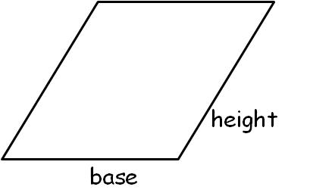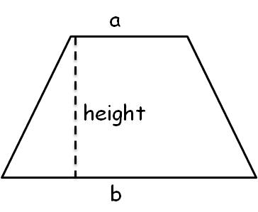

Surface Area
Surface area is the area of the surface of a 3D shape. To calculate the surface area, calculate the area of every face of the shape, then add those areas together.

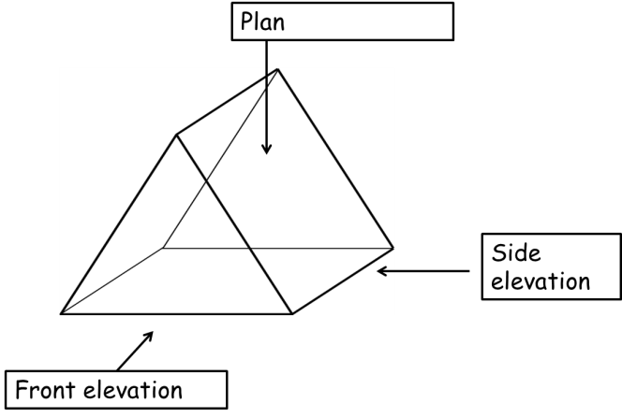
Plans/elevations

Plans and elevations can be drawn for
any 3D shape.

The view from
above is called
the plan:

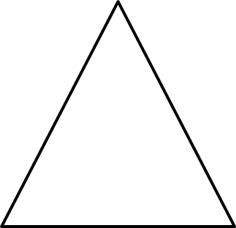
The view from the The view from the
front is called the side is called the
front elevation: side elevation:

Angles

An angle is a measure of a turn. They are measured in degrees, for example, 60º. There are different types of angle.
Acute Obtuse Reflex Right angle
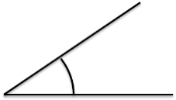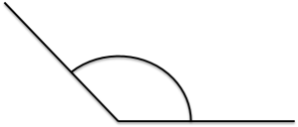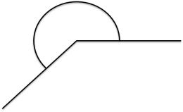
Less than 90º More than 90º but More than 180º but Exactly 90º
less than 180º less than 360º

Angles are measured using a protractor. It is important to emphasise that you measure from zero.

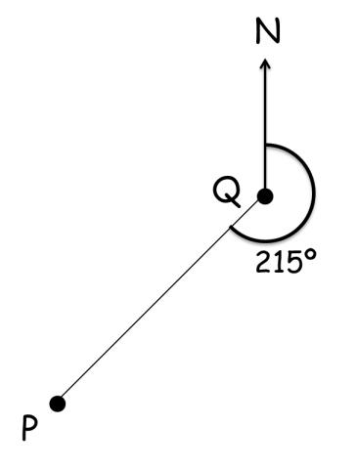
Bearings

Bearings are used to describe directions with angles. They are more precise than using North, South, East and West. Bearings are always measure clockwise, from the North line and must have 3 digits. For example 50º must be written as 050º.

Scale drawing

Maps and plans are accurate drawings from which measurements can be made. A scale is a ratio which shows the relationship between the length of the drawing (or model) and the length in real life.

Units of measure

The use of metric units of measure is encouraged. The metric system of measurement is based on powers of ten and uses the following prefixes:
- Kilo- meaning 1000
- Centi- meaning one hundredth
- Milli- meaning one thousandth
- Micro- meaning one millionth
These prefixes are then followed by a base unit:
- The base unit for length is metre
- The base unit for mass is gram
- The base unit for capacity is litre

Transformations

There are four main transformations.

Reflection

Images of shapes that are formed by reflecting a given shape about a line of reflection (or mirror line) are called reflections of the shapes. Lines of symmetry can be identified in images where reflection has already taken place. When an object is reflected, the lengths and the angles remain the same.

Rotation

A rotation can be described as a fraction of a turn or as an angle of a turn. The direction can be described as clockwise or anticlockwise. The point about which the shape is turned is called the centre of rotation and is often given as a coordinate. When an object is rotated, the lengths and the angles remain the same, but the shape is turned.

Translation

A translation is a sliding movement made from one or more moves. Both the direction and the distance need to be described for each move. Translations can be described using column vectors, for example ($\begin{matrix}3 \\ 2\end{matrix}$). The top number describes the movement to the right, the bottom number describes the movement up. A negative numbers means movement in the opposite direction. When an object is translated, the lengths and the angles remain the same.

Enlargement

An enlargement changes the size of the shape. It changes the lengths of the sides but not the shape. The scale factor of the enlargement is the number by which the lengths are multiplied by to get the lengths in the image. For example, a scale factor of 2 means all the lengths are doubled. Shapes can be enlarged from a point called the centre of enlargement.

Maths Glossary

Acute angle – An angle measuring less than 90°
Add/addition – To join two or more quantities to get the sum or total
Adjacent – Next to
Algebra – An area of maths where unknown quantities are represented by letters
Alternate angles – Equal angles within parallel lines that are identified by a Z shape
Angle – The amount of turning between two lines meeting at the same point
Anti-clockwise – The opposite direction to which hands move round a clock
Approximate – To estimate a number, usually through rounding
Arc – A section of the circumference of a circle
Area – The size of the space a surface takes up, measured in units²
Ascending – Going up
Average – A summary of a set of data, either mode, median and mean
Axis – Reference lines on a graph
Bar graph – A graph using bars to show quantities for easy comparison
Bisect – To divide into two equal sections
Box plot – A diagram that uses a number line to show the distribution of data through the minimum, lower quartile, median, upper quartile and maximum
Brackets – Symbols used to enclose an expression, ( )
Calculate – Work out, find the value of
Calculator – A device that performs mathematical operations
Capacity – The amount a container can hold
Centimetre – A metric unit for measuring length (10 millimetres)
Centre – The middle
Certain – Inevitable, will definitely happen
Chance – The likelihood that a particular outcome will occur
Circle – A 2D shape whose edge is always the same distance from the centre
Circumference – The perimeter of the circle
Chord – A straight line joining two points at the edge of the circle, not through the centre
Clockwise - The direction which hands move round a clock
Common denominator – A denominator which is a multiple of the other denominators
Compasses (pair of) – A mathematical instrument used to draw circles
Cone – A 3D shape with a circular base which tapers to a single vertex at the top
Congruent – Having the same shape and the same size
Continuous data – Data which could have an infinite number of values with a particular range
Coordinates – Pairs of numbers used to show a position of a graph with axes, eg (2,-4)
Corresponding angles– Equal angles within parallel lines that are identified by a F shape
Cross section – The face that results from slicing through a prism
Cube – A 3D shape with 6 square faces
Cuboid A 3D with 3 pairs of rectangular faces
Cube number – A number found by multiply a number by itself 3 times, eg 4³ = 4 x 4 x 4 = 64
Cylinder – A prism whose cross section is a circle
Data – A collection of information
Decagon – A 2D shape with 10 sides
Decimal – A part of a number or a whole, 0.4 or 3.279
Decrease – To make smaller
Degree – The unit with which angles are measured, eg 67°
Denominator – The bottom number of a fraction
Density - The degree of compactness of a substance, found by mass ÷ volume
Descending – Going down
Diagonal – A straight line joining two non-adjacent vertices
Diameter – A line going through a circle edge to edge that passes through the centre
Dice – A cube marked with dots or numbers
Digit – A symbol used to show a number, 1 2 3...
Discrete data - Data which has only a finite number of values
Divide/division – To share equally, ÷
Double – To multiply by 2
Edge – The part of a 3D shape where 2 faces meet
Equal to/equals – To have the same value, =
Equation - Two expressions that are equal to each other
Equilateral triangle – A triangle with 3 equal sides and 3 equal angles
Equivalent fractions – Two fractions representing the same proportion
Estimate – To find a close answer by rounding
Even number – A number in the 2x table
Even chance – An outcome shares the same probability of occurring with another
Expression (algebraic) – Made up of terms and operations (algebra)
Exterior angle – The angle formed outside a polygon when a side is extended
Face – The flat part of a 3D shape
Factor – A number that divides exactly into another
Formula – A mathematical rule to describe a relationship between quantities
Fraction – A part of a number or a whole, $\frac{3}{4}$
Frequency – The number of times a particular value appears in a set of data
Gradient – The slope of a line
Gram – A metric unit for measuring mass
Graph – A drawing or diagram used to record information
Half – To divide by 2
Hexagon – A 2D shape with 6 sides
Heptagon – A 2D shape with 7 sides
Highest common factor – The greatest of all the factors shared by a pair of numbers
Horizontal – A straight line parallel to the horizon
Hypotenuse – The longest side of a right-angled triangle
Impossible – Will not happen
Improper fraction – A fraction with a larger numerator than denominator
Increase – To make bigger
Index/indices – Numbers or letters raised to a power, 4² or a⁶
Inequality – Two amounts not equal to each other, < ≤ ≥ >
Infinite/infinity – Unlimited, goes on forever
Integer – A whole number
Interior angle – An angle inside a polygon
Intersect – The point where two lines cross
Inverse operations – Opposite operations, + inverse to -, x inverse to ÷
Irregular (polygon) – A polygon with different sized sides and angles
Isometric (paper) – equal dimensions between dots
Isosceles triangle – A triangle with 2 equal sides and 2 equal angles
Kilogram – A metric unit for measuring mass (1000 grams)
Kilometre – A metric unit for measuring length (1000 metres)
Kite – A 2D shape with two pairs of equal sides and one pair of opposite angles that are equal
Line of symmetry – Divides a shape into two congruent sides
Linear – Has one dimension
Litre – A metric unit for measuring capacity (1000 millilitres)
Lowest common multiple - The smallest of all the multiples shared by a pair of numbers
Maximum – The greatest possible value
Mean – An average found by finding the sum of the data and dividing by the number of values
Median – An average found by locating the middle value of an ordered set of data
Metre – A metric unit for measuring length (100 centimetres, 1000 millimetres)
Midpoint – The middles point between 2 values or 2 coordinates
Millilitre – A metric unit for measuring capacity
Millimetre – A metric unit for measuring length
Minimum – The smallest possible value
Minus - Negative
Mixed number – A number comprised of an integer and a fraction
Mode – An average found by identifying the value with the highest frequency
Multiply/multiplication – A number is added to itself a number of times, x
Multiple – A number in another number’s times table
Negative – Below/less than zero/0, -4
Net – A 2D shape that can be folded into a 3D shape
Nonagon – A 2D shape with 9 sides
Number line – A line marked with numbers
Numerator – The top number of a fraction
Obtuse angle - An angle measuring more than 90° but less than 180°
Octagon – A 2D shape with 8 sides
Odd number – A number not in the 2x table
Operations – Add, subtract, multiply, divide
Opposite angles – A pair of equal angles directly opposite each other formed by the intersection of 2 straight lines
Origin – Coordinate (0,0)
Outcome – One of the possible results of a probability experiment
Outlier – A value far away from the others in a set of data (also called anomaly)
Parallel – Lines that are the same distance apart
Parallelogram – A 2D shape with 2 pairs of parallel lines
Pentagon – A 2D shape with 5 sides
Percent/percentage – A part of a number or a whole. Per cent means out of 100, 46%
Perimeter – The distance around the edge of a 2D shape
Perpendicular – Two lines meeting at a right-angle
Pi – Ratio of the circumference to a circle’s diameter, π, 3.141592...
Pictogram – A graph using pictures to represent frequency
Pie chart – A graph using a divided circle where each section represents a part of the total
Place value – The value of a digit depending on its place in the number
Plan – A diagram showing the view from directly above
Plane – A flat surface
Polygon – A 2D shape with straight sides
Population – Whole set from which a sample is taken
Positive – Above/greater than zero/0
Prime – a number with only two factors, 1 and itself
Prime factor – A number which is both a factor of something and a prime
Prism – A 3D shape with a constant cross section throughout
Probability – The chance that a particular outcome will occur
Product – The result of multiplying
Proportion – A part to whole comparison
Protractor – An instrument used to measure the size of angles
Pyramid - A 3D shape with a polygon base which tapers to a single vertex at the top
Pythagoras – In any right-angled triangle where c is the hypotenuse, a² + b² = c²
Quadrant – Any quarter of a plane divided by an x- and y-axis
Quadrilateral – A 2D shape with 4 sides
Qualitative data – Non-numerical data
Quantitative data – Numerical data
Quantity – A number of something
Radius – The distance from the centre of a circle to its edge
Random – A chance pick from a number of items
Range – The smallest value subtracted from the greatest value
Ratio – Comparative value of 2 or more amounts
Reciprocal – One of two numbers whose product is 1, ½ and 2
Rectangle – A quadrilateral with two pairs of parallel sides with different lengths and all vertices are right-angles
Recurring decimal – A decimal which has repeating digits or a repeating pattern of digits
Reflection – A mirror view
Reflex angle – An angle measuring more than 180° and less than 360°
Regular polygon – A polygon with all sides and angles equal
Remainder – The remaining amount after dividing a quantity by a number that is not a factor
Rhombus – A parallelogram with all sides equal
Right-angle – An angle measuring exactly 90°
Right-angled triangle – A triangle with one right-angle
Rotation – To turn an object
Rotational symmetry – When a turning shape has the same outline as the original shape
Round/rounding – Change the number to a more convenient value
Sample – A part of the population to be used
Scale factor – The ratio of two corresponding edges on a scaled drawing
Scalene triangle – A triangle with all different sides and all different angles
Scatter diagram – A diagram with coordinates plotted to show the relationship between two variables
Sector – A section of a circle bounded by two radii and an arc
Segment – A section of a circle bounded by a chord and an arc
Semi-circle – Half a circle
Sequence – An ordered set of numbers or objects arranged according to a rule
Set (of data) – A collection of items
Similar - Having the same shape but a different size
Simplify (algebra) – To remove brackets, unnecessary terms and numbers
Simplify (fractions) – To reduce the numerator and denominator in a fraction to the smallest numbers possible
Solve/solution – To work out the answer
Sphere – A 3D shape that is perfectly round, a ball
Square – A 2D shape with all equal sides and all angles 90º
Square number – A number that results by multiplying another number by itself
Square root – The opposite of squaring a number
Subtract/subtraction – To take one quantity away from another, -
Sum – The result of adding
Surface area – The area of the surface of a 3D shape
Symmetry – An object is symmetrical when one half is a mirror image of the other
Tally – Use of sets of 5 marks to record a total, 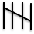
Term (n^{th}) – One of the numbers in a sequence
Tessellation – Patterns of shapes that fit together without any gaps
Tetrahedron – A 3D shape with four triangular faces, a triangular-based pyramid
Three-dimensional (3D) – Having three dimensions, length, width and height
Transformation – A change in position or size
Translation – To move an item in any direction without rotating it
Trapezium – A 2D shape with four sides, two of them being parallel
Tree diagram – A diagram used to display the probability of different outcomes with each branch representing one possible outcome
Triangle – A 2D shape with three sides
Triple/treble – To multiply by three
Two-dimensional (2D) - Having two dimensions, length and width
Unit - One
Unit of measure – Standard amount or quantity
Variable – Something that varies, represented by a letter in algebra
Venn diagram – A diagram using circles to show relationships between sets
Vertex/vertices – The point where two sides meet, or three or more faces
Vertical – Perpendicular to the horizon
Volume – The amount of space occupied by a 3D object
X-axis – The horizontal axis on a graph
Y-axis – The vertical axis on a graph
Y-intercept – Where a line intersects the y-axis

