Lines, Angles and Shapes (F)

Pre-Intervention Assessment

Name: _______________________________

Class: _______________________________

Date: _______________________________

Question | Objective | RAG
1 | Know angles around a point add up to 360° and angles on a straight line and angles in a triangle add up to 180°
2 | Solve problems involving corresponding, alternate and supplementary angles
3 | Calculate interior and exterior angles of a regular polygon
4 | Use the conditions for congruent triangles in formal geometrical proofs

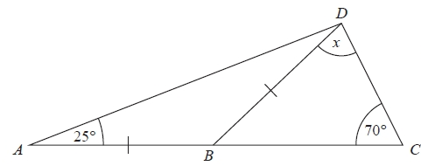
1. ABC is a straight line.
AB = BD
Angle BAD = 25°
Angle BCD = 70°
Work out the size of the angle marked x.
Give reasons for your answer.

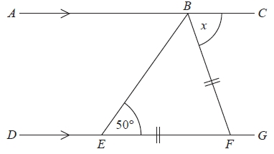
2. ABC is a straight line.
DEFG is a straight line.
AC is parallel to DG.
EF = BF.
Angle BEF = 50°.
Work out the size of the angle marked x.
Give reasons for your answer.

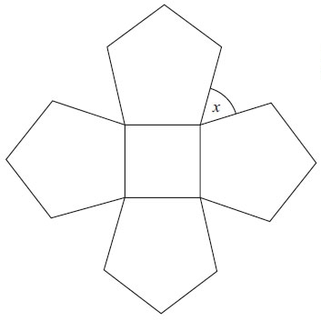
3. The diagram shows a square and 4 regular pentagons.
Work out the size of the angle marked x.

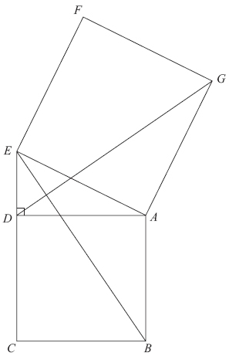
4. Diagram not drawn accurately.
In the diagram,
ADE is a right-angled triangle,
ABCD and AEFG are squares.
Prove that triangle ABE is congruent to triangle ADG.

[Glue here]

