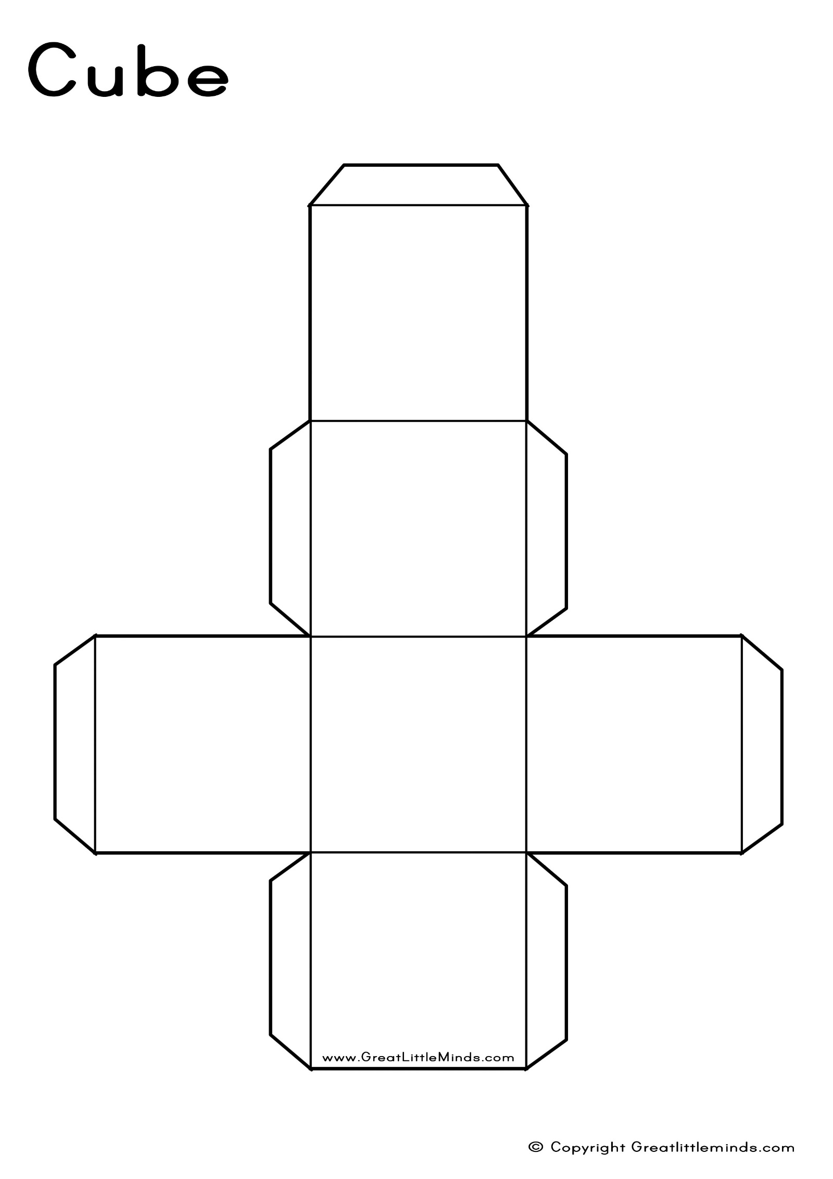

**Instructions:**

Make sure you cut out the net really neatly.

You will need to fold the cube and glue down each of the tabs.

When you put dots on each face (before or after – which will be easiest?), you need to make sure that the opposite faces add up to 7.

**Make a Die**