Plans and Elevations GREEN

- For each of these shapes, draw a plan view, a front elevation and a side elevation.
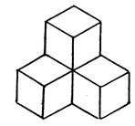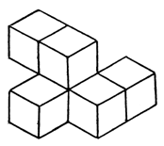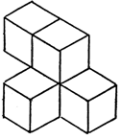

- Draw the plans and elevations for these 3D shapes.

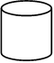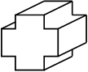

- Use the plans and elevations below to draw images of these 3D shapes on isometric paper.

 | Plan |  |  |  |  |  |  |  |  |  | Front Elevation |  |  |  |  |  |  |  |  |  | Side Elevation
a)
b)
c)
d)
e)

Plans and Elevations AMBER

- For each of these shapes, draw a plan view, a front elevation and a side elevation.
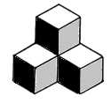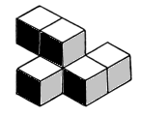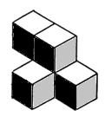

- Draw the plans and elevations for these 3D shapes.

- Use the plans and elevations below to draw images of these 3D shapes on isometric paper.

 | Plan |  |  |  |  |  |  |  |  |  | Front Elevation |  |  |  |  |  |  |  |  |  | Side Elevation
a)
b)
c)
d)
e)
Plans and Elevations RED

- Build these 3D shapes out of multi-link cubes. For each one draw a plan view, a front elevation and a side elevation.

- Draw the plans and elevations for these 3D shapes.

- Use the plans and elevations below to draw images of these 3D shapes on isometric paper.

 | Plan (birds-eye view) |  |  |  |  |  |  |  |  |  | Front Elevation |  |  |  |  |  |  |  |  |  | Side Elevation
a)
b)
c)
d)
e)

