Cubic Equations and Graphs GREEN

1. Which of the following equations are cubic? (Circle them )

y = 6x² + 3x – 2 y = 2x³ - 5x + 1 y = 8x⁴ + 10x² - 7 y = 5x + 6

y = 12 – 11x³ y = 4x² + 2x + 9 y = x³ - 7x² + 8x – 18 y = x² - 16

2. Use the solutions of the following equations to match them to their corresponding graphs below.

y = (x + 3)(x – 1)(x – 4) y = (x – 2)(x + 1)(x + 3) y = 5x(x + 1)(2x – 1)

3. Expand the following expressions.

a. (x + 2)(x + 5)(x + 1) b. (x – 3)(x + 4)(x – 2)

(x + 2)(x + 5)(x + 1) = _______________ (x – 3)(x + 4)(x – 2) = _______________
c. x(x + 5)(x – 4) d. (x + 3)³

x(x + 5)(x – 4) = _______________ (x + 3)³ = _______________

4. What equations do these graphs represent?

y = _______________ y = _______________ y = _______________

5. How many solutions does each cubic equation have?

a. (x + 1)(x – 3)(x + 4) = 0 ______ b. (x + 3)³ = 0 ______

c. -x(x + 1)(x - 3) = 0 ______ d. x²(x + 4) = 0 ______

e. (x² + 2x + 5)(x - 2) = 0 ______ f. (10 - x)(x + 4)(x – 1) = 0 ______

WWW: ___________________________________________________________

EBI: ___________________________________________________________

Cubic Equations and Graphs AMBER
Highest power = 3
1. Which of the following equations are cubic? (Circle them )

y = 6x² + 3x – 2 y = 2x³ - 5x + 1 y = 8x⁴ + 10x² - 7 y = 5x + 6

y = 12 – 11x³ y = 4x² + 2x + 9 y = x³ - 7x² + 8x – 18 y = x² - 16

2. Use the solutions of the following equations to match them to their corresponding graphs below.
What are their solutions if they = 0?

y = (x + 3)(x – 1)(x – 4) y = (x – 2)(x + 1)(x + 3) y = 5x(x + 1)(2x – 1)

Start with one pair of brackets, then do the other!
3. Expand the following expressions.

a. (x + 2)(x + 5)(x + 1) b. (x – 3)(x + 4)(x – 2)

(x + 2)(x + 5)(x + 1) = _______________ (x – 3)(x + 4)(x – 2) = _______________
c. x(x + 5)(x – 4) d. (x + 3)³

x(x + 5)(x – 4) = _______________ (x + 3)³ = _______________
Use the solutions to form the brackets
4. What equations do these graphs represent?

y = _______________ y = _______________ y = _______________

5. How many solutions does each cubic equation have?
Are any solutions repeated?

a. (x + 1)(x – 3)(x + 4) = 0 ______ b. (x + 3)³ = 0 ______

c. -x(x + 1)(x - 3) = 0 ______ d. x²(x + 4) = 0 ______

e. (x² + 2x + 5)(x - 2) = 0 ______ f. (10 - x)(x + 4)(x – 1) = 0 ______

WWW: ___________________________________________________________

EBI: ___________________________________________________________

Cubic Equations and Graphs RED
Highest power = 3
1. Which of the following equations are cubic? (Circle them )

y = 6x² + 3x – 2 y = 2x³ - 5x + 1 y = 8x⁴ + 10x² - 7 y = 5x + 6

y = 12 – 11x³ y = 4x² + 2x + 9 y = x³ - 7x² + 8x – 18 y = x² - 16

2. Use the solutions of the following equations to match them to their corresponding graphs below.
What are their solutions if they = 0?

y = (x + 3)(x – 1)(x – 4) y = (x – 2)(x + 1)(x + 3) y = 5x(x + 1)(2x – 1)
x = -3, ___ or ___
Start with one pair of brackets, then do the other!
3. Expand the following expressions.

a. (x + 2)(x + 5)(x + 1) b. (x – 3)(x + 4)(x – 2)

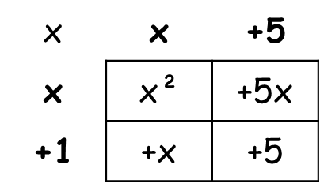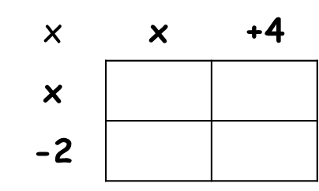

(x + 2)(x² + 6x + 5)

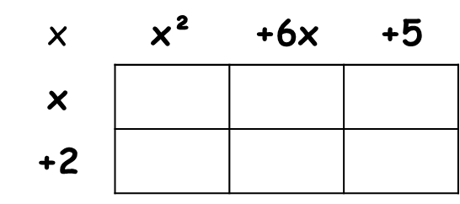

(x + 2)(x + 5)(x + 1) = _______________ (x – 3)(x + 4)(x – 2) = _______________
c. x(x + 5)(x – 4) d. (x + 3)³

x(x + 5)(x – 4) = _______________ (x + 3)³ = _______________
Use the solutions to form the brackets
4. What equations do these graphs represent?

y = _______________ y = _______________ y = _______________

5. How many solutions does each cubic equation have?
Are any solutions repeated?

a. (x + 1)(x – 3)(x + 4) = 0 ______ b. (x + 3)³ = 0 ______

c. -x(x + 1)(x - 3) = 0 ______ d. x²(x + 4) = 0 ______

e. (x² + 2x + 5)(x - 2) = 0 ______ f. (10 - x)(x + 4)(x – 1) = 0 ______

WWW: ___________________________________________________________

EBI: ___________________________________________________________

