Density Extension Question
The diagram shows a solid wooden sphere.
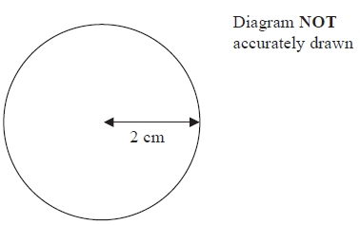
The radius of the sphere is 2 cm.
The mass of the sphere is 45 grams.
Wood will float on the Dead Sea only when the density of the wood is less than 1.24 g/cm³.
Will this wooden sphere float on the Dead Sea?
(Total for Question is 4 marks)

Density Extension Question
The diagram shows a solid wooden sphere.
The radius of the sphere is 2 cm.
The mass of the sphere is 45 grams.
Wood will float on the Dead Sea only when the density of the wood is less than 1.24 g/cm³.
Will this wooden sphere float on the Dead Sea?
(Total for Question is 4 marks)

