Band 2 – Test 1 Answers

1. | $\frac{2}{5}$ $\frac{1}{2}$ $\frac{2}{3}$ $\frac{3}{4}$ | 1 mark lost for each incorrect place | 2
2. | 24g £144 | 1 mark for 1/10 = 8g seen  1 mark for 10% or 1% seen  1 mark for each correct answer | 4
3. | Fraction Decimal Percentage  $\frac{1}{4}$ 0.25 25%  $\frac{2}{5}$ 0.4 40%  $\frac{17}{20}$ 0.85 85% | 1 mark for each correct answer | 3
4. | 200 g plain flour  150 g ground almonds  225 g soft brown sugar  150 g butter  10 ripe pears | 1 mark for 4 : 10 or x 2.5 seen  1 mark for 2 quantities correct  1 mark for all quantities correct | 3
5. | Farm shop is best value  Farm shop 1 kg = 72p  Supermarket 1 kg = 73.2p | 1 mark for each piece of working  1 mark for correct conclusion | 3
6. | 2 × 3 + 4 = 10  10 – 2 × 5 = 0  16 ÷ (2 × 4) = 2 | 1 mark for each correct answer | 3
7. | 5.8 | Correct answer | 1
8. | __48___ ___72___  1 and 48 1 and 72  2 and 24 2 and 36  3 and 16 3 and 24  4 and 12 4 and 18  6 and 8 6 and 12  8 and 9  HCF = 24 | 1 mark for each list of factors  1 mark for 24 | 3
9. | 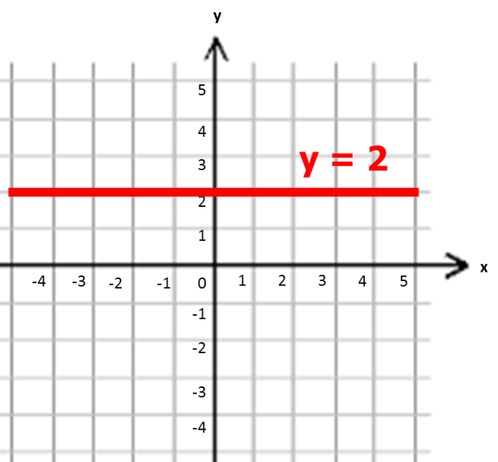 | Correct answer | 1
10. | 5n + 1 | 1 mark for 5n  1 mark for +1 | 2
11. | 8p + 5q | 1 mark for p simplified correctly  1 mark for q simplified correctly | 2
12. | 15 – 8 = 7 | 1 mark for 1 correct substitution  1 mark for correct answer | 2
13. | 2x + 3 = 11  2x = 8  x = 4 | 1 mark for 2x = 8  1 mark for correct answer | 2
14. | 360 – (45 + 90 + 122) = 360 – 257 = 103º | 1 mark for 257º seen  1 mark for correct answer | 2
15. | Correct sketch | 1 mark for each length/angle given | 3
16. | 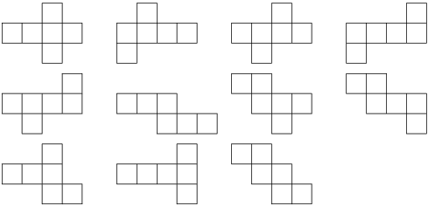 | 2 marks for any 1 of these nets | 2
17. |  | Correct answer | 2
18. | 5 x 8 = 40 cm² | 1 mark for correct working  1 mark for correct answer | 2
19. | 50 000 ÷ 100 = 500 cm² | 1 mark for 100 seen  1 mark for correct answer | 2
20. | 2 hours  Wednesday | 1 mark for each correct answer | 2
21. | Mode = 5 Mean = 38 ÷ 10 = 3.8 | 1 mark for correct answer for mode  1 mark for correct working for mean  1 mark for correct answer for mean | 3
22. | 1 – (0.38 + 0.27 + 0.15) = 1 – 0.8 = 0.2 | 1 mark for 0.8 seen  1 mark for correct answer | 2
23. | France Germany Spain Total  Female 2 23 9 34  Male 15 2 9 26  Total 17 25 18 60 | 2 marks for all correct  1 mark lost for each incorrect | 2

