Trigonometric Identities Starter

Complete this table to recap what you know about trig functions.

 | Sine | Cosine | Tangent
Period | ______º
Graph
(include intercepts with axes)
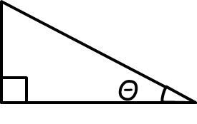 | Sin Θ = opp  hyp | Cos Θ = | Tan Θ =

