Venn Diagrams GREEN

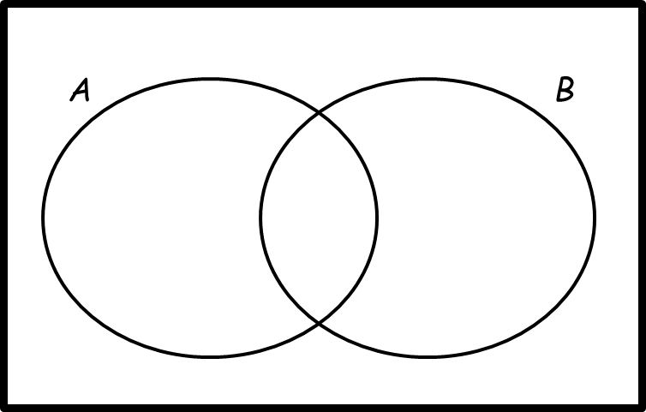
1. ξ = {1, 2, 3, 4, 5, 6, 7, 8, 9, 10, 11, 12, 13, 14, 15, 16}
A = multiples of 3
B = multiples of 5
a) Complete the Venn diagram.

One of the numbers is selected at random.
b) Write down P (A ∩ B)

………………………………………………………

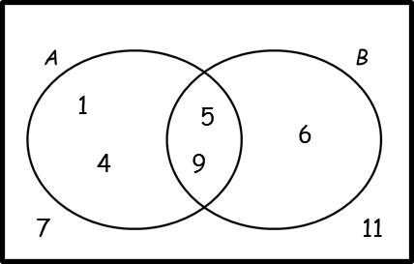
2. Here is a Venn diagram.
Write down the numbers that are in set:

a) B

………………………………………………………
b) A ∪ B

………………………………………………………
c) Write down P (A’)

………………………………………………………

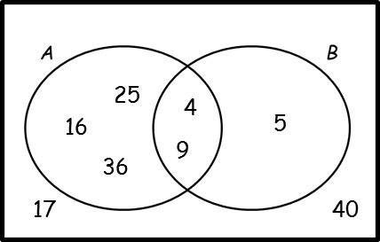
3. Here is a Venn diagram.
Write down the numbers that are in set:

a) A ∩ B

………………………………………………………
b) A ∪ B

………………………………………………………
c) A'

………………………………………………………

One of the numbers in the diagram is chosen at random.
d) Find the probability that the number is in set B’

………………………………………………………

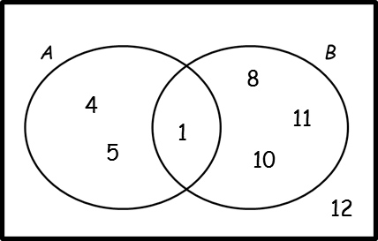
4. Here is a Venn diagram. A number is chosen at random.
a) Write down P (A ∩ B')

………………………………………………………

b) Write down P (A' ∪ B')

………………………………………………………

c) Write down P (B | A)

………………………………………………………

Venn Diagrams AMBER

1. ξ = {1, 2, 3, 4, 5, 6, 7, 8, 9, 10, 11, 12, 13, 14, 15, 16}
A = multiples of 3
B = multiples of 5
a) Complete the Venn diagram.

One of the numbers is selected at random.
b) Write down P (A ∩ B)
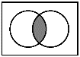

………………………………………………………

2. Here is a Venn diagram.
Write down the numbers that are in set:

a) B

………………………………………………………
b) A ∪ B
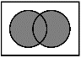
………………………………………………………
c) Write down P (A’)

………………………………………………………

3. Here is a Venn diagram.
Write down the numbers that are in set:

a) A ∩ B
………………………………………………………
b) A ∪ B
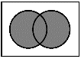
………………………………………………………
c) A'

………………………………………………………

One of the numbers in the diagram is chosen at random.
d) Find the probability that the number is in set B’

………………………………………………………

4. Here is a Venn diagram. A number is chosen at random.
a) Write down P (A ∩ B')

………………………………………………………

b) Write down P (A' ∪ B')

………………………………………………………

c) Write down P (B | A)
“The probability of B, given A”

………………………………………………………

Venn Diagrams RED

1. ξ = {1, 2, 3, 4, 5, 6, 7, 8, 9, 10, 11, 12, 13, 14, 15, 16}
A = multiples of 3
B = multiples of 5
a) Complete the Venn diagram.

One of the numbers is selected at random.
b) Write down P (A ∩ B)

………………………………………………………

2. Here is a Venn diagram.
Write down the numbers that are in set:

a) B
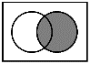
………………………………………………………
b) A ∪ B
………………………………………………………
c) Write down P (A’)
P (?) means “the probability of…”
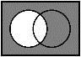
………………………………………………………

3. Here is a Venn diagram.
Write down the numbers that are in set:

a) A ∩ B
………………………………………………………
b) A ∪ B
………………………………………………………
c) A'
………………………………………………………

One of the numbers in the diagram is chosen at random.
d) Find the probability that the number is in set B’
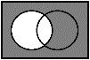
………………………………………………………

4. Here is a Venn diagram. A number is chosen at random.
a) Write down P (A ∩ B')

………………………………………………………

b) Write down P (A' ∪ B')

………………………………………………………

c) Write down P (B | A)
“The probability of B, given A”

………………………………………………………

